**HỌC VIỆN CÔNG NGHỆ BƯU CHÍNH VIỄN THÔNG**

**KHOA CÔNG NGHỆ THÔNG TIN**

-----🙞🙜🕮🙞🙜-----



**BÁO CÁO KẾT THÚC HỌC PHẦN**

**MÔN HỌC: PHÂN TÍCH & THIẾT KẾ HỆ THỐNG THÔNG TIN**

|  |  |
| --- | --- |
| **Giảng viên hướng dẫn** | **: Trần Đình Quế** |
| **Họ và tên sinh viên** | **: Nguyễn Thị Lan** |
| **Mã sinh viên** | **: B21DCCN818** |
| **Lớp** | **: D21CNPM05** |
| **Nhóm lớp**  **SĐT** | **: 09**  **: 0896029714** |

**Hà Nội – 2024**

# LỜI CẢM ƠN

Trước tiên chúng em xin gửi lời cảm ơn chân thành sâu sắc tới các thầy cô giáo trong trường Học viện Công nghệ Bưu chính viễn thông và các thầy cô giáo trong Bộ môn Khoa Công nghệ thông tin đã tận tình giảng dạy, truyền đạt cho em những kiến thức, kinh nghiệm quý báu trong suốt thời gian qua. Đặc biệt em xin gửi lời cảm ơn đến ***thầy giáo Trần Đình Quế*** đã tận tình giúp đỡ, trực tiếp chỉ bảo, hướng dẫn em trong suốt quá trình làm báo cáo. Trong thời gian làm việc với thầy, cô, chúng em không ngừng tiếp thu thêm nhiều kiến thức bổ ích mà còn học tập được tinh thần làm việc, thái độ nghiên cứu khoa học nghiêm túc, hiệu quả, đây là những điều rất cần thiết cho chúng em trong quá trình học và công tác sau này.

Sau cùng xin gửi lời cảm ơn chân thành tới gia đình, bạn bè đã động viên, đóng góp ý kiến và giúp đỡ trong quá trình học tập, nghiên cứu và hoàn thành báo cáo.

# MỤC LỤC

LỜI CẢM ƠN 1

MỤC LỤC 2

DANH MỤC HÌNH ẢNH 4

REQUIREMENTS 4

I. Determine requirements 5

1. Define use cases and draw use case diagram in two levels: General level (>=20 use cases) and Level 1 (detail) 5

1.1 Define use cases 5

1.2 Draw use case diagram in two levels 5

2. Write 30 scenarios and 30 user stories + acceptance criteria 5

2.1. 30 scenarios 5

2.2. 30 User Story with corresponding acceptance criteria 5

3. Draw 5 activity/swimlane diagrams + 5 sequence diagrams for the processes executed by customer and staff: 5

3.1 Create cart, checkout, select ship (drone), select pay and order, give comments & feed back of items 5

3.2 Process order: alert order (automatically), check order, send invoice/feedback to customer, send requirements to ship department and repository 5

3.3 Process payment 5

3.4 Process shipment (using drone) 5

II. Requirement Analysis 5

1. Write 50 CRC Cards 5

2. Draw a class diagram (analysis) with 50 classes 5

3. Construct data dictionary 6

4. Create data model 6

III. Design 7

1. Construct a class diagram (design) 7

1.1 Validate the class diagram in analysis (Name, attributes, methods, relationship...) 7

1.2 Add attributes, add methods, change multiplicity, change relationship 7

1.3 Change association classes into suitable relationships (aggregation, composition) 7

2. Using MVC model to design the e-commerce system 7

2.1 Using DAO pattern to classes 7

2.2 Using package notion in UML to group classes into packages and layers with the model MVC: Model layer, Controller model, View model 8

3. Construct database 13

3.1 Validate data model: check fields, key, connection multilicity... 13

3.2 Select a model for inheritance 14

3.3 Generate database with 14

4. Design interface (user interface and system interface) 14

4.1 Máy tính PC: 14

4.2 Mobile: 15

IV. Programming and Integration 15

1. Using Java Spring (Boot), JSP, CSS, NoteJS.... 15

2. Developing/utilizing techniques in deep learning to build modules search, analyze opinions/comments, recommender items, generate plots of analyzing customer’s tendency…. 15

# DANH MỤC HÌNH ẢNH

Hình 1. 1 Usecase tổng quát 7

Hình 1. 2: Usecase chi tiết register 7

Hình 1. 3: Usecase chi tiết Login 7

Hình 1. 4: Usecase chi tiết Browseproducts 7

Hình 1. 5: Usecase chi tiết Search product 7

Hình 1. 6: Usecase chi tiết Create cart 7

Hình 1. 7: Usecase chi tiết Process Order 7

Hình 1. 8: Usecase chi tiết Process payment 7

Hình 1. 9: Usecase chi tiết Process Shipment 7

Hình 1. 10: Usecase chi tiết Checkout 7

Hình 1. 11: Usecase chi tiết Management Manager 7

Hình 1. 12: Create Cart 7

Hình 1. 13: Payment 7

Hình 1. 14: Shipment 7

Hình 1. 15: Order 7

Hình 1. 16: Feedback 7

Hình 1. 17: Create Cart 7

Hình 1. 18: Payment 7

Hình 1. 19: Shipment 7

Hình 1. 20: Order 7

Hình 1. 21: Feedback 7

Hình 1. 22: Activity 1 7

Hình 1. 23: Activity 2 7

Hình 1. 24: Activity 3 7

Hình 1. 25: Activity 4 7

Hình 1. 26: Activity 5 7

Hình 1. 27: Sequence Diagram 1 7

Hình 1. 28: Sequence Diagram 2 7

Hình 1. 29: Sequence Diagram 3 7

Hình 1. 30: Sequence Diagram 4 7

Hình 1. 31: Sequence Diagram 5 7

Hình 1. 32: Staff Payment 7

Hình 1. 33: Customer Payment 7

Hình 1. 34: Refund Staff 7

Hình 1. 35: Refund Customer 7

Hình 1. 36: Payment Failed 7

Hình 1. 37: Customer Payment 7

Hình 1. 38: Staff Payment 7

Hình 1. 39: Payment Failed 7

Hình 1. 40: Refund Customer 7

Hình 1. 41: Refund Staff 7

Hình 1. 42: Activity Diagram 1 7

Hình 1. 43: Activity Diagram 2 7

Hình 1. 44: Activity Diagram 3 7

Hình 1. 45: Activity Diagram 4 7

Hình 1. 46: Activity Diagram 5 7

Hình 1. 47: Sequence Diagram 1 7

Hình 1. 48: Sequence Diagram 2 7

Hình 1. 49: Sequence Diagram 4 7

Hình 1. 50: Sequnece Diagram 5 7

Hình 2. 1: class diagram (analysis) with 50 classes 8

Hình 2. 2: data model 9

Hình 3. 1: DAO pattern to classes 10

Hình 3. 2: Package layer 11

Hình 3. 3: CustomerDAO 11

Hình 3. 4: Class Diagram Customer 12

Hình 3. 5: CartDAO 12

Hình 3. 6: Class Diagram Cart 13

Hình 3. 7: OrderDAO 13

Hình 3. 8: Class Diagram Order 13

Hình 3. 9: ItemDAO 14

Hình 3. 10: Class Diagram Item 14

Hình 3. 11: PaymentDAO 15

Hình 3. 12: Class Diagram Payment 15

Hình 3. 13: ShipmentDAO 16

Hình 3. 14: Class Diagram Shipment 16

# REQUIREMENTS

Develop an e-commerce site, which may be users by types of customers, types of staff, managers. This site provides services of purchasing ***books, clothes, mobile phone, laptop, shoes, electronic devices.*** Your tasks:

## I. Determine requirements

### 1. Define use cases and draw use case diagram in two levels: General level (>=20 use cases) and Level 1 (detail)

#### 1.1 Define use cases

|  |  |  |
| --- | --- | --- |
| **Actor** | **Use Case** | **Detail** |
| **Customer** | Register | The customer registers a new account. |
| Login | Log in to the system. |
| Browse Products | View the list of products by category or filter. |
| Search Products | Search for products by name or attributes. |
| Create Cart | Create a shopping cart for selected products. |
| Add Product to Cart | Add a product to the shopping cart. |
| Remove Product from Cart | Remove a product from the shopping cart. |
| View Product Details | View detailed information about a product. |
| Checkout | Proceed with the checkout process and select the shipping method. |
| Make Payment | Pay for the order using available payment methods. |
| Track Order | Track the status of an order after it’s placed. |
| Submit Feedback | Submit feedback or reviews for a product. |
| Request Refund | Request a refund for returned items. |
| Logout | Log out of the system securely. |
| **Staff** | Login | Log in to the system as a staff member. |
| Manage Inventory | Add, update, or delete product information in the inventory. |
| Update Product Information | Modify product details such as price, description, or availability. |
| Process Orders | Handle customer orders, including preparation and packaging. |
| Process Shipment | Arrange and ensure shipment of orders to customers. |
| Update Order Status | Update the status of orders (e.g., pending, shipped, delivered). |
| Handle Returns | Process returned products and adjust inventory accordingly. |
| Respond to Customer Inquiries | Provide assistance or answers to customer queries. |
| Process Feedback | Review, analyze, and address customer feedback or complaints. |
| Login | Log in to the system with manager privileges. |
| Manage Staff Accounts | Add, update, or delete staff and customer accounts. |
| Monitor System Performance | Track and evaluate the system's overall performance and usage. |
| Update Promotions/Discounts | Create and manage promotional campaigns or discounts. |
| View Sales Reports | Generate and analyze sales reports to assess business performance. |
| **Manager** | Generate Inventory Reports | Create detailed reports on inventory levels and status. |
| Assign Staff Roles | Assign specific roles or tasks to staff members. |
| Approve Refund Requests | Review and approve or reject customer refund requests. |
| Monitor System Logs | Track and analyze system activity logs for security and performance. |
| Oversee Order Processing | Supervise the order handling process, from placement to shipment. |

#### 1.2 Draw use case diagram in two levels

##### 1.2.1 Usecase tổng quát:

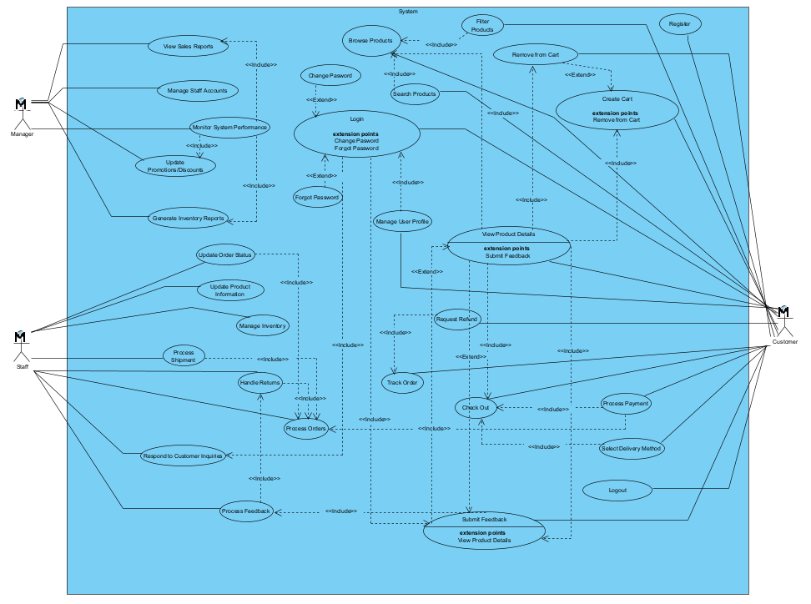

Hình 1. Usecase tổng quát

##### 1.2.2 Usecase chi tiết:

* ***Usecase chi tiết register:***

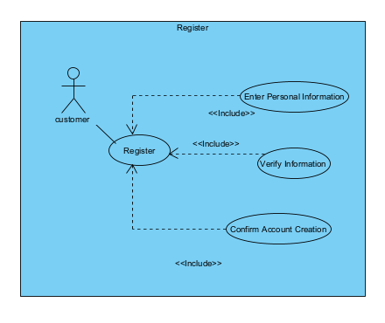

Hình 1. : Usecase chi tiết register

* ***Usecase chi tiết Login***:

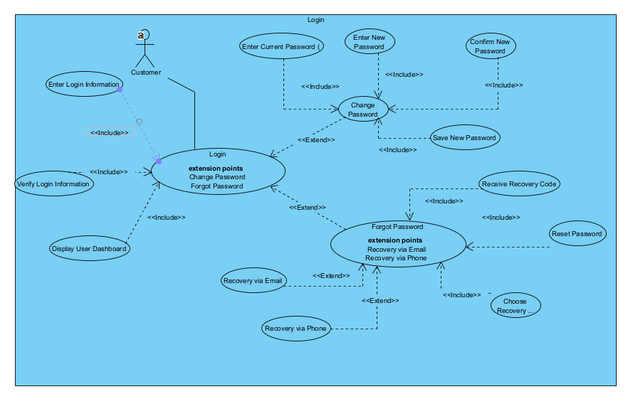

Hình 1. : Usecase chi tiết Login

* ***Usecase chi tiết Browseproducts:***

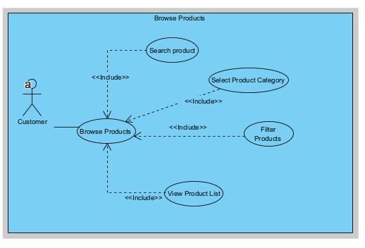

Hình 1. : Usecase chi tiết Browseproducts

* ***Usecase chi tiết Search products:***

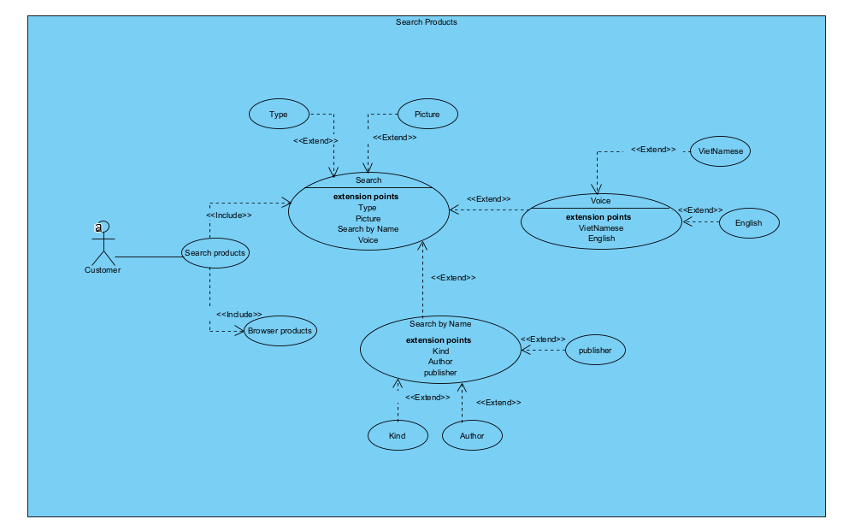

Hình 1. : Usecase chi tiết Search product

* ***Usecase chi tiết Create cart***:

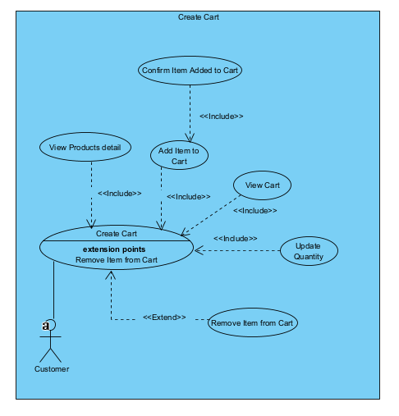

Hình 1. : Usecase chi tiết Create cart

* ***Usecase chi tiết Process Order:***

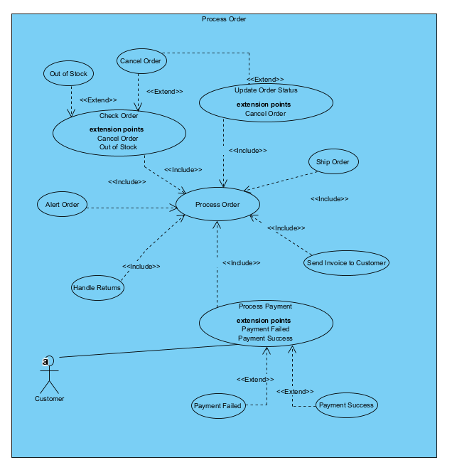

Hình 1. : Usecase chi tiết Process Order

* ***Usecase chi tiết Process payment***:

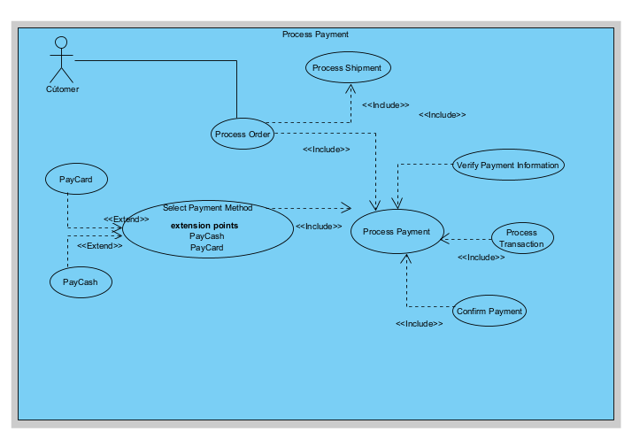

Hình 1. : Usecase chi tiết Process payment

* ***Usecase chi tiết Process Shipment:***

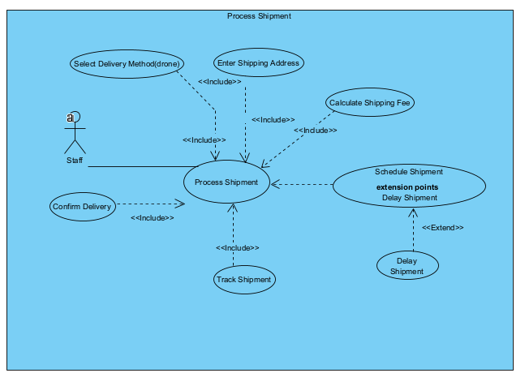

Hình 1. : Usecase chi tiết Process Shipment

* ***Usecase chi tiết Checkout***:

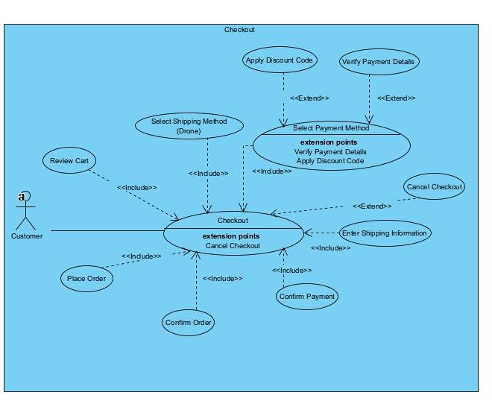

Hình 1. : Usecase chi tiết Checkout

* ***Usecase chi tiết Management Manager:***

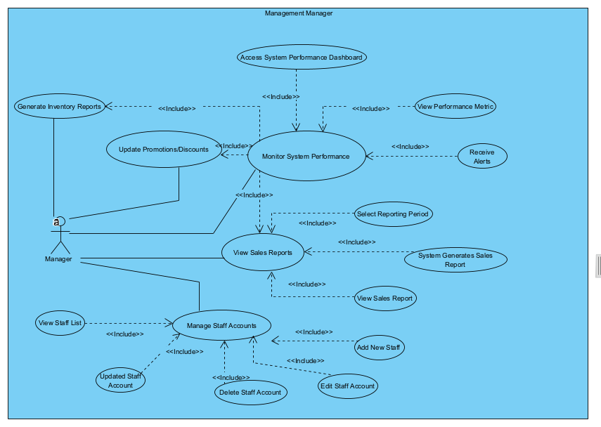

Hình 1. : Usecase chi tiết Management Manager

### 2. Write 30 scenarios and 30 user stories + acceptance criteria

#### 2.1. 30 scenarios

##### 1. Create cart

|  |  |  |  |
| --- | --- | --- | --- |
| ***Use Case ID:*** | UC01 | | |
| ***Use Case Name:*** | Create Cart | | |
| ***Created By:*** | Mạc Văn Thành | Last Updated By: |  |
| ***Date Created:*** | 19/10/2024 | Date Last Updated: |  |

|  |  |
| --- | --- |
| ***Actor:*** | Customer |
| ***Description:*** | Allows users to create a shopping cart for selected items. |
| ***Preconditions:*** | User must be logged in or register as a guest. |
| ***Postconditions:*** | A new cart is created and associated with the user account. |
| ***Priority:*** | High |
| ***Frequency of Use:*** | Frequent |
| ***Normal Course of Events:*** | 1. User navigates to the product listing page.  2. System displays available products with options to add to the cart.  3. User selects a product and clicks the "Add to Cart" button.  4. System adds the product to the user's cart and updates the cart icon with the total number of items.  5. System displays a confirmation message: "Item added to your cart!"  6. User can either continue shopping or click on the cart icon to view the cart.  7. If the user views the cart, the system displays a summary of items in the cart, including prices and total cost. |
| ***Alternative Courses:*** | - UC1.AC1:   * User is not logged in. * System prompts: "Please log in or create an account to add items to your cart."   -  UC1.AC2:   * User attempts to add an out-of-stock product. * System displays an error message: "This item is currently out of stock." |
| Exceptions: | -  UC1.EX1: Cart creation error.   * **Condition**: The system fails to create a cart due to a database error. * **Response**: The system alerts the user: "Unable to create a cart. Please try again later."   -  UC1.EX2: Duplicate cart attempt.   * **Condition**: A user tries to create a cart while another active cart exists. * **Response**: The system displays: "You already have an active cart. Please use it or clear it before creating a new one." |
| ***Includes:*** | **Session Management**: Keeps track of user sessions to associate carts with user profiles.  **Cart Initialization**: Sets default values for new carts (e.g., total price, item count). |
| ***Special Requirements:*** | -  Cart creation should complete within **2 seconds** to ensure a smooth user experience.  -  The system should support up to **50 items** in a single cart before needing to be split. |
| ***Assumptions:*** | -  Users are logged in or have a session created to associate with the cart.  -  The system has enough resources to handle concurrent cart creations. |
| ***Note and Issues:*** | -  **Notes**: Users should be able to create multiple carts for different shopping sessions.  -  **Issues**:   * How to manage cart persistence across sessions?   + **Responsible**: Development Team   + **Due Date**: [Specify Date]   + **Resolution**: Implement session management to save carts in the database. * What happens if a user tries to create a cart while already having one?   + **Responsible**: UX Team   + **Due Date**: [Specify Date]   + **Resolution**: Notify users of existing carts and prompt them for action. |

##### 2. Checkout

|  |  |  |  |
| --- | --- | --- | --- |
| Use Case ID: | UC02 | | |
| Use Case Name: | Checkout | | |
| Created By: | Mạc Văn Thành | Last Updated By: |  |
| Date Created: | 19/10/2024 | Date Last Updated: |  |

|  |  |
| --- | --- |
| Actor: | Customer |
| Description: | Users finalize their purchases by proceeding to checkout. |
| Preconditions: | Cart must have at least one item. |
| Postconditions: | User proceeds to payment and shipping options. |
| Priority: | High |
| Frequency of Use: | Frequent |
| Normal Course of Events: | 1. User navigates to the cart page.  2. System displays the items in the cart with a summary of costs and total amount.  3. User clicks the "Checkout" button.  4. System prompts the user to log in (if not logged in).  5. User enters their login credentials and clicks "Login."  6. System verifies the credentials against the database.  7. User reviews the shipping address displayed.  8. User clicks "Continue to Payment."  9. System displays available payment options.  10. User selects a payment method (e.g., credit card, PayPal).  11. User enters the necessary payment details.  12. System validates the payment information.  13. User clicks "Confirm Order."  14. System processes the checkout and displays a confirmation message: "Thank you for your order!" |
| Alternative Courses: | - UC1.AC1:   * User is not logged in. * System prompts: "Please log in or create an account to add items to your cart."   -  UC1.AC2:   * User attempts to add an out-of-stock product. * System displays an error message: "This item is currently out of stock." |
| Exceptions: | -  **UC2.EX1:** Checkout failure.   * **Condition:** The checkout process fails due to payment processing errors. * **Response:** The system alerts the user: "Checkout failed. Please review your payment information and try again."   -  **UC2.EX2:** Insufficient inventory.   * **Condition:** An item in the cart is no longer in stock during checkout. * **Response:** The system prompts: "One or more items are out of stock. Please remove them and try again." |
| Includes: | -  **Order Review**: Provides a summary of items before finalizing the checkout.  -  **Payment Processing**: Handles the payment transaction through the chosen gateway. |
| Special Requirements: | -  The checkout process should take no longer than **5 minutes** from start to finish.  -  Users should receive a confirmation email within **1 hour** of completing the checkout. |
| Assumptions: | -  Users have valid payment methods set up in their profiles.  -  The system is capable of handling multiple checkout requests simultaneously. |
| Note and Issues: | -  **Notes**: The checkout process should be streamlined for user convenience.  -  **Issues**:   * What information is required for the checkout?   + **Responsible**: Product Manager   + **Due Date**: [Specify Date]   + **Resolution**: Finalize required fields such as shipping address, payment details. * How to handle checkout for users with discount codes?   + **Responsible**: Development Team   + **Due Date**: [Specify Date]   + **Resolution**: Implement validation for discount codes during checkout. |

##### 3. Select ship (drone)

|  |  |  |  |
| --- | --- | --- | --- |
| Use Case ID: | UC03 | | |
| Use Case Name: | Select Ship (Drone) | | |
| Created By: | Mạc Văn Thành | Last Updated By: |  |
| Date Created: | 19/10/2024 | Date Last Updated: |  |

|  |  |
| --- | --- |
| Actor: | Customer |
| Description: | Users choose drone delivery as a shipping option. |
| Preconditions: | User is in the checkout process. |
| Postconditions: | Drone shipping option is selected for the order. |
| Priority: | Medium |
| Frequency of Use: | Moderate |
| Normal Course of Events: | -  **User navigates to the checkout page.**  1. System displays available shipping methods, including drone delivery.  2. User selects the drone delivery option.  3. System confirms the selection and updates the estimated delivery time.  4. User clicks "Continue to Payment."  5. System proceeds to the payment section, displaying the selected shipping method. |
| Alternative Courses: | -  UC3.AC1:   * User's address is not eligible for drone delivery. * System displays a message: "Drone delivery is not available for your selected address. Please choose another shipping method."   -  UC3.AC2:   * Technical issue with the shipping options. * System displays an error message: "Unable to retrieve shipping options. Please try again later." |
| Exceptions: | -  **UC3.EX1:** Delivery area not supported.   * **Condition:** The user selects drone delivery but their address is outside the service area. * **Response:** The system informs: "Drone delivery is not available in your area."   -  **UC3.EX2:** Drone unavailability.   * **Condition:** No drones are currently available for delivery. * **Response:** The system alerts the user: "No drones available for delivery at this time. Please choose a different shipping method." |
| Includes: | -  **Service Area Check**: Verifies if the delivery location is eligible for drone delivery.  -  **Drone Availability Check**: Checks the status and availability of drones in real-time. |
| Special Requirements: | -  The system must respond to delivery selection changes within **2 seconds**.  -  Drones should be dispatched based on priority, optimizing delivery times. |
| Assumptions: | -  Users are aware of drone delivery options and their limitations.  -  The system has accurate mapping data to determine service areas. |
| Note and Issues: | -  **Notes**: Ensure users are aware of the delivery time when selecting drone shipping.  -  **Issues**:   * Are there restrictions on where drones can deliver?   + **Responsible**: Logistics Team   + **Due Date**: [Specify Date]   + **Resolution**: Confirm delivery areas and implement checks in the system. * How will users be informed of delivery delays?   + **Responsible**: Customer Service Team   + **Due Date**: [Specify Date]   + **Resolution**: Create an alert system for delivery delays. |

##### 4. Select pay and order

|  |  |  |  |
| --- | --- | --- | --- |
| Use Case ID: | UC04 | | |
| Use Case Name: | Select pay and order | | |
| Created By: | Mạc Văn Thành | Last Updated By: |  |
| Date Created: | 19/10/2024 | Date Last Updated: |  |

|  |  |
| --- | --- |
| Actor: | Customer |
| Description: | Users select a payment method and confirm the order. |
| Preconditions: | User must have selected shipping and items. |
| Postconditions: | Order is confirmed, and payment is processed |
| Priority: | High |
| Frequency of Use: | Frequent |
| Normal Course of Events: | 1. User navigates to the payment section during checkout.  2. System displays available payment options (credit card, PayPal, etc.).  3. User selects a preferred payment method.  4. System prompts the user to enter the required payment details.  5. User enters their credit card information.  6. System validates the payment information format.  7. User clicks the "Pay Now" button.  8. System contacts the payment gateway for authorization.  9. Payment gateway confirms the transaction.  10. System updates the order status to "Paid" and displays a confirmation message: "Your payment has been successfully processed." |
| Alternative Courses: | -  UC4.AC1:   * Payment information is invalid. * System displays an error message: "Invalid payment information. Please check your details and try again."   -  UC4.AC2:   * Payment fails. * System alerts the user: "Payment processing failed. Please select another payment method." * System displays an error message: "This item is currently out of stock." |
| Exceptions: | -  **UC4.EX1:** Payment method declined.   * **Condition:** The user’s payment method is rejected during the transaction. * **Response:** The system notifies the user: "Your payment was declined. Please check your payment details."   -  **UC4.EX2:** Order processing error.   * **Condition:** An error occurs while processing the order. * **Response:** The system displays: "An error occurred while processing your order. Please try again." |
| Includes: | -  **Payment Processing**: Integrates with payment gateways to handle transactions securely.  -  **Order Confirmation**: Sends confirmation to users once the order is successfully placed. |
| Special Requirements: | -  Payment processing should complete in **less than 3 seconds**.  -  The system should securely encrypt all payment information. |
| Assumptions: | -  Users have a valid and active payment method selected.  -  The system is capable of handling peak loads during high traffic. |
| Note and Issues: | -  **Notes**: Offer multiple payment methods for user convenience.  -  **Issues**:   * What payment gateways will be integrated?   + **Responsible**: Finance Team   + **Due Date**: [Specify Date]   + **Resolution**: Choose payment gateways and finalize agreements. * How will failed payment attempts be handled?   + **Responsible**: Development Team   + **Due Date**: [Specify Date]   + **Resolution**: Implement a retry mechanism and notify users of failures. |

##### 5. Give comments & feed back of items

|  |  |  |  |
| --- | --- | --- | --- |
| Use Case ID: | UC05 | | |
| Use Case Name: | Give comments & feed back of items | | |
| Created By: | Mạc Văn Thành | Last Updated By: |  |
| Date Created: | 19/10/2024 | Date Last Updated: |  |

|  |  |
| --- | --- |
| Actor: | Customer |
| Description: | Users can provide reviews and feedback on purchased items. |
| Preconditions: | User must have purchased the item. |
| Postconditions: | Feedback is recorded and displayed on the item page. |
| Priority: | Medium |
| Frequency of Use: | Occasional |
| Normal Course of Events: | 1. User navigates to their order history.  2. System displays a list of past purchases with options to review.  3. User selects a specific item to review.  4. System prompts the user to enter a rating and comments.  5. User enters a rating (1-5 stars) and types their comments.  6. User clicks the "Submit Feedback" button.  7. System validates the input for completeness and appropriateness.  8. If valid, system stores the feedback and updates the item’s review section.  9. System displays a confirmation message: "Thank you for your feedback!" |
| Alternative Courses: | -  UC5.AC1:   * User tries to comment on an item they have not purchased. * System displays an error message: "You can only leave feedback for items you have purchased."   -  UC5.AC2:   * Feedback submission fails due to a technical issue. * System alerts the user: "There was an error submitting your feedback. Please try again later." |
| Exceptions: | -  **UC5.EX1:** Feedback submission error.   * **Condition:** The system fails to save the feedback due to a database issue. * **Response:** The system alerts the user: "Unable to submit your feedback. Please try again later."   -  **UC5.EX2:** Invalid feedback format.   * **Condition:** The user submits feedback that does not meet format requirements (e.g., too short). * **Response:** The system prompts: "Feedback must be at least 10 characters long." |
| Includes: | -  **Feedback Validation**: Checks the content of the feedback before submission.  -  **Feedback Storage**: Saves feedback to the database for future reference. |
| Special Requirements: | -  Feedback submission should be processed within **2 seconds**.  -  Users should be able to edit or delete their feedback for **up to 24 hours** after submission. |
| Assumptions: | -  Users are logged in or have an identifiable account to associate the feedback.  -  The system is capable of handling concurrent feedback submissions. |
| Note and Issues: | -  **Notes**: Users should be able to edit their feedback within a certain timeframe.  -  **Issues**:   * How will feedback be moderated to prevent abuse?   + **Responsible**: Content Moderation Team   + **Due Date**: [Specify Date]   + **Resolution**: Establish guidelines for feedback moderation. * What happens if a product receives a large volume of negative feedback?   + **Responsible**: Product Manager   + **Due Date**: [Specify Date]   + **Resolution**: Create a flagging system to review such products. |

##### 6. Alert order (automatically)

|  |  |  |  |
| --- | --- | --- | --- |
| Use Case ID: | UC06 | | |
| Use Case Name: | Alert Order (Automatically) | | |
| Created By: | Mạc Văn Thành | Last Updated By: |  |
| Date Created: | 19/10/2024 | Date Last Updated: |  |

|  |  |
| --- | --- |
| Actor: | Customer, System |
| Description: | The system alerts users about their order status. |
| Preconditions: | An order must exist. |
| Postconditions: | User receives notifications about order updates. |
| Priority: | High |
| Frequency of Use: | Frequent |
| Normal Course of Events: | 1. System processes an order and updates the order status (e.g., processing, shipped, delivered).  2. System monitors the order status in real-time.  3. When the status changes, the system automatically triggers a notification.  4. System sends a notification to the user’s registered email or mobile number.  5. User receives the order status update (e.g., "Your order has been shipped"). |
| Alternative Courses: | -  UC6.AC1:   * Notification fails to send due to a server issue. * System logs the error for review.   -  UC6.AC2:   * User has opted out of notifications. * System does not send any alerts. |
| Exceptions: | -  **UC6.EX1:** Alert notification failure.   * **Condition:** The system fails to send order alerts due to a service outage. * **Response:** The system logs the error and will attempt to resend notifications later.   -  **UC6.EX2:** User preferences not set.   * **Condition:** The user has not set preferences for receiving alerts. * **Response:** The system displays: "You have not set your notification preferences. Please update your settings." |
| Includes: | -  **Notification Preferences**: Allows users to set preferences for how they receive order alerts (e.g., email, SMS).  -  **Alert Generation**: Automatically triggers alerts based on order status changes. |
| Special Requirements: | -  Alerts should be sent within **5 minutes** of a status change.  -  Users should have access to a log of past alerts within their account. |
| Assumptions: | -  Users are familiar with how to set their notification preferences.  -  The system can handle multiple alert requests simultaneously. |
| Note and Issues: | -  **Notes**: Alerts should be sent via email and SMS for user preferences.  -  **Issues**:   * Are users notified of alerts for all orders or only specific ones?   + **Responsible**: Development Team   + **Due Date**: [Specify Date]   + **Resolution**: Define criteria for alert notifications. * How will the system handle user preferences for alerts?   + **Responsible**: UX Team   + **Due Date**: [Specify Date]   + **Resolution**: Implement user settings for alert preferences. |

##### 7. Check order

|  |  |  |  |
| --- | --- | --- | --- |
| Use Case ID: | UC07 | | |
| Use Case Name: | Check order | | |
| Created By: | Mạc Văn Thành | Last Updated By: |  |
| Date Created: | 19/10/2024 | Date Last Updated: |  |

|  |  |
| --- | --- |
| Actor: | Customer |
| Description: | Users can view the status of their orders. |
| Preconditions: | User must be logged in. |
| Postconditions: | Order details are displayed. |
| Priority: | High |
| Frequency of Use: | Frequent |
| Normal Course of Events: | 1. User navigates to the order tracking page.  2. System displays a list of user orders with their current status.  3. User selects an order to view more details.  4. System retrieves order details from the database.  5. System shows detailed information about the selected order (items, shipping status, expected delivery).  6. User reviews the order details and can click on "Return" or "Contact Support." |
| Alternative Courses: | -  UC7.AC1:   * User has no orders. * System displays a message: "You have no orders to display."   -  UC7.AC2:   * Error retrieving order details. * System alerts the user: "Unable to retrieve order details at this time. Please try again later." |
| Exceptions: | -  **UC7.EX1:** Order not found.   * **Condition:** The user tries to check an order that does not exist. * **Response:** The system informs the user: "No order found with the provided ID."   -  **UC7.EX2:** User session expired.   * **Condition:** The user’s session expires while checking order status. * **Response:** The system prompts: "Your session has expired. Please log in to check your orders." |
| Includes: | -  **Order Retrieval**: Fetches order details based on the order ID or user account.  -  **Order History Display**: Shows a list of past orders for the user. |
| Special Requirements: | -  Order checks must complete within **3 seconds**.  -  Users should have access to order details, including item status and tracking information. |
| Assumptions: | -  Users have valid order IDs or are logged in to access their order history.  -  The system maintains an up-to-date record of all orders. |
| Note and Issues: | -  **Notes**: Users should be able to see real-time order updates.  -  **Issues**:   * How frequently will order status be updated in the system?   + **Responsible**: Backend Team   + **Due Date**: [Specify Date]   + **Resolution**: Implement a polling mechanism for order updates. * What happens if the order information is not found?   + **Responsible**: Customer Service Team   + **Due Date**: [Specify Date]   + **Resolution**: Establish a fallback process for unresolved orders. |

##### 8. Send invoice/feedback to customer

|  |  |  |  |
| --- | --- | --- | --- |
| Use Case ID: | UC08 | | |
| Use Case Name: | Send Invoice/Feedback to Customer | | |
| Created By: | Mạc Văn Thành | Last Updated By: |  |
| Date Created: | 19/10/2024 | Date Last Updated: |  |

|  |  |
| --- | --- |
| Actor: | Customer, System |
| Description: | Automatically send invoices and feedback requests to customers after order completion |
| Preconditions: | Order must be completed and payment processed. |
| Postconditions: | Invoice and feedback request are sent to the customer.. |
| Priority: | High |
| Frequency of Use: | Frequent |
| Normal Course of Events: | 1. System processes an order and generates an invoice.  2. System composes an email containing the invoice details.  3. System sends the invoice to the customer's registered email address.  4. System waits for a specified time period post-delivery.  5. System composes a feedback request email to the customer.  6. System sends the feedback request email to the customer’s registered email address. |
| Alternative Courses: | -  UC8.AC1:   * Invoice email fails to send. * System logs the error and attempts to resend later.   -  UC8.AC2:   * User has opted out of feedback requests. * System does not send the feedback request email. |
| Exceptions: | -  **UC8.EX1:** Email sending failure.   * **Condition:** The system fails to send the invoice due to an email service outage. * **Response:** The system logs the error and attempts to resend later.   -  **UC8.EX2:** Invalid email address.   * **Condition:** The user provides an invalid email address for sending invoices. * **Response:** The system displays: "Invalid email address. Please check and enter a valid email." |
| Includes: | -  **Invoice Generation**: Automatically generates invoices based on completed orders.  -  **Email Integration**: Sends invoices to the user’s provided email address. |
| Special Requirements: | -  Invoices must be sent within **1 hour** of order completion.  -  The system should provide a summary of sent invoices in the user's account. |
| Assumptions: | -  Users have provided a valid email address for communication.  -  The system can manage email services without interruptions. |
| Note and Issues: | -  **Notes**: Invoices must comply with local regulations.  -  **Issues**:   * What formats will the invoices be sent in (PDF, HTML)?   + **Responsible**: Finance Team   + **Due Date**: [Specify Date]   + **Resolution**: Decide on invoice formats and implement generation logic. * How will invoices be stored for future access?   + **Responsible**: IT Team   + **Due Date**: [Specify Date]   + **Resolution**: Set up a document management system for invoices. |

##### 9. Send requirements to ship department and repository

|  |  |  |  |
| --- | --- | --- | --- |
| Use Case ID: | UC09 | | |
| Use Case Name: | Send Requirements to Ship Department and Repository | | |
| Created By: | Mạc Văn Thành | Last Updated By: |  |
| Date Created: | 19/10/2024 | Date Last Updated: |  |

|  |  |
| --- | --- |
| Actor: | System, Shipping Department |
| Description: | System automatically sends shipping requirements to the relevant departments. |
| Preconditions: | Order must be confirmed and ready for shipment. |
| Postconditions: | Shipping department receives order and shipping details. |
| Priority: | High |
| Frequency of Use: | Frequent |
| Normal Course of Events: | 1. System checks inventory levels post-order processing.  2. If stock is below the threshold, system composes a restock request.  3. System sends the request to the shipping department.  4. System updates the inventory repository to reflect the order.  5. System logs the transaction for record-keeping. |
| Alternative Courses: | -  UC9.AC1:   * Shipping department email fails to send. * System logs the error and escalates to an administrator.   -  UC9.AC2:   * Inventory update fails. * System triggers a notification for manual review. |
| Exceptions: | -  **UC9.EX1:** Requirements transmission failure.   * **Condition:** The system fails to send shipping requirements to the designated department. * **Response:** The system alerts: "Unable to send requirements. Please try again."   -  **UC9.EX2:** Missing shipping requirements.   * **Condition:** Required information for shipping is incomplete or missing. * **Response:** The system prompts: "Please complete all required shipping information before sending." |
| Includes: | -  **Requirement Validation**: Ensures all necessary shipping details are present before sending.  -  **Communication Protocol**: Follows standard protocols for communicating with the shipping department. |
| Special Requirements: | -  Requirements must be sent within **10 minutes** of order placement.  -  The system should maintain a log of all sent requirements for reference. |
| Assumptions: | -  Users are familiar with the shipping requirements for their orders.  -  The system can handle communication with the shipping department efficiently. |
| Note and Issues: | -  **Notes**: Automation should be in place to avoid manual errors.  -  **Issues**:   * How will the system handle failures in sending requirements?   + **Responsible**: IT Support Team   + **Due Date**: [Specify Date]   + **Resolution**: Create a retry mechanism for failed notifications. * How will the shipping department receive the requirements?   + **Responsible**: Logistics Team   + **Due Date**: [Specify Date]   + **Resolution**: Implement automated email or notification systems. |

##### 10. Process payment

|  |  |  |  |
| --- | --- | --- | --- |
| Use Case ID: | UC10 | | |
| Use Case Name: | Process payment | | |
| Created By: | Mạc Văn Thành | Last Updated By: |  |
| Date Created: | 19/10/2024 | Date Last Updated: |  |

|  |  |
| --- | --- |
| Actor: | Customer, Payment Gateway |
| Description: | Process the payment for the user's order through the selected payment method. |
| Preconditions: | User must have selected items for purchase and proceeded to checkout. |
| Postconditions: | Payment is processed successfully, or an error is returned. |
| Priority: | High |
| Frequency of Use: | Frequent |
| Normal Course of Events: | 1. User navigates to the "Order Summary" page after adding items to the cart.  2. System displays the complete order details, including items, quantities, prices, delivery address, and shipping options.  3. User reviews the order details and clicks on the "Proceed to Payment" button.  4. System prompts the user to confirm the delivery address and choose a payment method (Credit Card, Debit Card, PayPal, etc.).  5. User selects "Credit Card" as the payment method and clicks "Next".  6. System displays a payment form for the user to enter credit card details (Card Number, Expiry Date, CVV, and Cardholder Name).  7. User enters the card number and clicks "Continue".  8. System validates the card number format (16 digits, no spaces). If invalid, it shows an error message "Invalid Card Number. Please re-enter."  9. User corrects the card number and enters the expiry date and CVV, then clicks "Submit".  10. System validates the expiry date (MM/YY format) and CVV (3 digits). If the format is incorrect, it displays an error message "Invalid Expiry Date or CVV. Please check your entries."  11. User re-enters the correct expiry date and CVV.  12. System performs a preliminary authorization check with the card provider for the entered payment details.  13. User waits for the system to process the authorization.  14. System receives a response from the card provider, confirming that the card is valid and funds are sufficient.  15. User sees a "Payment Authorized" message and clicks "Confirm Payment".  16. System deducts the amount from the user's card and generates a receipt.  17. System updates the order status to "Payment Completed" and triggers a notification to the shipping department to prepare the order for shipment.  18. System sends an email confirmation with the order receipt to the user’s registered email address.  19. System displays a final confirmation screen with the message, "Your payment was successful. Thank you for your order!"  20. User exits the payment page and can view the updated order status in their order history. |
| Alternative Courses: | - UC10.AC1: Invalid Credit Card Format   * User enters an invalid card number (e.g., fewer than 16 digits). * System Response: System displays an error message, "Invalid Card Number. Please enter a 16-digit card number without spaces or special characters."   - UC10.AC2: Insufficient Funds   * Card provider responds with an "Insufficient Funds" error during authorization. * System Response: System displays an error, "Payment failed: Insufficient funds. Please use a different card or payment method."   - UC10.AC3: Payment Gateway Timeout   * The connection to the payment gateway times out. * System Response: System displays a timeout message, "Unable to reach payment provider. Please try again."   - UC10.AC4: Card Expired   * User's card is expired (e.g., expiration date is in the past). * System Response: System displays, "Payment failed: Card expired. Please use a different card."   - UC10.AC5: User Cancels Payment   * User decides to cancel the payment process before confirmation. * System Response: System cancels the payment and returns the user to the "Order Summary" page. |
| Exceptions: | -  UC10.EX1: Payment Processing Failure.   * **Condition**: The payment system fails to process due to a transaction error. * **Response**: The system alerts: "Unable to process payment. Please check your payment information or try again later."   -  UC10.EX2: Insufficient Funds.   * **Condition**: The user's payment method has insufficient funds. * **Response**: The system displays: "Insufficient funds. Please use a different payment method."   -  UC10.EX3: Invalid Payment Method.   * **Condition**: User attempts to use a payment method that is not accepted (e.g., expired card). * **Response**: The system alerts: "The selected payment method is invalid. Please select a valid method."   -  UC10.EX4: Payment Gateway Timeout.   * **Condition**: The connection to the payment gateway times out during processing. * **Response**: The system displays: "Payment processing is taking longer than expected. Please check your internet connection or try again."   -  UC10.EX5: Duplicate Transaction Detected.   * **Condition**: The system identifies a duplicate payment request for the same order. * **Response**: The system alerts: "Duplicate transaction detected. Your payment has already been processed." |
| Includes: | -  **Payment Gateway Integration:** Interfaces with external payment processors (e.g., PayPal, Stripe) to handle transactions securely.  -  **Transaction Logging:** Records payment details for auditing and customer reference.  -  **User Notification System:** Sends payment confirmation and failure notifications via email or in-app alerts. |
| Special Requirements: | -  Payment processing must complete within 5 seconds.  -  The system must encrypt sensitive information for security compliance (e.g., PCI DSS).  -  User data must be protected against unauthorized access during the payment process.  -  The system should be capable of handling at least 100 concurrent payment transactions. |
| Assumptions: | -  Users have valid payment methods saved or are able to input payment details.  -  The system regularly tests and maintains payment gateway integrations.  -  Users have a stable internet connection to complete the payment process. |
| Note and Issues: | -  **Notes**: Ensure secure handling of payment information.  -  **Issues**:   * What security measures are in place for payment processing?   + **Responsible**: Security Team   + **Due Date**: [Specify Date]   + **Resolution**: Review and implement necessary security protocols. * How will disputes over payments be managed?   + **Responsible**: Finance Team   + **Due Date**: [Specify Date]   + **Resolution**: Establish a dispute resolution process. |

##### 11. Process shipment (using drone)

|  |  |  |  |
| --- | --- | --- | --- |
| Use Case ID: | UC11 | | |
| Use Case Name: | Process shipment (using drone) | | |
| Created By: | Mạc Văn Thành | Last Updated By: |  |
| Date Created: | 19/10/2024 | Date Last Updated: |  |

|  |  |
| --- | --- |
| Actor: | Shipping Department, Drone |
| Description: | Handle the logistics of shipping orders using drones. |
| Preconditions: | Orders must be ready for shipment with confirmed payment. |
| Postconditions: | Orders are shipped, and tracking information is updated. |
| Priority: | High |
| Frequency of Use: | Frequent |
| Normal Course of Events: | 1. System checks the order status and identifies eligible orders for drone shipment.  2. System assigns a drone for the shipment based on location and availability.  3. System generates a shipment plan with the delivery route.  4. System notifies the shipping department about the planned shipment.  5. Shipping department prepares the package for drone pickup.  6. Drone arrives at the warehouse for pickup.  7. System confirms pickup and provides real-time tracking information.  8. User receives a notification with tracking details for their shipment.  9. Drone delivers the package to the specified address.  10. System updates the order status to "Delivered" and sends a confirmation notification to the user. |
| Alternative Courses: | -  UC11.AC1:   * Drone is not available for delivery. * System alerts the shipping department: "No drones available for shipment. Please arrange an alternative delivery method."   -  UC11.AC2:   * Delivery location is not suitable for drone delivery (e.g., high-rise building). * System notifies the user: "Drone delivery is not available for your location. Please select an alternative shipping method."   -  UC11.AC3:   * Drone encounters technical issues during flight. * System logs the issue and attempts to reroute the drone or schedule a replacement. |
| Exceptions: | -  UC11.EX1: Drone Not Available.   * **Condition**: No drones are available for shipment at the moment. * **Response**: The system alerts: "No drones available for shipment. Please try again later."   -  UC11.EX2: Drone Delivery Failure.   * **Condition**: The drone experiences a technical failure during delivery. * **Response**: The system displays: "Drone delivery has failed. A support agent will contact you."   -  UC11.EX3: Delivery Address Not Reachable.   * **Condition**: The entered delivery address is not accessible by drones. * **Response**: The system notifies: "The specified address is not reachable by drone delivery. Please provide an alternative address."   -  UC11.EX4: Weather Conditions Unfavorable.   * **Condition**: Adverse weather conditions prevent drone flight. * **Response**: The system alerts: "Drone delivery is suspended due to unfavorable weather conditions." |
| Includes: | -  **Drone Fleet Management:** Tracks and manages the availability and status of drones.  -  **Route Optimization Algorithm:** Calculates the most efficient route for drone delivery.  -  **User Notification System:** Sends updates about the shipment status to users via email or app notifications. |
| Special Requirements: | -  The drone must be able to complete deliveries within a designated time frame, typically not exceeding 30 minutes for local deliveries.  -  The system must ensure compliance with local regulations regarding drone operations and airspace usage.  -  Delivery tracking should provide real-time updates to users on the drone's location.  -  Drones should have a minimum battery life that allows for safe returns even in case of delays. |
| Assumptions: | -  Users have opted for drone delivery as a shipping method.  -  The necessary infrastructure (e.g., drone charging stations) is in place for operations.  -  The user has provided an accurate and reachable delivery address. |
| Note and Issues: | -  **Notes**: Drones should be able to provide estimated delivery times.  -  **Issues**:   * How will users track their drone shipment?   + **Responsible**: Logistics Team   + **Due Date**: [Specify Date]   + **Resolution**: Develop a tracking system integrated with the drone network. * What contingencies are in place for lost drones?   + **Responsible**: Logistics Team   + **Due Date**: [Specify Date]   + **Resolution**: Create a protocol for reporting and handling lost shipments. |

##### 12. User Registration and Profile Setup

|  |  |  |  |
| --- | --- | --- | --- |
| Use Case ID: | UC12 | | |
| Use Case Name: | User Registration and Profile Setup | | |
| Created By: | Mạc Văn Thành | Last Updated By: |  |
| Date Created: | 19/10/2024 | Date Last Updated: |  |

|  |  |
| --- | --- |
| Actor: | Customer |
| Description: | Allows new users to register and set up their profile. |
| Preconditions: | User must access the registration page. |
| Postconditions: | User account is created, and profile information is saved.. |
| Priority: | High |
| Frequency of Use: | Occasional |
| Normal Course of Events: | 1. User navigates to the registration page.  2. System displays the registration form with required fields (name, email, password, etc.).  3. User fills out the registration form.  4. System validates the form for completeness and correct format.  5. User submits the registration form.  6. System checks if the email is already registered.  7. If not registered, system creates a new account and sends a verification email.  8. User receives the verification email and clicks the verification link.  9. System confirms the email address and prompts the user to complete their profile.  10 User completes their profile setup (address, phone number, preferences).  11. System saves the profile information and displays a welcome message. |
| Alternative Courses: | -  UC12.AC1:   * User submits an already registered email. * System displays an error message: "This email address is already registered. Please use a different email or log in."   -  UC12.AC2:   * User submits the form with invalid data (e.g., weak password). * System displays validation messages for each incorrect field.   -  UC12.AC3:   * Verification email fails to send. * System logs the error and prompts the user to resend the verification email. |
| Exceptions: | -  UC12.EX1: Email Already Registered.   * **Condition**: The email address provided is already associated with an existing account. * **Response**: The system displays: "This email address is already registered. Please use a different email or log in."   -  UC12.EX2: Weak Password.   * **Condition**: The user enters a password that does not meet the security criteria (e.g., length, character variety). * **Response**: The system alerts: "Your password must be at least 8 characters long and contain at least one uppercase letter, one lowercase letter, and one number."   -  UC12.EX3: Invalid Email Format.   * **Condition**: The user inputs an incorrectly formatted email address. * **Response**: The system displays: "Please enter a valid email address."   -  UC12.EX4: Registration Timeout.   * **Condition**: The registration process takes too long, and the session expires. * **Response**: The system alerts: "Session expired. Please refresh the page and try again."   -  UC12.EX5: Missing Required Fields.   * **Condition**: The user submits the registration form without filling in all required fields. * **Response**: The system notifies: "Please fill in all required fields before submitting." |
| Includes: | -  **Email Verification Process:** Sends a verification email to confirm the user's email address.  -  **Profile Completion Guidance:** Provides tips or prompts for completing the user profile after registration.  -  **Security Question Setup:** Allows users to set security questions for account recovery. |
| Special Requirements: | -  The registration process should complete within 2 minutes under normal conditions.  -  The system must securely store passwords using encryption and hashing algorithms.  -  Email verification should be sent immediately upon registration, and the link should expire within 24 hours. |
| Assumptions: | -  Users have access to a valid email address for registration.  -  The registration form will be easily accessible on the website or app.  -  Users will follow the instructions for creating a secure password and completing their profiles |
| Note and Issues: | -  **Notes**: Allow users to register using social media accounts.  -  **Issues**:   * What data is required for user registration?   + **Responsible**: Product Manager   + **Due Date**: [Specify Date]   + **Resolution**: Finalize registration fields. * How will user identity be verified during registration?   + **Responsible**: Security Team   + **Due Date**: [Specify Date]   + **Resolution**: Implement email/SMS verification during registration. |

##### 13. User Authentication

|  |  |  |  |
| --- | --- | --- | --- |
| Use Case ID: | UC13 | | |
| Use Case Name: | User Authentication | | |
| Created By: | Mạc Văn Thành | Last Updated By: |  |
| Date Created: | 19/10/2024 | Date Last Updated: |  |

|  |  |
| --- | --- |
| Actor: | Customer |
| Description: | Validates user credentials during login. |
| Preconditions: | User must have a registered account. |
| Postconditions: | User is granted access to their account.. |
| Priority: | High |
| Frequency of Use: | Frequent |
| Normal Course of Events: | 1. User navigates to the login page.  2. System displays the login form with fields for email and password.  3. User enters their registered email and password.  4. System validates the credentials against the database.  5. If credentials are valid, system logs the user in and redirects them to the dashboard.  6. System displays a welcome message with the user’s name. |
| Alternative Courses: | -  UC13.AC1:   * User enters incorrect credentials. * System displays an error message: "Invalid email or password. Please try again."   -  UC13.AC2:   * User attempts to log in without an internet connection. * System displays an error message: "Unable to connect to the server. Please check your internet connection."   -  UC13.AC3:   * User's account is locked due to multiple failed login attempts. * System displays a message: "Your account has been locked. Please contact support for assistance." |
| Exceptions: | -  UC13.EX1: Invalid Credentials.   * **Condition**: The user enters an incorrect username or password. * **Response**: The system displays: "Invalid username or password. Please try again."   -  UC13.EX2: Account Locked.   * **Condition**: The user has exceeded the maximum number of allowed login attempts. * **Response**: The system alerts: "Your account has been locked due to multiple failed login attempts. Please reset your password or contact support."   -  UC13.EX3: Password Expired.   * **Condition**: The user's password has expired and needs to be changed. * **Response**: The system prompts: "Your password has expired. Please reset your password to continue."   -  UC13.EX4: Two-Factor Authentication Failure.   * **Condition**: The user fails to enter the correct verification code for two-factor authentication. * **Response**: The system notifies: "The verification code is incorrect. Please try again."   -  UC13.EX5: Session Timeout.   * **Condition**: The user's session has timed out due to inactivity. * **Response**: The system alerts: "Your session has expired. Please log in again." |
| Includes: | -  **Password Reset Process:** Provides a link for users to reset their password if forgotten.  -  **Two-Factor Authentication Setup:** Offers options for users to enable two-factor authentication for added security.  -  **Security Logging:** Records login attempts for security monitoring and auditing. |
| Special Requirements: | -  The authentication process should be completed within 3 seconds under normal conditions.  -  The system must use HTTPS for secure transmission of credentials.  -  The maximum number of login attempts before locking the account should be configurable (e.g., 5 attempts). |
| Assumptions: | -  Users have valid accounts and remember their login credentials.  -  Users will be aware of the two-factor authentication process if enabled.  -  Users will have access to their registered email for password recovery options. |
| Note and Issues: | -  **Notes**: Implement multi-factor authentication for added security.  -  **Issues**:   * What authentication methods will be supported?   + **Responsible**: Security Team   + **Due Date**: [Specify Date]   + **Resolution**: Decide on supported authentication methods. * How will the system handle locked accounts after failed login attempts?   + **Responsible**: Development Team   + **Due Date**: [Specify Date]   + **Resolution**: Implement an account lockout policy. |

##### 14. Account Recovery

|  |  |  |  |
| --- | --- | --- | --- |
| Use Case ID: | UC14 | | |
| Use Case Name: | Account Recovery | | |
| Created By: | Mạc Văn Thành | Last Updated By: |  |
| Date Created: | 19/10/2024 | Date Last Updated: |  |

|  |  |
| --- | --- |
| Actor: | Customer |
| Description: | Provides users with options to recover their account if they forget their password. |
| Preconditions: | User must be on the login page. |
| Postconditions: | User successfully recovers their account. |
| Priority: | High |
| Frequency of Use: | Occasional |
| Normal Course of Events: | 1. User navigates to the login page.  2. User clicks on "Forgot Password?" link.  3. System prompts the user to enter their registered email.  4. User enters their email and submits the request.  5. System sends a password reset link to the email.  6. User checks their email and clicks on the reset link.  7. System prompts the user to enter a new password.  8. User enters and confirms the new password.  9. System validates the password strength and updates the password in the database.  10. User receives a confirmation message that their password has been successfully reset. |
| Alternative Courses: | -  UC14.AC1:   * User enters an unregistered email. * System displays an error message: "This email address is not associated with any account."   -  UC14.AC2:   * Password reset link fails to send. * System alerts the user: "An error occurred while sending the reset link. Please try again later."   -  UC14.AC3:   * User attempts to use an expired reset link. * System displays a message: "This password reset link has expired. Please request a new one." |
| Exceptions: | -  UC14.EX1: Invalid Email Address.   * **Condition**: The user enters an unrecognized email address during the recovery process. * **Response**: The system displays: "The email address entered is not associated with any account."   -  UC14.EX2: Email Sending Failure.   * **Condition**: The system fails to send the recovery email due to server issues. * **Response**: The system alerts: "Unable to send recovery email. Please try again later."   -  UC14.EX3: Expired Recovery Link.   * **Condition**: The user attempts to use a recovery link that has expired. * **Response**: The system notifies: "The recovery link has expired. Please request a new recovery email." |
| Includes: | -  **Email Verification:** Confirms that the email address provided by the user is registered.  -  **Security Questions:** Allows users to answer security questions as an alternative recovery method.  -  **Logging of Recovery Attempts:** Records recovery attempts for security purposes. |
| Special Requirements: | -  Recovery emails must be sent within 5 seconds of the request.  -  The recovery link in the email should expire within 30 minutes for security reasons.  -  The system must use a CAPTCHA to prevent automated abuse during recovery requests. |
| Assumptions: | -  Users have access to the email account they registered with.  -  Users remember the answers to their security questions if this option is enabled. |
| Note and Issues: | -  **Notes**: Ensure users can recover accounts easily without compromising security.  -  **Issues**:   * What verification methods will be used for account recovery?   + **Responsible**: Development Team   + **Due Date**: [Specify Date]   + **Resolution**: Implement email/SMS verification for recovery. * How will the system prevent unauthorized account recovery?   + **Responsible**: Security Team   + **Due Date**: [Specify Date]   + **Resolution**: Implement additional security questions for recovery. |

##### 15. Dynamic Item Search and Filtering

|  |  |  |  |
| --- | --- | --- | --- |
| Use Case ID: | UC15 | | |
| Use Case Name: | Dynamic Item Search and Filtering | | |
| Created By: | Mạc Văn Thành | Last Updated By: |  |
| Date Created: | 19/10/2024 | Date Last Updated: |  |

|  |  |
| --- | --- |
| Actor: | Customer |
| Description: | Allows users to search for items and apply filters based on various criteria. |
| Preconditions: | User must be on the shopping page. |
| Postconditions: | Search results are displayed based on user criteria. |
| Priority: | Medium |
| Frequency of Use: | Frequent |
| Normal Course of Events: | 1. User navigates to the product listing page.  2. System displays a search bar and filter options (category, price range, brand, etc.).  3. User enters a search term in the search bar.  4. System retrieves matching items from the database.  5. User applies additional filters (e.g., price, rating).  6. System updates the displayed items based on applied filters.  7. User reviews the filtered results and selects an item to view details. |
| Alternative Courses: | -  UC15.AC1:   * No items match the search criteria. * System displays a message: "No items found matching your search. Please try different keywords."   -  UC15.AC2:   * User enters invalid characters in the search bar. * System alerts the user: "Please enter a valid search term."   -  UC15.AC3:   * Database retrieval fails during search. * System displays an error message: "Unable to retrieve search results. Please try again later." |
| Exceptions: | -  UC15.EX1: Search Query Error.   * **Condition**: The system encounters an error while processing the search query. * **Response**: The system alerts: "An error occurred while searching. Please try again later."   -  UC15.EX2: No Results Found.   * **Condition**: The search query does not return any items. * **Response**: The system displays: "No items match your search criteria. Please try different keywords."   -  UC15.EX3: Filter Conflict.   * **Condition**: The user applies conflicting filters (e.g., selecting both "New" and "Used" conditions). * **Response**: The system informs: "The selected filters conflict. Please adjust your filters." |
| Includes: | -  **Search Algorithm:** Executes the search based on user-defined criteria (e.g., keywords, categories).  -  **Result Sorting Options:** Allows users to sort search results by price, popularity, or rating.  -  **Saved Searches:** Enables users to save frequently used search parameters for quick access. |
| Special Requirements: | -  Search queries should return results in less than 2 seconds.  -  The system must support at least 100 concurrent searches without performance degradation. |
| Assumptions: | -  Users are familiar with the search functionality available on the platform.  -  The product database is up-to-date and reflects current inventory. |
| Note and Issues: | -  **Notes**: Enhance search functionality with advanced filtering options.  -  **Issues**:   * How will search results be ranked?   + **Responsible**: Development Team   + **Due Date**: [Specify Date]   + **Resolution**: Define search ranking algorithms. * How will the system handle no results found?   + **Responsible**: UX Team   + **Due Date**: [Specify Date]   + **Resolution**: Provide suggestions or alternative search options. |

##### 16. Personalized Recommendations

|  |  |  |  |
| --- | --- | --- | --- |
| Use Case ID: | UC16 | | |
| Use Case Name: | Personalized Recommendations | | |
| Created By: | Mạc Văn Thành | Last Updated By: |  |
| Date Created: | 19/10/2024 | Date Last Updated: |  |

|  |  |
| --- | --- |
| Actor: | Customer, System |
| Description: | Provides personalized item recommendations based on user behavior and preferences. |
| Preconditions: | User must be logged in to receive personalized recommendations. |
| Postconditions: | Recommendations are displayed to the user. |
| Priority: | Medium |
| Frequency of Use: | Frequent |
| Normal Course of Events: | 1. System analyzes the user's purchase history and browsing behavior.  2. System generates a list of personalized recommendations.  3. User navigates to the recommendations section on the dashboard.  4. System displays recommended items with images, prices, and brief descriptions.  5. User clicks on a recommended item to view details. |
| Alternative Courses: | -  UC16.AC1:   * User has no purchase history. * System displays a message: "No recommendations available. Start shopping to receive personalized suggestions."   -  UC16.AC2:   * Error retrieving recommendation data from the database. * System alerts the user: "Unable to fetch personalized recommendations at this time. Please try again later." |
| Exceptions: | -  UC16.EX1: Recommendation Engine Failure.   * **Condition**: The recommendation engine fails to generate suggestions. * **Response**: The system alerts: "Unable to fetch recommendations at this time. Please try again later."   -  UC16.EX2: No Purchase History.   * **Condition**: The user has not made any purchases, limiting personalized recommendations. * **Response**: The system displays: "No recommendations available. Start shopping to receive personalized suggestions."   -  UC16.EX3: Privacy Settings Blocked Recommendations.   * **Condition**: The user has disabled tracking for personalized recommendations. * **Response**: The system informs: "Personalized recommendations are turned off in your account settings." |
| Includes: | -  **User Purchase History Analysis:** Analyzes past purchases to generate recommendations.  -  **Similar Items Algorithm:** Suggests items similar to those viewed or added to the cart. |
| Special Requirements: | -  Recommendations should be generated and displayed within 3 seconds.  -  The recommendation system must handle a minimum of 200 requests concurrently. |
| Assumptions: | -  Users are open to receiving personalized recommendations based on their activity.  -  The recommendation algorithm is regularly updated for accuracy. |
| Note and Issues: | -  **Notes**: Use machine learning for better recommendation accuracy.  -  **Issues**:   * What data sources will be used for generating recommendations?   + **Responsible**: Data Science Team   + **Due Date**: [Specify Date]   + **Resolution**: Identify and integrate necessary data sources. * How will the system ensure recommendations are relevant?   + **Responsible**: Data Science Team   + **Due Date**: [Specify Date]   + **Resolution**: Continuously test and update recommendation algorithms. |

##### 17. Real-Time Cart Management

|  |  |  |  |
| --- | --- | --- | --- |
| Use Case ID: | UC17 | | |
| Use Case Name: | Real-Time Cart Management | | |
| Created By: | Mạc Văn Thành | Last Updated By: |  |
| Date Created: | 19/10/2024 | Date Last Updated: |  |

|  |  |
| --- | --- |
| Actor: | Customer |
| Description: | Allows users to view and manage items in their cart in real time. |
| Preconditions: | User must have items added to their cart. |
| Postconditions: | Cart updates reflect user actions immediately.. |
| Priority: | High |
| Frequency of Use: | Frequent |
| Normal Course of Events: | 1. User adds items to the cart from the product listing page.  2. System updates the cart icon in real-time with the number of items.  3. User navigates to the cart page to view items.  4. System displays all items in the cart with options to edit quantities or remove items.  5. User updates the quantity of an item.  6. System recalculates the total cost automatically.  7. User clicks "Proceed to Checkout."  8. System redirects the user to the checkout page. |
| Alternative Courses: | -  UC17.AC1:   * Item is removed from inventory after being added to the cart. * System alerts the user: "One of the items in your cart is no longer available."   -  UC17.AC2:   * User's session times out while managing the cart. * System displays a message: "Your session has expired. Please log in again to manage your cart." |
| Exceptions: | -  UC17.EX1: Cart Update Failure.   * **Condition**: The system fails to update the cart due to a server error. * **Response**: The system displays: "Unable to update cart. Please try again later."   -  UC17.EX2: Item Not Available.   * **Condition**: A user attempts to add an out-of-stock item to the cart. * **Response**: The system alerts: "This item is currently out of stock and cannot be added to your cart."   -  UC17.EX3: Cart Timeout.   * **Condition**: The user's session times out while managing the cart. * **Response**: The system notifies: "Your session has expired. Please log in again to access your cart." |
| Includes: | -  **Cart Synchronization:** Synchronizes cart contents across multiple devices.  -  **Item Recommendation in Cart:** Suggests additional items based on current cart contents. |
| Special Requirements: | -  Cart updates must reflect in real-time without needing a page refresh.  -  The system should allow up to 100 simultaneous cart management sessions. |
| Assumptions: | -  Users will have a stable internet connection for real-time cart updates.  -  Users are familiar with adding or removing items from their cart. |
| Note and Issues: | -  **Notes**: Ensure cart updates are reflected across devices.  -  **Issues**:   * How will cart synchronization be handled for multiple devices?   + **Responsible**: Development Team   + **Due Date**: [Specify Date]   + **Resolution**: Implement real-time database updates for cart synchronization. * What happens if a user has items in the cart that are out of stock?   + **Responsible**: Inventory Team   + **Due Date**: [Specify Date]   + **Resolution**: Implement alerts for out-of-stock items in the cart. |

##### 18. Automated Return Processing

|  |  |  |  |
| --- | --- | --- | --- |
| Use Case ID: | UC18 | | |
| Use Case Name: | Automated Return Processing | | |
| Created By: | Mạc Văn Thành | Last Updated By: |  |
| Date Created: | 19/10/2024 | Date Last Updated: |  |

|  |  |
| --- | --- |
| Actor: | Customer, System |
| Description: | Enables users to initiate product returns automatically through the system. |
| Preconditions: | User must have an order that is eligible for return. |
| Postconditions: | Return request is submitted, and user is notified. |
| Priority: | Medium |
| Frequency of Use: | Occasional |
| Normal Course of Events: | 1. User navigates to their order history.  2. User selects an item they wish to return.  3. System displays the return policy and options for return.  4. User selects the reason for return and clicks "Submit Return Request."  5. System validates the return request against the return policy.  6. If valid, system generates a return shipping label.  7. User receives the return shipping label via email.  8. User prints the label and attaches it to the package.  9. User ships the item back to the company.  10. System updates the order status to "Returned." |
| Alternative Courses: | -  UC18.AC1:   * User attempts to return an item past the return window. * System displays an error message: "This item is not eligible for return."   -  UC18.AC2:   * System encounters an error generating the shipping label. * System alerts the user: "Unable to generate the return label. Please try again later."   -  UC18.AC3:   * User selects a reason for return that is not valid. * System prompts the user to select a valid reason for return. |
| Exceptions: | -  UC18.EX1: Return Request Denied.   * **Condition**: The return request does not meet policy criteria (e.g., past return window). * **Response**: The system displays: "Return request cannot be processed. Please check the return policy."   -  UC18.EX2: Item Not Returnable.   * **Condition**: The user attempts to return an item that is non-returnable (e.g., opened electronics). * **Response**: The system alerts: "This item is not eligible for return."   -  UC18.EX3: Return Shipping Label Failure.   * **Condition**: The system fails to generate a return shipping label. * **Response**: The system informs: "Unable to generate return shipping label. Please try again later." |
| Includes: | -  **Return Policy Check:** Verifies if the item is eligible for return based on the policy.  -  **Return Shipping Label Generation:** Automatically generates a shipping label for the return. |
| Special Requirements: | -  Return processing should be completed within 2 seconds.  -  The system must provide return instructions clearly in the return confirmation email. |
| Assumptions: | -  Users are familiar with the return policies of the platform.  -  Users have access to the original packaging for returning items. |
| Note and Issues: | -  **Notes**: Simplify the return process for users.  -  **Issues**:   * How will return policies be communicated to users?   + **Responsible**: Customer Service Team   + **Due Date**: [Specify Date]   + **Resolution**: Update FAQs and provide clear instructions on return policies. * What conditions must be met for a return to be processed?   + **Responsible**: Logistics Team   + **Due Date**: [Specify Date]   + **Resolution**: Define and document return eligibility criteria. |

##### 19. Customer Feedback and Rating System

|  |  |  |  |
| --- | --- | --- | --- |
| Use Case ID: | UC19 | | |
| Use Case Name: | Customer Feedback and Rating System | | |
| Created By: | Mạc Văn Thành | Last Updated By: |  |
| Date Created: | 19/10/2024 | Date Last Updated: |  |

|  |  |
| --- | --- |
| Actor: | Customer |
| Description: | Allows customers to submit feedback and rate items after purchase. |
| Preconditions: | User must have completed a purchase. |
| Postconditions: | Feedback is recorded and associated with the item. |
| Priority: | Medium |
| Frequency of Use: | Occasional |
| Normal Course of Events: | 1. User navigates to their order history.  2. User selects an item they wish to provide feedback on.  3. System displays the feedback form with rating options (e.g., stars) and comments.  4. User selects a rating and writes a comment.  5. User submits the feedback.  6. System validates the input and saves the feedback to the database.  7. System updates the item’s average rating and displays a confirmation message. |
| Alternative Courses: | -  UC19.AC1:   * User attempts to submit feedback without a rating. * System displays an error message: "Please select a rating before submitting your feedback."   -  UC19.AC2:   * Feedback submission fails due to a server error. * System alerts the user: "Unable to submit feedback at this time. Please try again later."   -  UC19.AC3:   * User submits feedback for an item that is not purchased from the platform. * System displays an error message: "You can only provide feedback for items you have purchased." |
| Exceptions: | -  UC19.EX1: Feedback Submission Failure.   * **Condition**: The system encounters an error while trying to submit feedback (e.g., server issues). * **Response**: The system alerts: "Unable to submit your feedback. Please try again later."   -  UC19.EX2: Invalid Rating Value.   * **Condition**: The user submits a rating that is outside the accepted range (e.g., rating must be between 1 and 5). * **Response**: The system displays: "Please enter a valid rating between 1 and 5."   -  UC19.EX3: Duplicate Feedback Submission.   * **Condition**: The user attempts to submit feedback for the same product more than once within a short timeframe. * **Response**: The system informs: "You have already submitted feedback for this product. Please update your existing feedback if necessary." |
| Includes: | -  **Rating System:** Allows users to rate products on a scale (e.g., 1 to 5 stars).  -  **Feedback Text Box:** Provides users with a space to write their comments or suggestions.  -  **Display of Aggregate Ratings:** Shows average ratings and total feedback count for each product. |
| Special Requirements: | -  Feedback submissions should be processed within 3 seconds.  -  The system must validate input fields (e.g., ensuring that the text is not empty and that the rating is within the specified range).  -  The system should allow users to edit their feedback within 30 days of submission. |
| Assumptions: | -  Users have purchased or interacted with the product before providing feedback.  -  Users have a valid account for submitting feedback and ratings.  -  Feedback and ratings can influence product visibility and recommendations on the platform. |
| Note and Issues: | -  **Notes**: Encourage users to provide honest feedback through incentives.  -  **Issues**:   * How will feedback be collected and analyzed?   + **Responsible**: Data Analysis Team   + **Due Date**: [Specify Date]   + **Resolution**: Implement a system for collecting and analyzing user feedback. * What actions will be taken on negative feedback?   + **Responsible**: Customer Service Team   + **Due Date**: [Specify Date]   + **Resolution**: Establish a response protocol for negative feedback. |

##### 20. Supplier Communication for Inventory Replenishment

|  |  |  |  |
| --- | --- | --- | --- |
| Use Case ID: | UC20 | | |
| Use Case Name: | Supplier Communication for Inventory Replenishment | | |
| Created By: | Mạc Văn Thành | Last Updated By: |  |
| Date Created: | 19/10/2024 | Date Last Updated: |  |

|  |  |
| --- | --- |
| Actor: | System, Supplier |
| Description: | Enables the system to communicate with suppliers for inventory replenishment based on stock levels. |
| Preconditions: | Inventory levels must fall below the reorder threshold. |
| Postconditions: | Supplier is notified for replenishment, and inventory records are updated. |
| Priority: | High |
| Frequency of Use: | Frequent |
| Normal Course of Events: | 1. System monitors inventory levels regularly.  2. If stock falls below the predefined threshold, system identifies items for replenishment.  3. System generates a restock request for low inventory items.  4. System sends the request to the supplier via email or communication platform.  5. Supplier receives the request and prepares the items for shipment.  6. System logs the replenishment request for record-keeping. |
| Alternative Courses: | -  UC20.AC1:   * Email to the supplier fails to send. * System logs the error and escalates it to an inventory manager.   -  UC20.AC2:   * Supplier responds with delays or issues in fulfilling the request. * System notifies the inventory manager: "Supplier unable to fulfill replenishment request in a timely manner." |
| Exceptions: | -  UC20.EX1: Communication Failure.   * **Condition**: The system fails to send a notification to the supplier due to network issues. * **Response**: The system alerts: "Unable to communicate with the supplier. Please check your internet connection."   -  UC20.EX2: Invalid Supplier Information.   * **Condition**: The supplier's contact details are incomplete or incorrect. * **Response**: The system displays: "Invalid supplier information. Please verify the details and try again."   -  UC20.EX3: No Replenishment Needed.   * **Condition**: The inventory levels do not meet the threshold for replenishment. * **Response**: The system notifies: "No need for replenishment at this time."   -  UC20.EX4: Supplier Response Delay.   * **Condition**: The supplier does not respond to the replenishment request within the expected time frame. * **Response**: The system alerts: "Supplier has not responded. Please check back later or contact manually." |
| Includes: | -  **Notification System:** Sends automated messages to suppliers when inventory levels fall below a threshold.  -  **Reporting Tools:** Generates reports on inventory levels and supplier responsiveness. |
| Special Requirements: | -  Communication must be logged for audit purposes.  -  Notifications should be sent within 2 minutes of the threshold being reached. |
| Assumptions: | -  Suppliers are reachable and have reliable contact information.  -  The inventory management system accurately reflects current stock levels. |
| Note and Issues: | -  **Notes**: Automate the replenishment process where possible.  -  **Issues**:   * How will suppliers be notified when stock levels are low?   + **Responsible**: Inventory Management Team   + **Due Date**: [Specify Date]   + **Resolution**: Implement automatic alerts to suppliers based on inventory thresholds. * What criteria will determine the urgency of replenishment?   + **Responsible**: Inventory Management Team   + **Due Date**: [Specify Date]   + **Resolution**: Define priority levels for different items based on sales data. |

##### 21. Transaction History and Financial Reporting

|  |  |  |  |
| --- | --- | --- | --- |
| Use Case ID: | UC21 | | |
| Use Case Name: | Transaction History and Financial Reporting | | |
| Created By: | Mạc Văn Thành | Last Updated By: |  |
| Date Created: | 19/10/2024 | Date Last Updated: |  |

|  |  |
| --- | --- |
| Actor: | Customer |
| Description: | Allows customers to view their order history and track the status of current orders. |
| Preconditions: | User must be logged in to access order history. |
| Postconditions: | User views order details and current tracking information. |
| Priority: | High |
| Frequency of Use: | Frequent |
| Normal Course of Events: | 1. User navigates to the transaction history page.  2. System displays a list of past transactions, including order details and amounts.  3. User selects a specific transaction to view more details.  4. For administrators, system provides options to generate financial reports (daily, weekly, monthly).  5. User selects the report type and specifies the date range.  6. System generates and displays the requested financial report. |
| Alternative Courses: | -  UC21.AC1:   * User tries to access transaction history without being logged in. * System displays an error message: "You must be logged in to view your transaction history."   -  UC21.AC2:   * No transaction history is found for the user. * System displays a message: "No transactions found."   -  UC21.AC3:   * Report generation fails due to a server error. * System alerts the user: "Unable to generate the report at this time. Please try again later."   -  UC21.AC4:   * User requests a report for a date range with no transactions. * System displays a message: "No transactions available for the selected date range." |
| Exceptions: | -  UC21.EX1: Data Retrieval Failure.   * **Condition**: The system fails to fetch transaction data due to database issues. * **Response**: The system alerts: "Unable to retrieve transaction history. Please try again later."   -  UC21.EX2: Invalid Date Range.   * **Condition**: The user enters a date range that does not exist or is incorrectly formatted. * **Response**: The system displays: "Please enter a valid date range."   -  UC21.EX3: Insufficient Permissions.   * **Condition**: The user does not have the required permissions to view transaction history. * **Response**: The system informs: "You do not have the necessary permissions to access this information."   -  UC21.EX4: No Transactions Found.   * **Condition**: The specified date range returns no transaction records. * **Response**: The system displays: "No transactions found for the specified date range." |
| Includes: | -  **Data Analytics Module:** Analyzes transaction data for trends and insights.  -  **Report Generation Tool:** Generates financial reports based on transaction history. |
| Special Requirements: | -  Reports should be generated within 5 seconds.  -  The system must ensure data accuracy and consistency in reporting. |
| Assumptions: | -  Users have access to a valid account with transaction history.  -  The system is regularly updated to reflect real-time transaction data. |
| Note and Issues: | -  **Notes**: Users should have easy access to their transaction history.  -  **Issues**:   * How long will transaction records be retained?   + **Responsible**: Finance Team   + **Due Date**: [Specify Date]   + **Resolution**: Define retention policies for transaction data. * What formats will reports be generated in?   + **Responsible**: Finance Team   + **Due Date**: [Specify Date]   + **Resolution**: Establish report formats (e.g., PDF, Excel). |

##### 22. Customer Loyalty Program Management

|  |  |  |  |
| --- | --- | --- | --- |
| Use Case ID: | UC22 | | |
| Use Case Name: | Customer Loyalty Program Management | | |
| Created By: | Mạc Văn Thành | Last Updated By: |  |
| Date Created: | 19/10/2024 | Date Last Updated: |  |

|  |  |
| --- | --- |
| Actor: | Customer |
| Description: | Allows users to enroll in and manage their participation in the customer loyalty program, earning points for purchases and redeeming them for rewards |
| Preconditions: | -  The user must be logged into their account.  -  The user must have made at least one eligible purchase to join the loyalty program. |
| Postconditions: | -  The user’s loyalty points are updated based on their transactions.  -  Users can view available rewards and redeem points for discounts or products.  -  The system logs all loyalty program activities for auditing purposes. |
| Priority: | High |
| Frequency of Use: | Frequent |
| Normal Course of Events: | 1. User navigates to the loyalty program section.  2. System displays current points balance and available rewards.  3. User redeems points for rewards or discounts.  4. System validates the redemption and updates the points balance.  5. User receives confirmation of successful redemption. |
| Alternative Courses: | - UC22.AC1:   * User attempts to redeem points without sufficient balance. * **System displays an error message:** "Insufficient points for redemption."   -  UC22.AC2:   * System fails to update points balance due to an error. * **System alerts the user:** "Unable to update your points balance at this time."   -  UC22.AC3:   * User tries to access the loyalty program without being a member. * **System prompts:** "Please enroll in the loyalty program to access this feature." |
| Exceptions: | -  UC22.EX1: Loyalty Points Update Failure.   * **Condition**: The system fails to update loyalty points due to a processing error. * **Response**: The system alerts: "Unable to update loyalty points. Please try again later."   -  UC22.EX2: Invalid Loyalty Account.   * **Condition**: The user attempts to access a loyalty account that does not exist. * **Response**: The system displays: "No loyalty account found for this user."   -  UC22.EX3: Redemption Limit Exceeded.   * **Condition**: The user tries to redeem more points than available in their account. * **Response**: The system informs: "Redemption exceeds available loyalty points."   -  UC22.EX4: Inactive Loyalty Program.   * **Condition**: The loyalty program is currently inactive or under maintenance. * **Response**: The system notifies: "The loyalty program is currently unavailable. Please check back later." |
| Includes: | -  **Points Tracking System:** Monitors and updates customer loyalty points based on purchases.  -  **Redemption Processing System:** Handles the redemption of loyalty points for discounts or rewards. |
| Special Requirements: | -  Updates to loyalty points should occur in real-time.  -  The system should provide clear visibility of available loyalty points to users. |
| Assumptions: | -  Users are enrolled in the loyalty program.  -  The loyalty program rules and rewards are clearly communicated to users. |
| Note and Issues: | -  **Notes**: Integrate loyalty programs with user accounts seamlessly.  -  **Issues**:   * How will loyalty points be calculated and redeemed?   + **Responsible**: Marketing Team   + **Due Date**: [Specify Date]   + **Resolution**: Define point allocation and redemption processes. * How will the program be marketed to users?   + **Responsible**: Marketing Team   + **Due Date**: [Specify Date]   + **Resolution**: Create marketing campaigns to promote the loyalty program. |

##### 23. User Behavior Analytics

|  |  |  |  |
| --- | --- | --- | --- |
| Use Case ID: | UC23 | | |
| Use Case Name: | User Behavior Analytics | | |
| Created By: | Mạc Văn Thành | Last Updated By: |  |
| Date Created: | 19/10/2024 | Date Last Updated: |  |

|  |  |
| --- | --- |
| Actor: | Customer, System |
| Description: | Tracks and analyzes user interactions with the website, collecting data on browsing patterns, purchase history, and product preferences to provide insights for improving user experience and targeted marketing. |
| Preconditions: | -  The user must have an active account and be logged in.  -  The system must have analytics tools integrated to track user behavior. |
| Postconditions: | -  User behavior data is collected and stored in the analytics database.  -  The system generates reports and insights for the marketing team to enhance user engagement and personalization. |
| Priority: | Medium |
| Frequency of Use: | Frequent |
| Normal Course of Events: | 1. System collects data on user interactions (clicks, searches, purchases).  2. Admin accesses the analytics dashboard.  3. System displays key metrics (e.g., most viewed items, conversion rates).  4. Admin analyzes the data to identify trends and opportunities for improvement. |
| Alternative Courses: | -  UC23.AC1:   * Data collection fails due to system error. * System logs the error and alerts the admin.   -  UC23.AC2:   * Admin tries to access analytics without proper permissions. * System displays an error message: "Access denied. You do not have permission to view this data." |
| Exceptions: | -  UC23.EX1: Data Collection Failure.   * **Condition**: The system fails to collect user interaction data due to a technical issue. * **Response**: The system alerts: "Unable to collect user behavior data. Please try again later."   -  UC23.EX2: Analysis Timeout.   * **Condition**: The data analysis process takes longer than expected and times out. * **Response**: The system displays: "Data analysis is taking longer than usual. Please check back later."   -  UC23.EX3: Incomplete Data Set.   * **Condition**: Not enough data is available for accurate behavior analysis. * **Response**: The system informs: "Insufficient data for meaningful analysis."   -  UC23.EX4: User Privacy Violation.   * **Condition**: The system detects a potential breach of user privacy during data collection. * **Response**: The system alerts: "Privacy violation detected. Data collection has been halted." |
| Includes: | -  **Analytics Dashboard:** Displays user behavior trends and insights.  -  **Reporting Module:** Generates reports on user engagement and interaction metrics. |
| Special Requirements: | -  Analytics processes should be completed within 10 seconds.  -  The system must comply with data protection regulations (e.g., GDPR). |
| Assumptions: | -  Users consent to data collection for analysis purposes.  -  The system has mechanisms to ensure data security and privacy. |
| Note and Issues: | -  **Notes**: Use analytics to enhance user experience.  -  **Issues**:   * What tools will be used for tracking user behavior?   + **Responsible**: Data Science Team   + **Due Date**: [Specify Date]   + **Resolution**: Select and implement user behavior analytics tools. * How will user privacy be ensured during tracking?   + **Responsible**: Compliance Officer   + **Due Date**: [Specify Date]   + **Resolution**: Review and implement data privacy policies. |

##### 24. System Maintenance and Update Notifications

|  |  |  |  |
| --- | --- | --- | --- |
| Use Case ID: | UC24 | | |
| Use Case Name: | System Maintenance and Update Notifications | | |
| Created By: | Mạc Văn Thành | Last Updated By: |  |
| Date Created: | 19/10/2024 | Date Last Updated: |  |

|  |  |
| --- | --- |
| Actor: | Customer, System |
| Description: | Involves notifying users of scheduled system maintenance and updates. Users receive alerts about potential service interruptions and details about new features or improvements. |
| Preconditions: | -  The system must have a maintenance schedule established.  -  Users must be subscribed to receive notifications. |
| Postconditions: | -  Users receive timely notifications regarding system maintenance and updates.  -  Users have access to information about new features or improvements made to the system. |
| Priority: | Medium |
| Frequency of Use: | Frequent |
| Normal Course of Events: | 1. System schedules maintenance and updates.  2. System generates notifications to inform users about the upcoming maintenance.  3. Users receive notifications via email or app alerts.  4. System provides information about expected downtime and updates. |
| Alternative Courses: | -  UC24.AC1:   * User tries to access the system during maintenance. * System displays a message: "The system is currently under maintenance. Please check back later."   -  UC24.AC2:   * Notification fails to send due to a server error. * System logs the error and escalates it to the admin. |
| Exceptions: | -  UC24.EX1: Notification Delivery Failure.   * **Condition**: The system fails to deliver maintenance notifications to users. * **Response**: The system alerts: "Unable to deliver maintenance notifications. Please check your notification settings."   -  UC24.EX2: Update Rollback Failure.   * **Condition**: The system fails to roll back a failed update. * **Response**: The system displays: "Update rollback failed. Please contact support."   -  UC24.EX3: Insufficient Permissions to Schedule Maintenance.   * **Condition**: A user without the appropriate permissions attempts to schedule maintenance. * **Response**: The system informs: "You do not have the necessary permissions to schedule maintenance." |
| Includes: | -  **Notification System:** Sends alerts and reminders about upcoming maintenance and updates.  -  **Logging System:** Records all maintenance activities and updates for auditing. |
| Special Requirements: | -  Maintenance notifications should be sent at least 24 hours in advance.  -  The system must ensure minimal downtime during updates. |
| Assumptions: | -  Users are informed about system maintenance schedules in advance.  -  The system is regularly monitored to identify and resolve issues promptly. |
| Note and Issues: | -  **Notes**: Keep users informed about system maintenance schedules.  -  **Issues**:   * How will users be notified about maintenance?   + **Responsible**: IT Support Team   + **Due Date**: [Specify Date]   + **Resolution**: Develop a notification system for scheduled maintenance. * What contingency plans are in place for unexpected downtime?   + **Responsible**: IT Support Team   + **Due Date**: [Specify Date]   + **Resolution**: Create a response plan for system outages. |

##### 25. Social Media Sharing

|  |  |  |  |
| --- | --- | --- | --- |
| Use Case ID: | UC25 | | |
| Use Case Name: | Social Media Sharing | | |
| Created By: | Mạc Văn Thành | Last Updated By: |  |
| Date Created: | 19/10/2024 | Date Last Updated: |  |

|  |  |
| --- | --- |
| Actor: | Customer, System |
| Description: | Allows users to share their purchases, wishlists, or favorite products on social media platforms |
| Preconditions: | -  The user must be logged into their account.  -  The user must have connected their social media accounts to the system. |
| Postconditions: | -  The selected content is successfully shared on the user’s social media account.  -  The system tracks shares for marketing and engagement analysis. |
| Priority: | High |
| Frequency of Use: | Frequent |
| Normal Course of Events: | 1. User navigates to a product or content page.  2. User clicks the social media sharing button.  3. System prompts the user to select a platform (e.g., Facebook, Twitter).  4. User selects a platform and posts the content.  5. System confirms the successful sharing of the content. |
| Alternative Courses: | -  UC25.AC1:   * User attempts to share content without being logged in to social media. * System prompts: "Please log in to your social media account to share."   -  UC25.AC2:   * Sharing fails due to network issues. * System alerts the user: "Unable to share at this time. Please check your connection." |
| Exceptions: | -  UC25.EX1: Share Failure.   * **Condition**: The system fails to share content on social media due to API issues. * **Response**: The system alerts: "Unable to share content. Please try again later."   -  UC25.EX2: Invalid Social Media Account.   * **Condition**: The user attempts to share content on an unlinked or invalid social media account. * **Response**: The system displays: "Please link a valid social media account to share content."   -  UC25.EX3: Exceeded Sharing Limit.   * **Condition**: The user exceeds the maximum number of shares allowed within a specific timeframe. * **Response**: The system informs: "You have reached your sharing limit for this timeframe."   -  UC25.EX4: Content Blocked by Social Media Platform.   * **Condition**: The content violates the policies of the selected social media platform. * **Response**: The system notifies: "Your content was blocked by the social media platform due to policy violations." |
| Includes: | -  **Social Media Integration Module:** Interfaces with various social media platforms for sharing content.  -  **Content Validation System:** Checks if the content meets social media guidelines before sharing. |
| Special Requirements: | -  Sharing actions should complete within 3 seconds.  -  The system must provide clear feedback to users after each share attempt. |
| Assumptions: | -  Users have active accounts on the selected social media platforms.  -  The system complies with social media APIs and guidelines. |
| Note and Issues: | -  **Notes**: Implement social sharing features for products and feedback.  -  **Issues**:   * Which social media platforms will be supported?   + **Responsible**: Marketing Team   + **Due Date**: [Specify Date]   + **Resolution**: Decide on supported platforms for sharing. * How will sharing actions be tracked and analyzed?   + **Responsible**: Analytics Team   + **Due Date**: [Specify Date]   + **Resolution**: Implement tracking mechanisms for shared content. |

##### 26. User-Generated Content Management

|  |  |  |  |
| --- | --- | --- | --- |
| Use Case ID: | UC26 | | |
| Use Case Name: | User-Generated Content Management | | |
| Created By: | Mạc Văn Thành | Last Updated By: |  |
| Date Created: | 19/10/2024 | Date Last Updated: |  |

|  |  |
| --- | --- |
| Actor: | Customer, System |
| Description: | User-Generated Content Management |
| Preconditions: | -  The user must be logged into their account.  -  The system must have content moderation capabilities enabled. |
| Postconditions: | -  User-generated content is successfully submitted and queued for moderation.  -  Approved content is published on product pages for other users to see. |
| Priority: | High |
| Frequency of Use: | Frequent |
| Normal Course of Events: | 1. User navigates to a product page with user-generated content.  2. User submits a review or comment.  3. System validates the content for appropriateness.  4. If valid, system displays the new content on the page.  5. Admin reviews user-generated content for moderation. |
| Alternative Courses: | -  UC26.AC1:   * User submits content with prohibited language. * System displays an error message: "Your content contains prohibited language. Please revise."   -  UC26.AC2:   * Admin finds inappropriate content. * System allows the admin to flag or remove the content.   -  UC26.AC3:   * User attempts to submit a review for a product they haven’t purchased. * System displays an error message: "You can only review products you have purchased." |
| Exceptions: | -  UC26.EX1: Account Creation Failure.   * **Condition**: The system fails to create a new user account due to server issues. * **Response**: The system alerts: "Unable to create account. Please try again later."   -  UC26.EX2: Invalid Credentials.   * **Condition**: The user enters incorrect login credentials. * **Response**: The system displays: "Invalid username or password. Please try again."   -  UC26.EX3: Account Deactivation Error.   * **Condition**: The user cannot deactivate their account due to a system error. * **Response**: The system informs: "Unable to deactivate account. Please contact support."   -  UC26.EX4: Email Already Registered.   * **Condition**: The user attempts to create an account with an email already in use. * **Response**: The system notifies: "This email is already registered. Please use a different email."   -  UC26.EX5: Password Reset Link Failure.   * **Condition**: The system fails to send a password reset link due to email service issues. * **Response**: The system alerts: "Unable to send password reset link. Please try again later." |
| Includes: | -  **Email Verification System:** Sends a verification link to the user's email during account creation.  -  **Password Management Module:** Handles password changes and resets securely.  -  **Profile Update Functionality:** Allows users to update their personal information. |
| Special Requirements: | -  Account creation and password reset processes must complete within 5 seconds.  -  The system must use strong encryption for storing user passwords.  -  Users must verify their email addresses before full account activation. |
| Assumptions: | -  Users have access to a valid email address for account registration.  -  The system regularly updates security measures to protect user accounts. |
| Note and Issues: | -  **Notes**: Encourage users to contribute content, such as reviews and images.  -  **Issues**:   * How will user-generated content be moderated?   + **Responsible**: Content Moderation Team   + **Due Date**: [Specify Date]   + **Resolution**: Establish moderation guidelines for user-generated content. * What rights will users retain over their content?   + **Responsible**: Legal Team   + **Due Date**: [Specify Date]   + **Resolution**: Clarify content rights and user agreements. |

##### 27. Abandoned Cart Recovery

|  |  |  |  |
| --- | --- | --- | --- |
| Use Case ID: | UC27 | | |
| Use Case Name: | Abandoned Cart Recovery | | |
| Created By: | Mạc Văn Thành | Last Updated By: |  |
| Date Created: | 19/10/2024 | Date Last Updated: |  |

|  |  |
| --- | --- |
| Actor: | Customer, system |
| Description: | This use case targets users who have added items to their cart but did not complete the purchase. The system sends reminders via email or notifications, encouraging users to return and finalize their transactions. |
| Preconditions: | -  The user must have items in their shopping cart.  -  The user must not have completed the purchase within a specified timeframe (e.g., 24 hours). |
| Postconditions: | -  Users receive reminders about their abandoned cart.  -  The system tracks user engagement with recovery notifications. |
| Priority: | High |
| Frequency of Use: | Frequent |
| Normal Course of Events: | 1. System detects items in the user's cart without a completed purchase.  2. System waits for a predefined time (e.g., 24 hours).  3. System sends a reminder email to the customer about their abandoned cart.  4.  Email includes a link to the cart and an incentive (e.g., discount). |
| Alternative Courses: | -  UC27.AC1:   * User completes the purchase before receiving the reminder. * System does not send the reminder.   -  UC27.AC2:   * Email reminder fails to send. * System logs the error and escalates to admin. |
| Exceptions: | -  UC27.EX1: Item Addition Failure.   * **Condition**: The system fails to add an item to the shopping cart due to inventory issues. * **Response**: The system alerts: "Unable to add item. Item may be out of stock."   -  UC27.EX2: Item Removal Failure.   * **Condition**: The user attempts to remove an item that is not in the cart. * **Response**: The system displays: "Item not found in the cart."   -  UC27.EX3: Cart Expiration.   * **Condition**: The user's shopping cart has expired due to inactivity. * **Response**: The system informs: "Your shopping cart has expired. Please re-add items."   -  UC27.EX4: Item Quantity Limit Exceeded.   * **Condition**: The user tries to add more items than available in stock. * **Response**: The system notifies: "You cannot add more than the available quantity."   -  UC27.EX5: Price Change Notification Failure.   * **Condition**: The system fails to notify the user of a price change on an item in the cart. * **Response**: The system alerts: "Unable to notify you of price changes. Please check the item details." |
| Includes: | -  **Inventory Check System:** Ensures item availability before adding to the cart.  -  **Pricing Update Module:** Monitors price changes and updates users accordingly.  -  **Cart Summary Display:** Provides users with a summary of items and total costs. |
| Special Requirements: | -  The system should update the cart in real-time without requiring a page refresh.  -  Users should be able to retrieve their shopping cart from any device if logged in.  -  Cart items should be saved for a minimum of 30 days for returning users. |
| Assumptions: | -  Users are logged into their accounts while managing the shopping cart.  -  The system regularly synchronizes with inventory databases for real-time updates. |
| Note and Issues: | -  **Notes**: Use email reminders to encourage cart recovery.  -  **Issues**:   * How long after cart abandonment will reminders be sent?   + **Responsible**: Marketing Team   + **Due Date**: [Specify Date]   + **Resolution**: Define a timeline for sending reminders. * What incentives will be offered to recover abandoned carts?   + **Responsible**: Marketing Team   + **Due Date**: [Specify Date]   + **Resolution**: Develop strategies for incentivizing cart recovery. |

##### 28. View Shippment status

|  |  |  |  |
| --- | --- | --- | --- |
| Use Case ID: | UC28 | | |
| Use Case Name: | View Shippment status | | |
| Created By: | Mạc Văn Thành | Last Updated By: |  |
| Date Created: | 19/10/2024 | Date Last Updated: |  |

|  |  |
| --- | --- |
| Actor: | Customer, System |
| Description: | This use case allows users to view the current status of their shipments. Users can track their orders in real-time and receive updates about shipping milestones (e.g., dispatched, in transit, delivered). |
| Preconditions: | -  The user must be logged into their account.  -  The user must have placed an order that has been shipped. |
| Postconditions: | -  Users can view the up-to-date status of their shipments.  -  The system provides tracking information and expected delivery dates. |
| Priority: | Medium |
| Frequency of Use: | Frequent |
| Normal Course of Events: | 1. User navigates to the shipment status page.  2. User enters their order number or tracking ID.  3. System retrieves the shipment status from the shipping carrier.  4. System displays the current status, estimated delivery date, and tracking information. |
| Alternative Courses: | -  UC28.AC1:   * User enters an invalid order number. * System displays an error message: "Invalid order number. Please try again."   -  UC28.AC2:   * Shipment status cannot be retrieved due to a server error. * System alerts the user: "Unable to retrieve shipment status at this time." |
| Exceptions: | -  UC28.EX1: Order Creation Failure.   * **Condition**: The system fails to create an order due to payment issues. * **Response**: The system alerts: "Unable to create order. Please check your payment details."   -  UC28.EX2: Order Status Update Failure.   * **Condition**: The system fails to update the order status due to a processing error. * **Response**: The system displays: "Unable to update order status. Please try again later."   -  UC28.EX3: Item Unavailability During Order Processing.   * **Condition**: An item in the order is no longer available after the order is placed. * **Response**: The system informs: "One or more items are no longer available. Your order has been updated."   -  UC28.EX4: Shipping Address Validation Failure.   * **Condition**: The user provides an invalid shipping address. * **Response**: The system notifies: "Please enter a valid shipping address."   -  UC28.EX5: Order Cancellation Error.   * **Condition**: The user attempts to cancel an order that cannot be canceled. * **Response**: The system alerts: "Unable to cancel order. Please check the order status." |
| Includes: | -  **Payment Processing Module:** Handles payment transactions securely.  -  **Shipping Integration System:** Coordinates shipping and tracking of orders.  -  **Order Confirmation Notifications:** Sends confirmation emails to users upon order placement. |
| Special Requirements: | -  Orders must be processed and confirmed within 3 seconds.  -  The system must ensure secure handling of payment information in compliance with regulations.  -  Users should receive real-time updates on order status via email and SMS. |
| Assumptions: | -  Users have provided valid payment and shipping information.  -  The inventory system is regularly updated to reflect available products. |
| Note and Issues: | -  **Notes**: Users should see real-time tracking updates for their shipments.  -  **Issues**:   * What information will be displayed for shipment tracking?   + **Responsible**: Development Team   + **Due Date**: [Specify Date]   + **Resolution**: Define the data fields to be shown to users. * How will users be notified of changes in shipment status?   + **Responsible**: Logistics Team   + **Due Date**: [Specify Date]   + **Resolution**: Implement a notification system for status changes. |

##### 29. Search for Items

|  |  |  |  |
| --- | --- | --- | --- |
| Use Case ID: | UC29 | | |
| Use Case Name: | Search for Items | | |
| Created By: | Mạc Văn Thành | Last Updated By: |  |
| Date Created: | 19/10/2024 | Date Last Updated: |  |

|  |  |
| --- | --- |
| Actor: | Customer, System |
| Description: | This use case enables users to search for products within the system using various filters (e.g., category, price range, ratings) to find items that meet their criteria. |
| Preconditions: | -  The user must be logged into their account or browsing as a guest.  -  The system must have a searchable product catalog. |
| Postconditions: | -  Users receive search results based on their query and selected filters.  -  The system logs user search queries for analytics purposes. |
| Priority: | High |
| Frequency of Use: | Frequent |
| Normal Course of Events: | 1. User enters a search term in the search bar.  2. System retrieves relevant items based on the search term.  3. System displays the search results, including product names, images, and prices.  4. User selects a product from the search results for more details. |
| Alternative Courses: | -  UC29.AC1:   * No products match the search criteria. * System displays a message: "No results found for your search."   -  UC29.AC2:   * User enters a misspelled search term. * System suggests corrections or similar items.   -  UC29.AC3:   * User tries to search without entering any terms. * System prompts: "Please enter a search term." |
| Exceptions: | -  UC29.EX1: Review Submission Failure.   * **Condition**: The system fails to submit a review due to server issues. * **Response**: The system alerts: "Unable to submit review. Please try again later."   -  UC29.EX2: Invalid Rating Value.   * **Condition**: The user submits a rating outside the accepted range (e.g., 1-5 stars). * **Response**: The system displays: "Please provide a rating between 1 and 5."   -  UC29.EX3: Duplicate Review Submission.   * **Condition**: The user tries to submit more than one review for the same product. * **Response**: The system informs: "You have already submitted a review for this product."   -  UC29.EX4: Review Moderation Delay.   * **Condition**: The submitted review is under moderation and cannot be published immediately. * **Response**: The system notifies: "Your review is currently under moderation."   -  UC29.EX5: Review Editing Error.   * **Condition**: The user encounters an error while attempting to edit their review. * **Response**: The system alerts: "Unable to edit review. Please try again later." |
| Includes: | -  **Review Submission Module:** Allows users to submit and edit reviews for products.  -  **Moderation System:** Ensures reviews meet community guidelines before being published.  -  **Rating Aggregation Tool:** Calculates and displays average product ratings. |
| Special Requirements: | -  Reviews should be published within 24 hours of submission.  -  The system must provide users with guidelines for submitting constructive reviews.  -  All submitted reviews should be logged for auditing purposes. |
| Assumptions: | -  Users are logged into their accounts when submitting reviews.  -  The system has mechanisms in place to detect and handle fraudulent reviews. |
| Note and Issues: | -  **Notes**: Ensure search algorithms return relevant results quickly.  -  **Issues**:   * What search terms will be prioritized in the results?   + **Responsible**: Development Team   + **Due Date**: [Specify Date]   + **Resolution**: Define priority keywords and phrases for searches. * How will the system handle spelling errors in searches?   + **Responsible**: Development Team   + **Due Date**: [Specify Date]   + **Resolution**: Implement a fuzzy search algorithm to accommodate misspellings. |

##### 30. Update Profile

|  |  |  |  |
| --- | --- | --- | --- |
| Use Case ID: | UC30 | | |
| Use Case Name: | Update Profile | | |
| Created By: | Mạc Văn Thành | Last Updated By: |  |
| Date Created: | 19/10/2024 | Date Last Updated: |  |

|  |  |
| --- | --- |
| Actor: | Customer, System |
| Description: | This use case allows users to update their personal information, including name, email, phone number, and shipping addresses. Users can manage their account settings for better personalization and communication. |
| Preconditions: | -  The user must be logged into their account.  -  The user must have access to the profile update section. |
| Postconditions: | -  The user’s profile information is successfully updated in the system.  -  Users receive a confirmation of the changes made to their profile. |
| Priority: | Medium |
| Frequency of Use: | Frequent |
| Normal Course of Events: | 1. User navigates to the profile settings page.  2. User updates desired fields (e.g., name, email, address).  3. User submits the changes.  4. System validates the input data and updates the profile.  5. System displays a confirmation message of successful update. |
| Alternative Courses: | -  UC30.AC1:   * User attempts to submit an empty required field. * System displays an error message: "This field cannot be empty."   -  UC30.AC2:   * Email format is invalid. * System alerts the user: "Please enter a valid email address."   -  UC30.AC3:   * User tries to update profile while not logged in. * System redirects the user to the login page.   -  UC30.AC4:   * System fails to update the profile due to a server error. * System alerts the user: "Unable to update your profile at this time. Please try again later." |
| Exceptions: | -  UC30.EX1: Preference Update Failure.   * **Condition**: The system fails to update notification preferences due to server issues. * **Response**: The system alerts: "Unable to update notification preferences. Please try again later."   -  UC30.EX2: Invalid Notification Preference.   * **Condition**: The user selects an invalid option for notifications. * **Response**: The system displays: "Please select a valid notification preference."   -  UC30.EX3: Subscription Cancellation Error.   * **Condition**: The user attempts to cancel a subscription that cannot be canceled. * **Response**: The system informs: "Unable to cancel subscription. Please check your subscription status."   -  UC30.EX4: Notifications Not Supported.   * **Condition**: The user selects a notification type that is not supported by the system. * **Response**: The system notifies: "Selected notification type is not available."   -  UC30.EX5: Email Delivery Failure.   * **Condition**: The system fails to send notifications to the user's email address. * **Response**: The system alerts: "Unable to deliver notifications to your email. Please check your email settings." |
| Includes: | -  **User Interface for Preferences:** Allows users to set their notification preferences easily.  -  **Notification Delivery System:** Sends notifications based on user-selected preferences.  -  **Subscription Management Tool:** Allows users to manage subscriptions to newsletters and alerts |
| Special Requirements: | -  Preference updates should be processed in real-time.  -  The system must ensure users can easily opt-out of notifications at any time.  -  Users should receive a confirmation email upon changing their notification preferences. |
| Assumptions: | -  Users are aware of the types of notifications available.  -  The system regularly checks and updates user email addresses for notification delivery. |
| Note and Issues: | -  **Notes**: Users should have easy access to update their profile information.  -  **Issues**:   * What fields will be editable by users?   + **Responsible**: UX Team   + **Due Date**: [Specify Date]   + **Resolution**: Define editable fields and permissions for users. * How will changes to profile information be verified?   + **Responsible**: Security Team   + **Due Date**: [Specify Date]   + **Resolution**: Implement verification processes for sensitive updates. |

#### 2.2. 30 User Story with corresponding acceptance criteria

|  |  |
| --- | --- |
| **User Story** | **Acceptance Criteria** |
| As a shopper, I want to **view a list of products** so I can select some to purchase. | - See a thumbnail image of each product. - Click to view detailed information for a product. - Add a product to the cart from the detail page. - Filter products by categories or price. - Search for specific products. - View product ratings and reviews. |
| As a shopper, I want to **review my cart** so I can make adjustments before checkout. | - View product quantities and items in the cart. - See the total cost before taxes and shipping. - Remove items from the cart. - Adjust the quantity of each product. - Click to navigate to a product detail page. |
| As a shopper, I want to **check out** so I can get my products shipped to me. | - Trigger checkout from any page if there are items in the cart. - Enter a shipping address. - Enter a billing address. - Enter payment details securely. - Review order summary before confirming. - Apply any promotional codes or discounts. |
| As a shopper, I want to **compare products** so I can choose the best option. | - Select multiple products for comparison. - View a table comparing key features such as price, specifications, and ratings. - Highlight differences between products. - Add compared items to the cart directly from the comparison page. - Save comparison data for future reference. |
| As a shopper, I want to **search for a specific item** so I can quickly find what I need. | - Type keywords in the search bar. - Use filters like category, price, and ratings. - See search suggestions as I type. - Highlight matching items in the search results. - Save recent searches for easy access. |
| As a shopper, I want to **filter products by category** so I can browse specific types of items. | - Display a list of categories for browsing. - Allow filtering by sub-categories. - Sort filtered items by price, popularity, or rating. - Apply multiple filters at once (e.g., price range + category). - Show how many products are available per filter. |
| As a shopper, I want to **view detailed product information** so I can make informed decisions. | - Show product descriptions, features, and specifications. - Display high-quality images and zoom options. - Include customer reviews and ratings. - List available colors, sizes, or models. - Provide delivery and return information. |
| As a shopper, I want to **track my order status** so I know when to expect my delivery. | - Show current order status (e.g., processing, shipped, delivered). - Display estimated delivery date. - Provide a tracking link for shipments. - Notify via email or app when the order status changes. - Offer a way to contact customer support for order issues. |
| As a shopper, I want to **cancel my order** before it is shipped if I change my mind. | - Provide a "Cancel Order" button in the order details. - Show the option only if the order has not yet shipped. - Confirm cancellation with an email notification. - Automatically refund the payment if the order is canceled. - Allow canceling specific items in a larger order. |
| As a shopper, I want to **create and manage wishlists** so I can save items for future purchase. | - Option to create multiple wishlists. - Add products to wishlists from the product detail page. - Share wishlists with others via email or social media. - Remove or move items between lists. - Receive notifications when wishlist items go on sale. |
| As a shopper, I want to **rate and review products** so I can provide feedback. | - Leave a star rating (e.g., 1-5 stars) for products. - Write a review with comments on the product. - Attach images or videos to the review. - Edit or delete my review after submission. - See the number of helpful votes on reviews. |
| As a shopper, I want to **receive order confirmation and shipping updates** via email. | - Send a confirmation email after placing an order. - Provide order details in the email (e.g., items, total cost, shipping address). - Send updates when the order is shipped. - Include a tracking link in shipping update emails. - Provide estimated delivery dates in each email. |
| As a shopper, I want to **save my payment information** securely for faster future checkouts. | - Save payment methods securely in my account. - Support multiple saved payment methods. - Allow me to set a default payment method. - Require verification (e.g., 2FA) when adding or editing payment methods. - Option to delete stored payment methods at any time. |
| As a shopper, I want to **use promo codes** during checkout so I can apply discounts. | - Provide a field for entering promo codes on the checkout page. - Validate the promo code before applying it. - Display the discount amount in the order summary. - Allow the use of multiple promo codes if applicable. - Show error messages for invalid or expired promo codes. |
| As a shopper, I want to **schedule deliveries** so I can choose a convenient time. | - Offer delivery scheduling options at checkout. - Show available delivery dates and times based on my location. - Confirm delivery date and time via email or app. - Allow rescheduling if needed. - Display estimated delivery time slots. |
| As a shopper, I want to **leave product questions** so I can clarify any doubts I have about the item. | - Allow customers to ask questions on the product page. - Notify me when my question is answered. - Display customer and seller responses publicly. - Let users upvote or downvote responses. - Send me follow-up recommendations based on my question. |
| As a shopper, I want to **be notified of flash sales** so I don’t miss out on limited-time offers. | - Send flash sale notifications via email or app. - Display countdown timers for sale durations. - Highlight flash sale items on the homepage. - Allow adding flash sale items to my cart quickly. - Display original and discounted prices clearly. |
| As a shopper, I want to **easily initiate returns** so I can return products that don’t meet my expectations. | - Provide a return option in the order history. - Generate a prepaid return label automatically. - Allow tracking of return status. - Specify refund timelines. - Notify me when the return is processed and the refund is initiated. |
| As a shopper, I want to **browse trending products** so I can discover popular items. | - Highlight trending products on the homepage. - Show trending products based on my browsing history. - Provide filters to sort trending items by category or price. - Display customer reviews on trending products. - Indicate why products are trending (e.g., limited stock, top-rated). |
| As a shopper, I want to **save my shipping addresses** for future orders so I don’t have to re-enter them. | - Store multiple shipping addresses in my account. - Allow me to set a default shipping address. - Option to delete or edit addresses anytime. - Select a saved address during checkout. - Ensure security measures when adding new addresses. |
| As a shopper, I want to **compare shipping options** so I can choose the best one based on cost and delivery speed. | - Display available shipping methods at checkout. - Show estimated delivery dates for each method. - Display the cost of each shipping option. - Provide free shipping options when applicable. - Highlight the fastest and cheapest shipping options. |
| As a shopper, I want to **receive a reminder when I leave items in my cart** so I don’t forget to complete my purchase. | - Send an email reminder if I leave items in my cart. - Include a link to return to the cart. - Notify me of any price changes for items in my cart. - Display available discounts on abandoned items. - Provide options to remove items from the reminder email. |
| As a shopper, I want to **browse personalized recommendations** so I can find items based on my preferences. | - Show product recommendations based on my previous purchases and browsing history. - Allow me to save recommended products to wishlists. - Display recommendations on the homepage and product detail pages. - Option to mark items I’m not interested in. - Offer filters to refine recommendations. |
| As a shopper, I want to **view my purchase history** so I can reference past orders. | - Display a list of all my past orders. - Show order details such as products purchased, date, and total amount. - Include a link to reorder the same items. - Filter past orders by date or product. - Provide options to download or print order receipts. |
| As a shopper, I want to **contact customer support** easily if I have issues with my order. | - Provide a "Contact Support" button in my account or order details. - Allow support contact via live chat, phone, or email. - Show response times for each contact method. - Send a ticket confirmation email for email inquiries. - Offer FAQs or knowledge base links to solve common issues. |
| As a shopper, I want to **receive back-in-stock notifications** for out-of-stock items. | - Let me sign up for back-in-stock notifications on the product detail page. - Send an email when the item becomes available. - Include a direct link to purchase the item in the email. - Notify me of the item’s quantity limit. - Allow me to remove back-in-stock alerts at any time. |
| As a shopper, I want to **review size charts** for clothing items so I can ensure the best fit. | - Display size charts on the product detail page for clothing. - Offer a size conversion tool for different regions (e.g., US, EU sizes). - Allow customers to leave reviews about the fit (e.g., true to size, too small, too large). - Provide recommendations based on previous purchases. - Show a size calculator for complex sizing. |
| As a shopper, I want to **create a customer account** so I can save my information for faster checkouts. | - Provide an easy signup form with email or social media login options. - Allow password reset options via email. - Require email verification after account creation. - Let me update my account information later. - Send me a welcome email after signup. |
| As a shopper, I want to **receive a confirmation email when I sign up for an account** so I know my registration was successful. | - Send a confirmation email immediately after signup. - Include a link to verify my email address. - Display account activation confirmation after verification. - Send me welcome offers or discounts in the email. - Provide contact details for customer support in the email. |
| As a shopper, I want to **apply multiple discount codes** during checkout to maximize savings. | - Allow me to enter and apply more than one discount code at checkout. - Show which discounts were applied and how much was saved. - Warn me if any codes are incompatible. - Display total savings before completing the order. |

### 3. Draw 5 activity/swimlane diagrams + 5 sequence diagrams for the processes executed by customer and staff:

#### 3.1 Create cart, checkout, select ship (drone), select pay and order, give comments & feed back of items

##### 5 Activity Diagrams

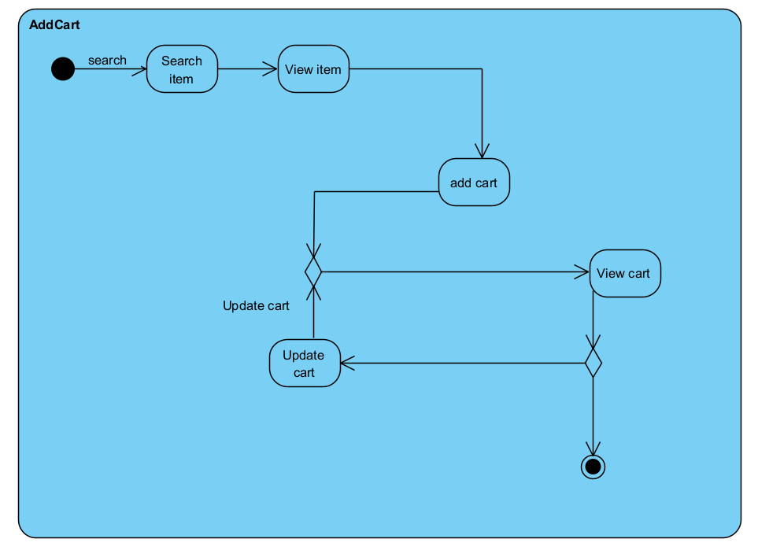

Hình 1. : Create Cart

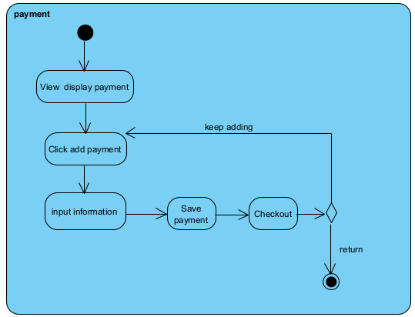

Hình 1. : Payment

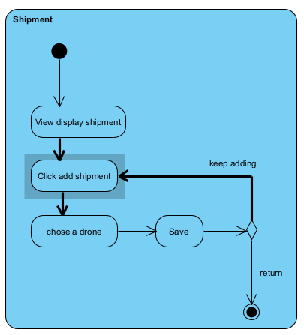

Hình 1. : Shipment

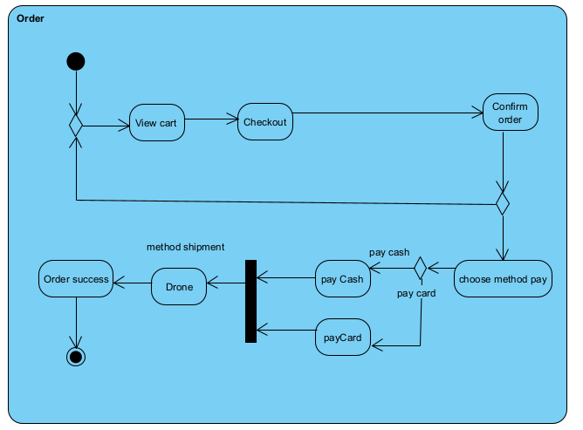

Hình 1. : Order

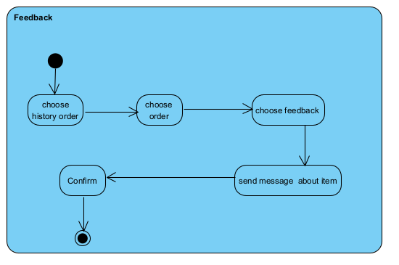

Hình 1. : Feedback

##### 5 Sequences Diagrams

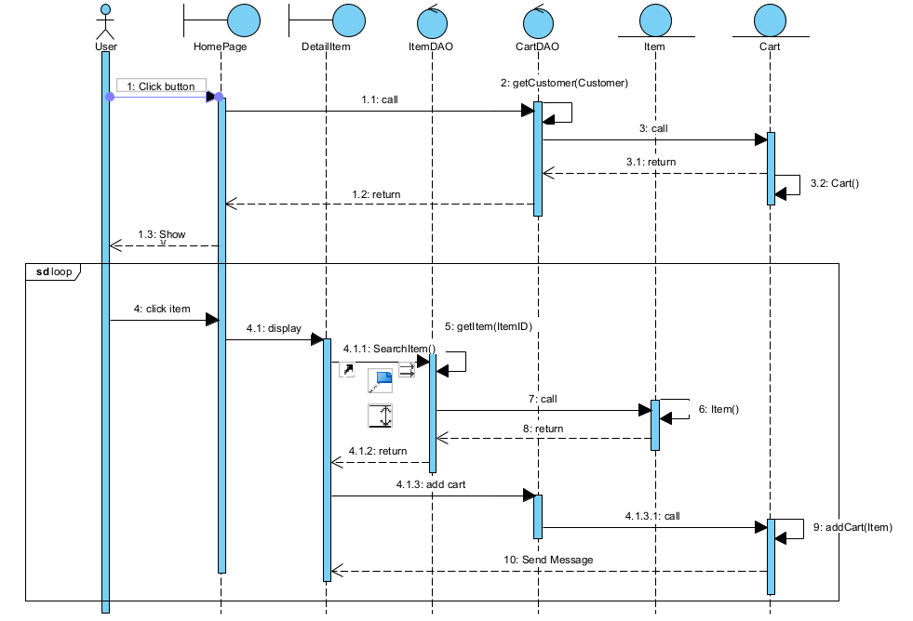

Hình 1. : Create Cart

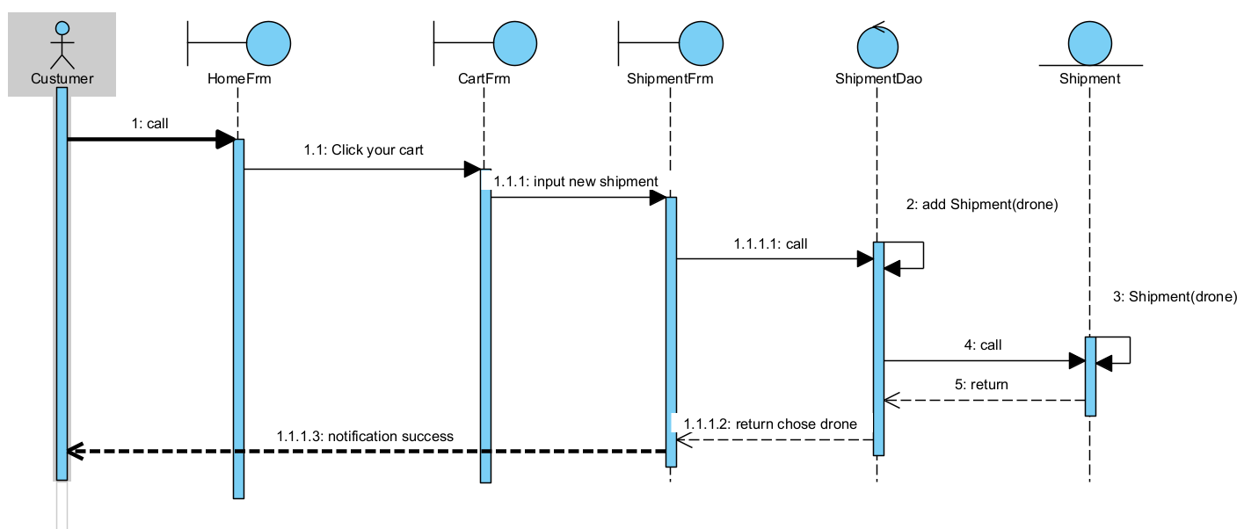

Hình 1. : Payment



Hình 1. : Shipment

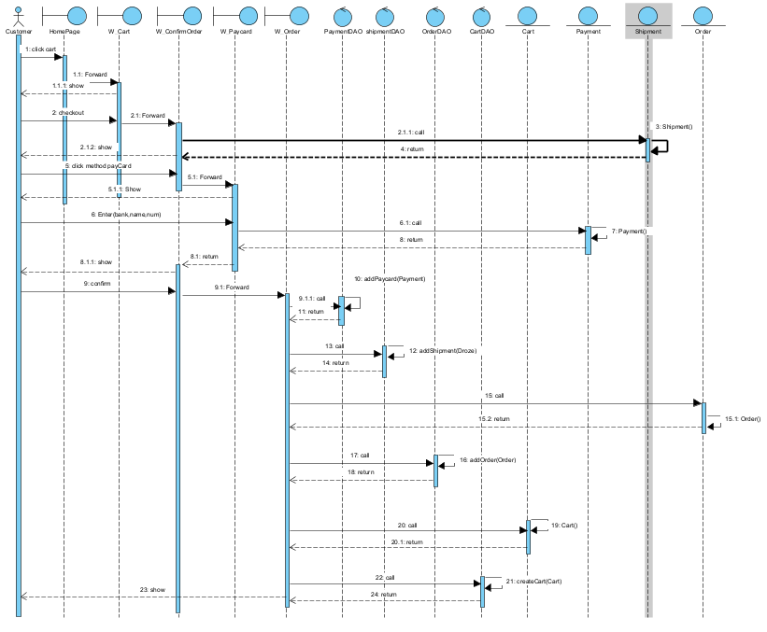

Hình 1. : Order

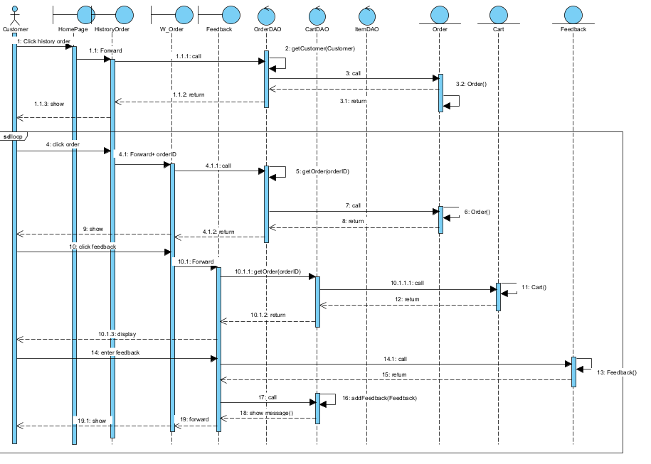

Hình 1. : Feedback

#### 3.2 Process order: alert order (automatically), check order, send invoice/feedback to customer, send requirements to ship department and repository

##### 5 Activity Diagrams

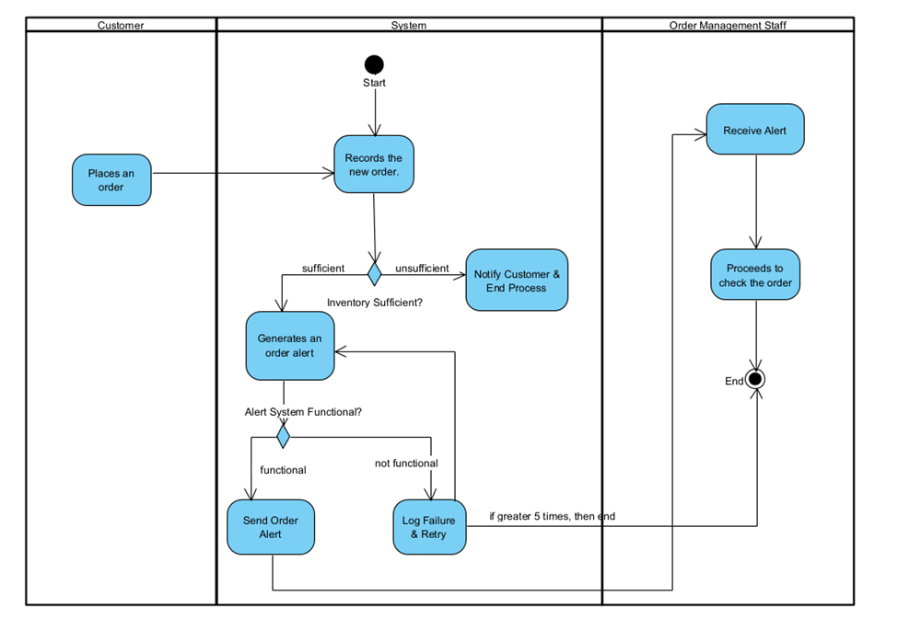

Hình 1. : Activity 1

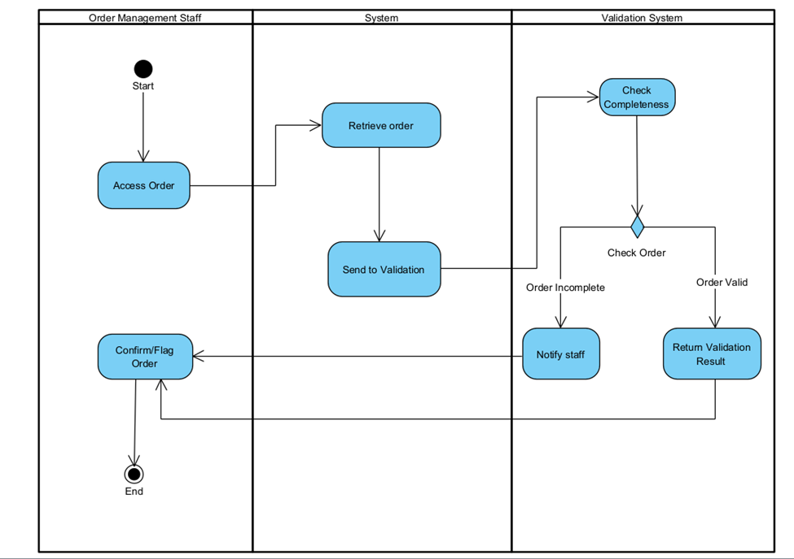

Hình 1. : Activity 2

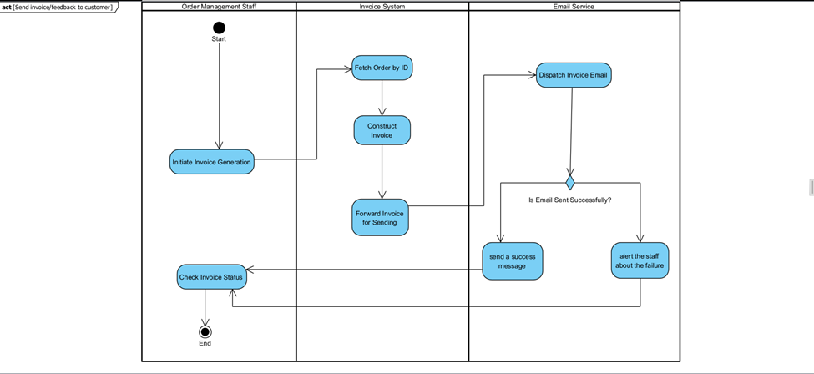

Hình 1. : Activity 3

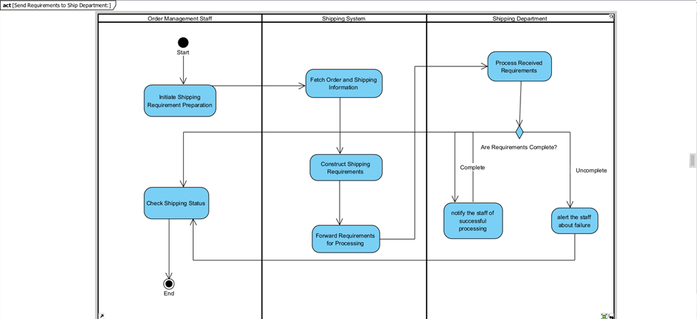

Hình 1. : Activity 4

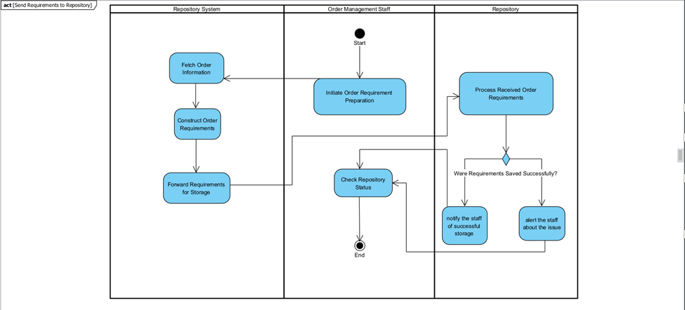

Hình 1. : Activity 5

##### 5 Sequence Diagram

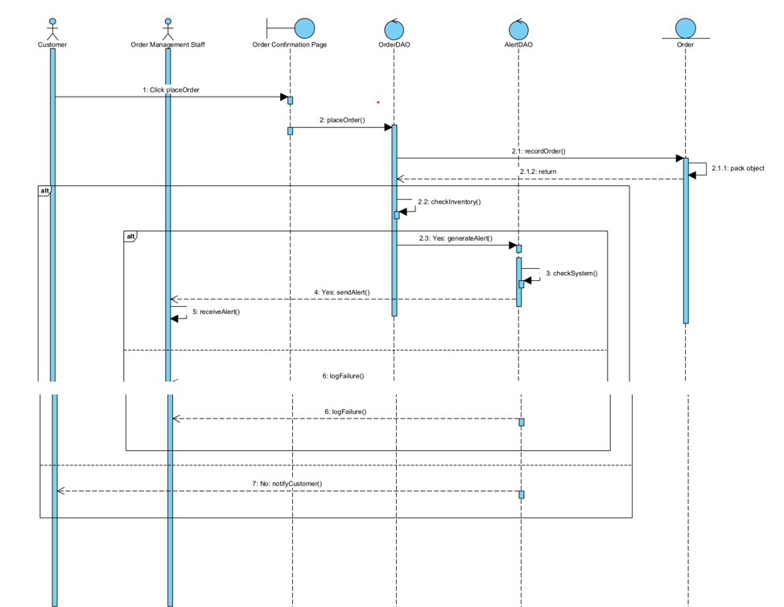

Hình 1. : Sequence Diagram 1

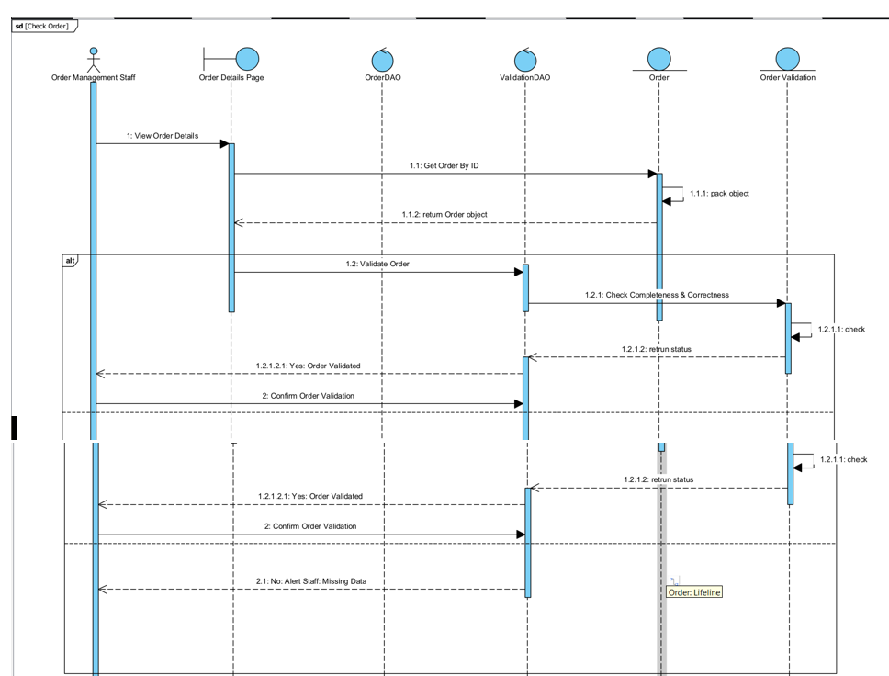

Hình 1. : Sequence Diagram 2

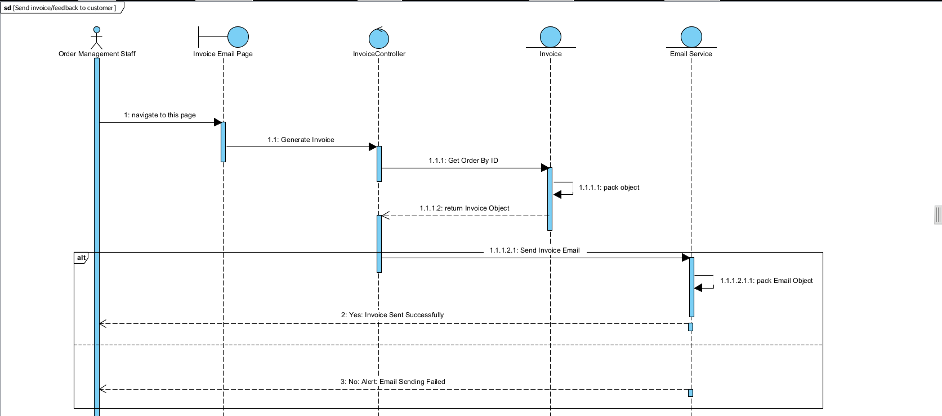

Hình 1. : Sequence Diagram 3

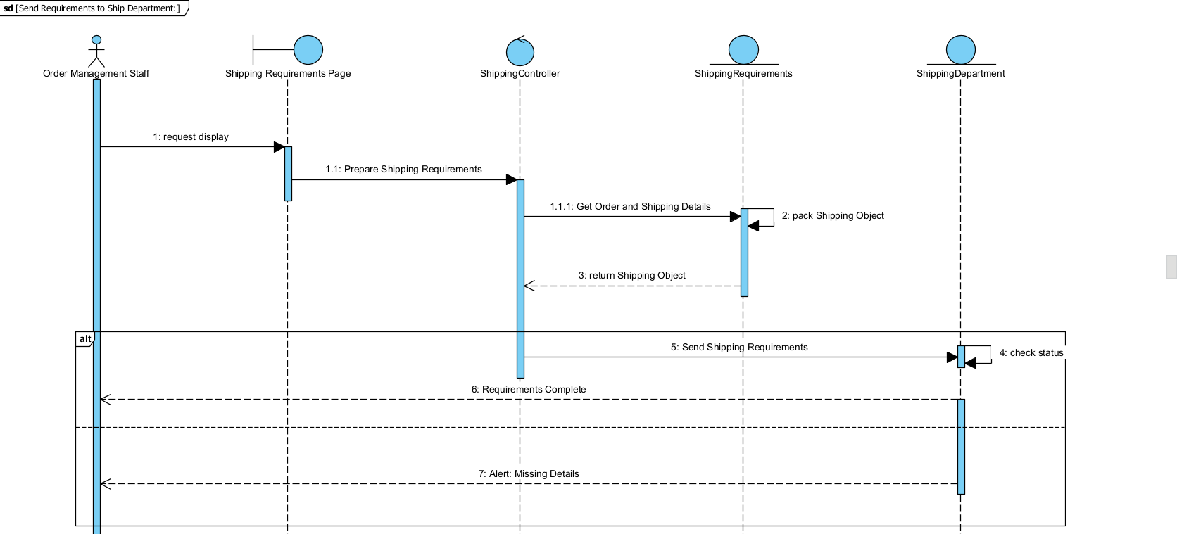

Hình 1. : Sequence Diagram 4

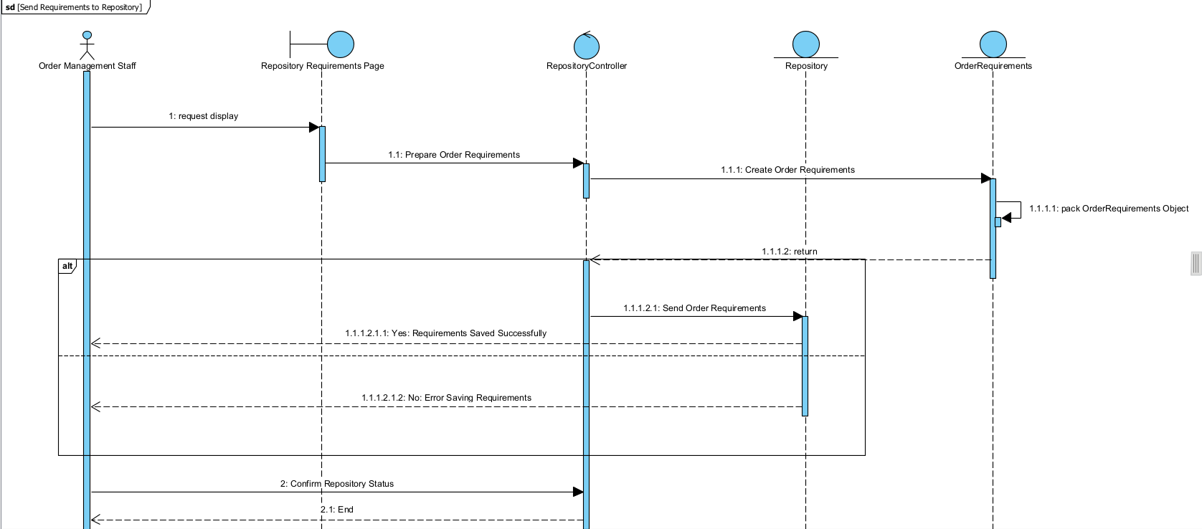

Hình 1. : Sequence Diagram 5

#### 3.3 Process payment

##### 5 Activity diagrams

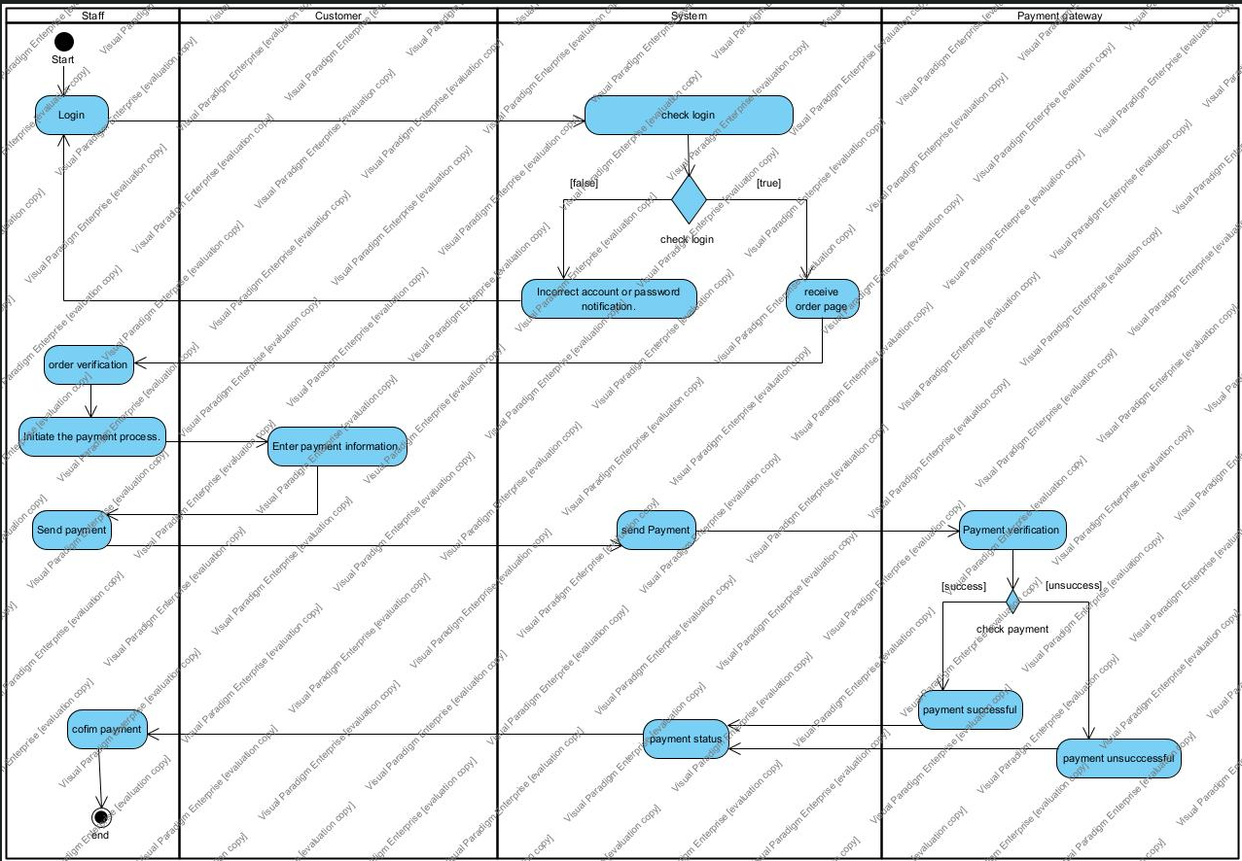

Hình 1. : Staff Payment

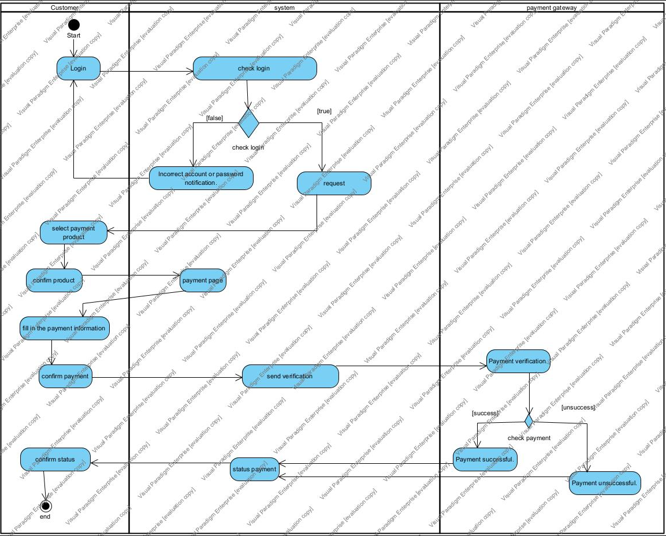

Hình 1. : Customer Payment

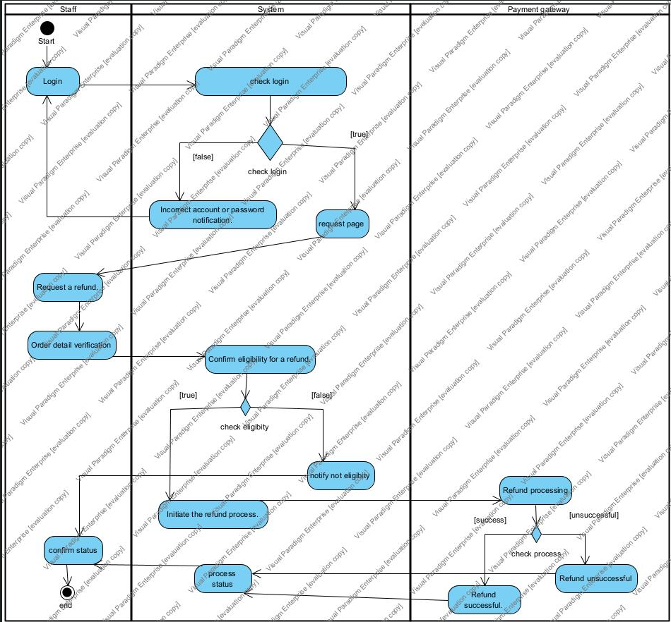

Hình 1. : Refund Staff

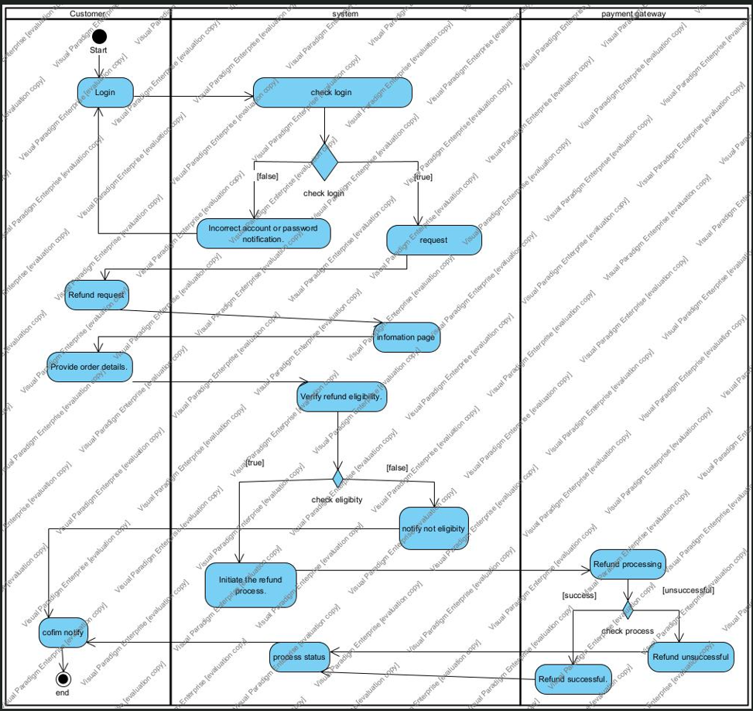

Hình 1. : Refund Customer

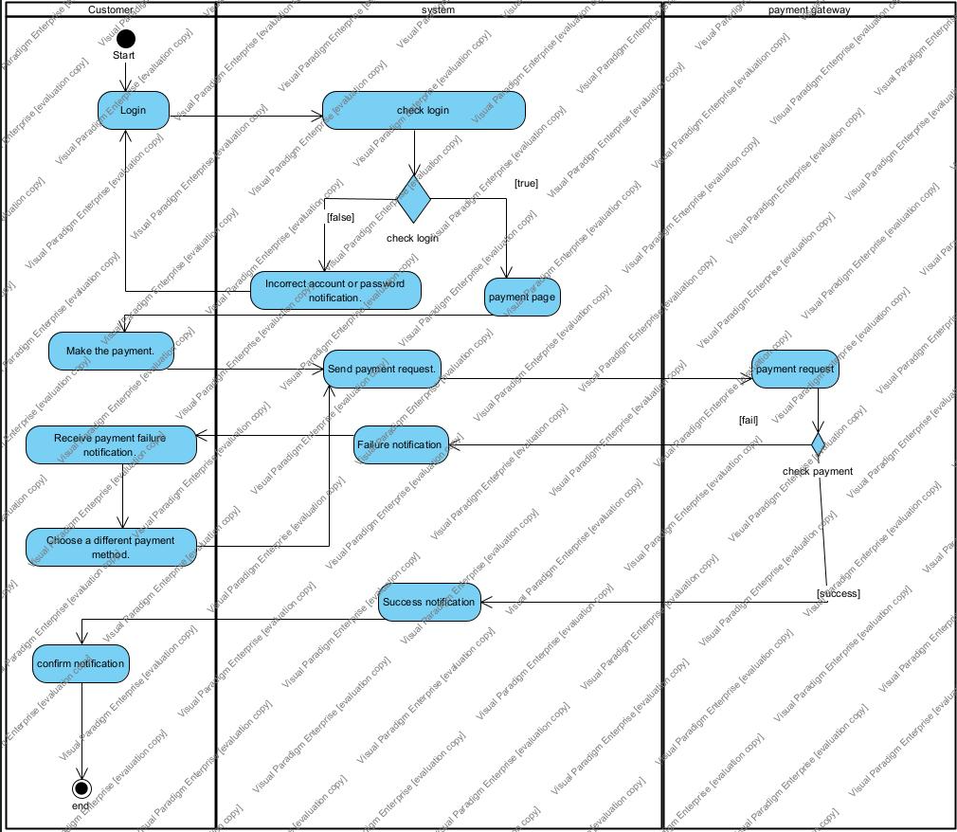

Hình 1. : Payment Failed

##### 5 sequence diagrams for: Process payment

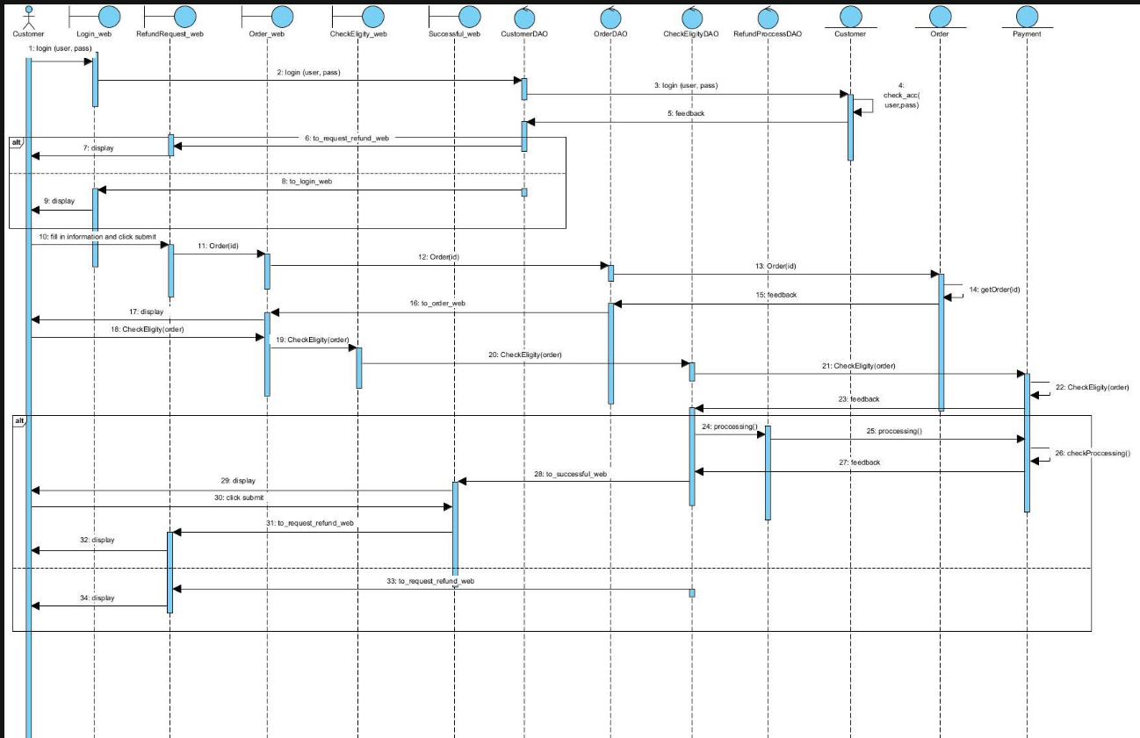

Hình 1. : Customer Payment

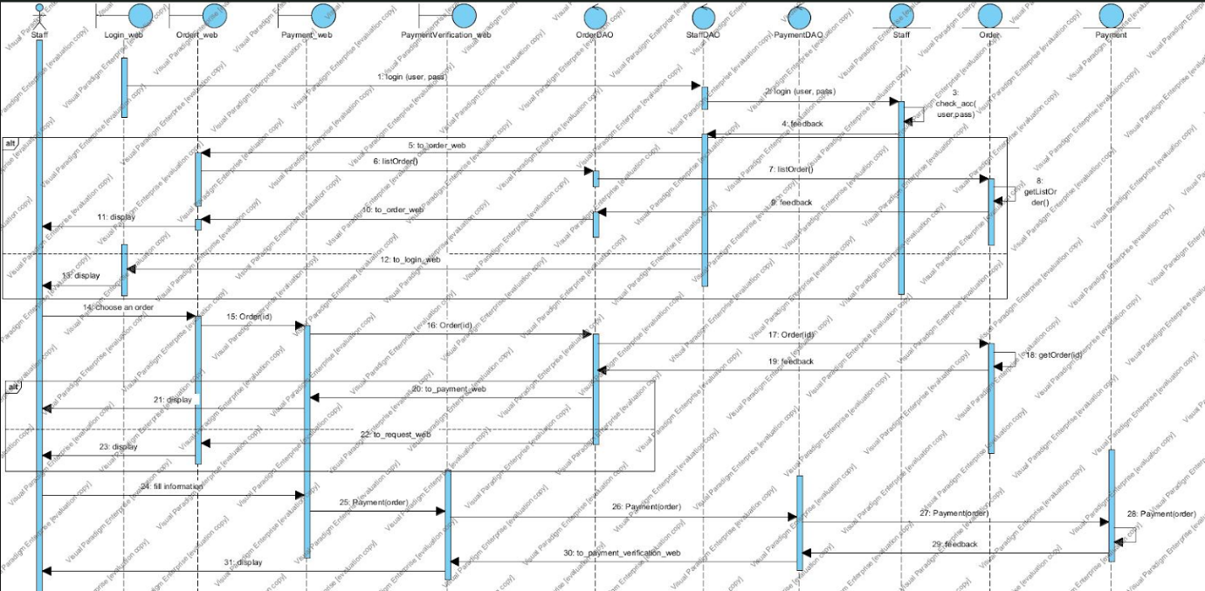

Hình 1. : Staff Payment

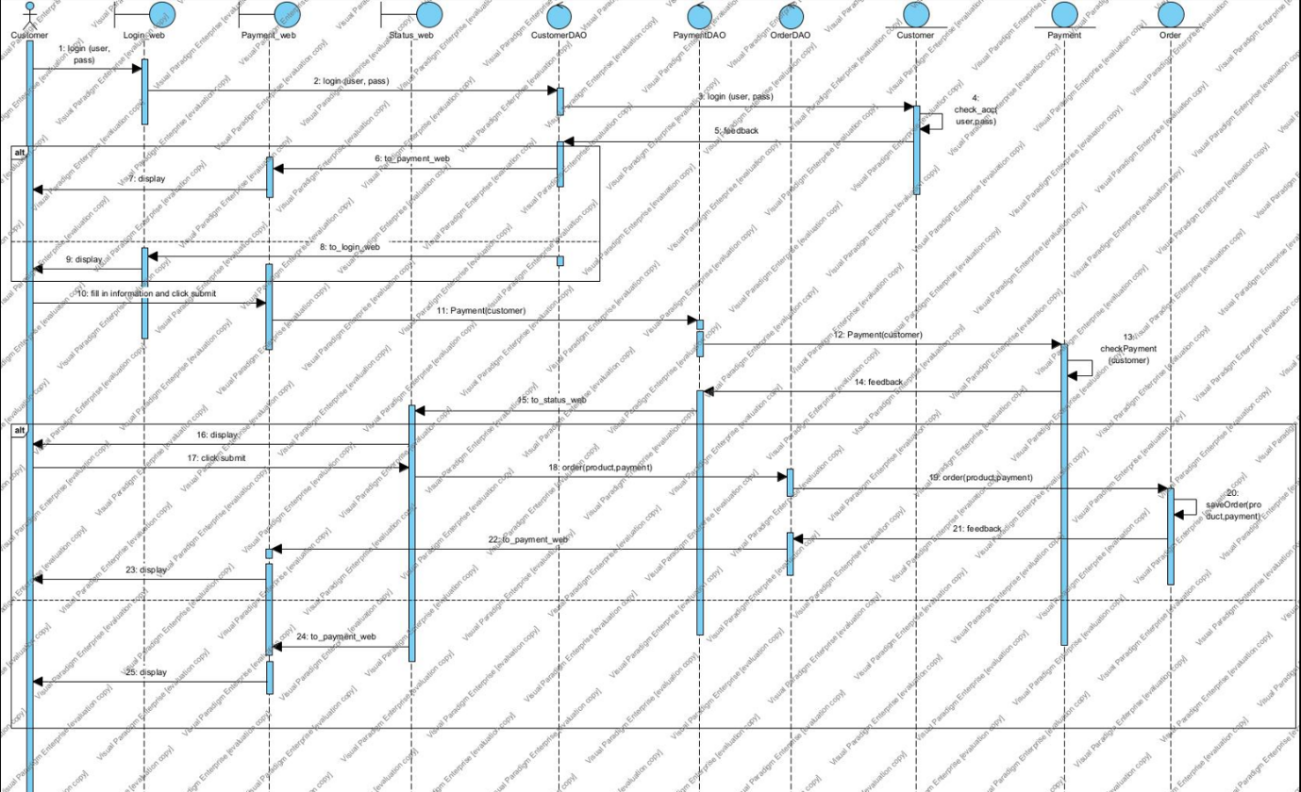

Hình 1. : Payment Failed

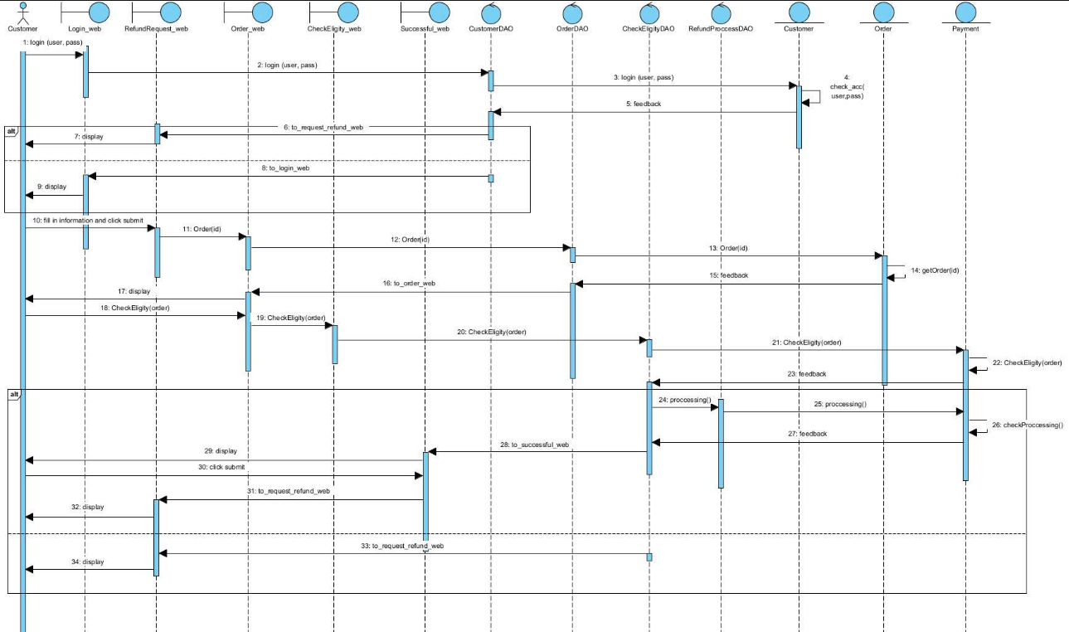

Hình 1. : Refund Customer

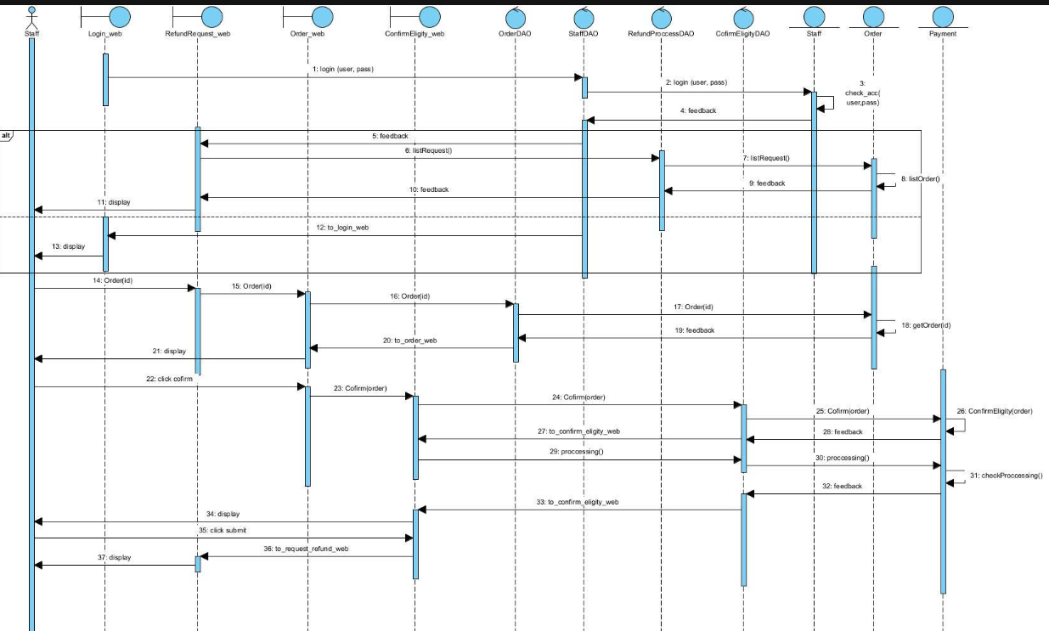

Hình 1. : Refund Staff

#### 3.4 Process shipment (using drone)

##### 5 Activity Diagram

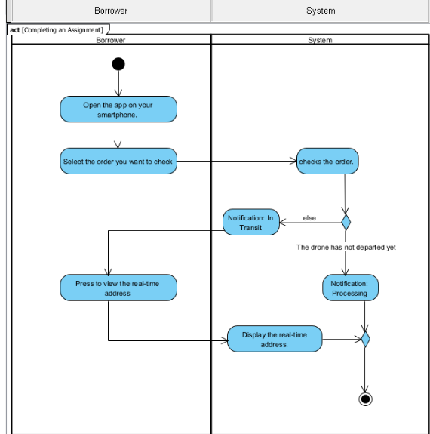

Hình 1. : Activity Diagram 1

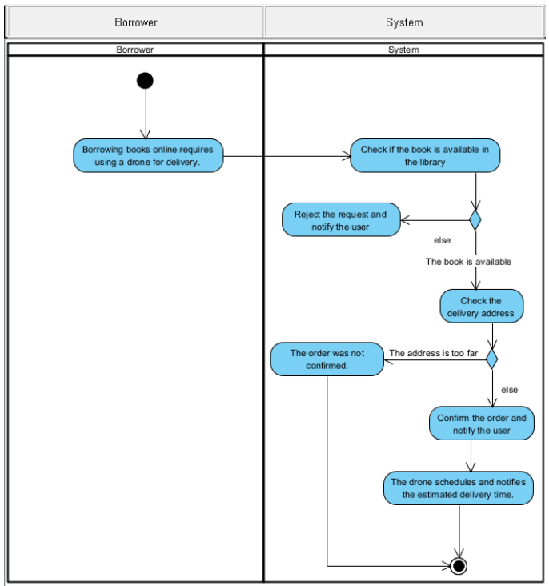

Hình 1. : Activity Diagram 2

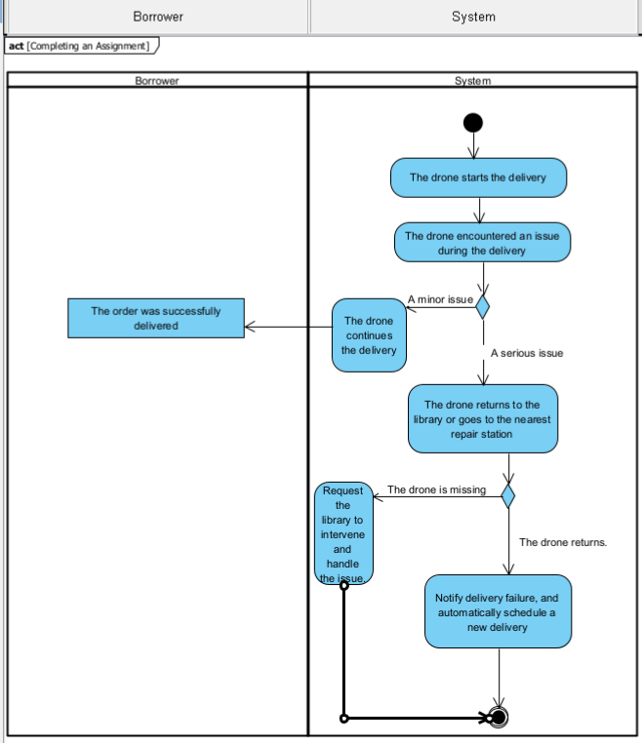

Hình 1. : Activity Diagram 3

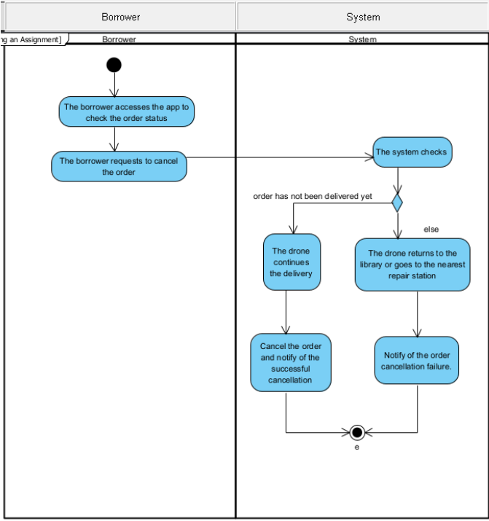

Hình 1. : Activity Diagram 4

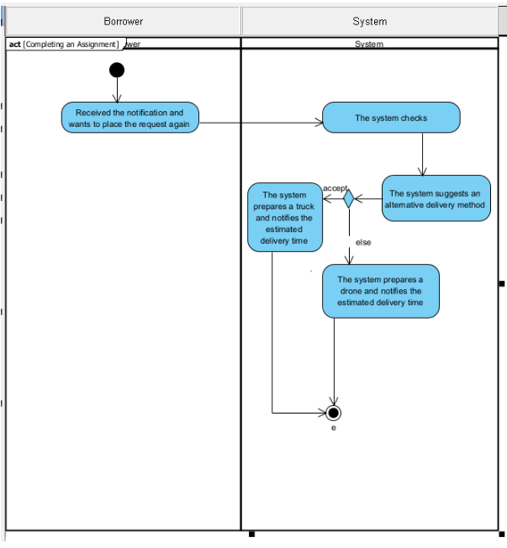

Hình 1. : Activity Diagram 5

##### 5 Sequence Diagram

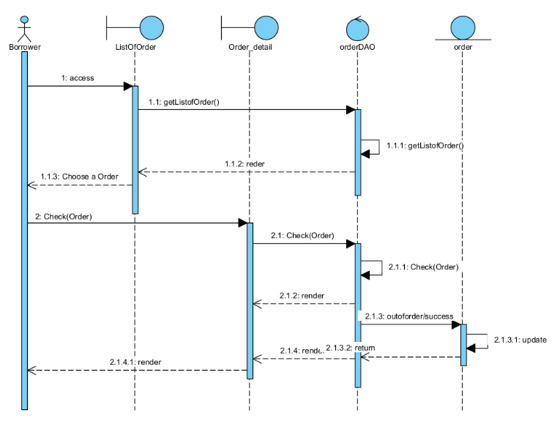

Hình 1. : Sequence Diagram 1

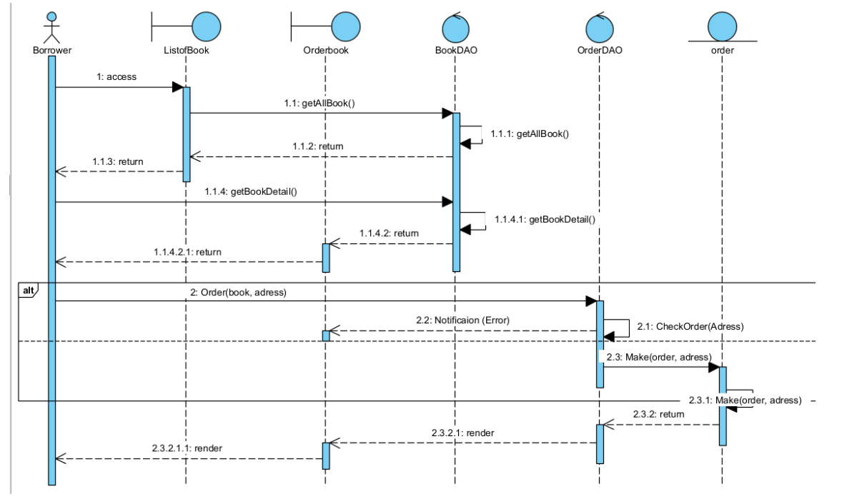

Hình 1. : Sequence Diagram 2

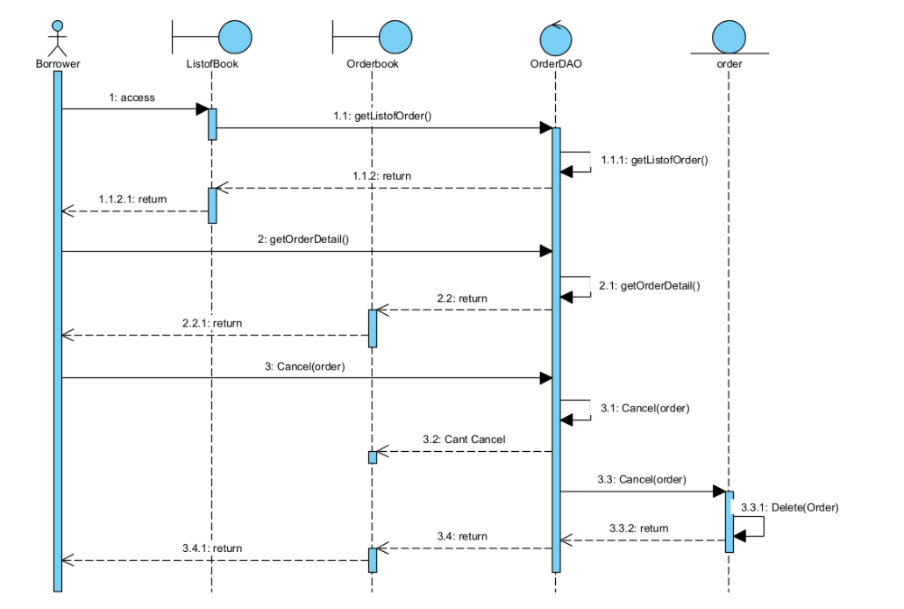

Hình 1. : Sequence Diagram 4

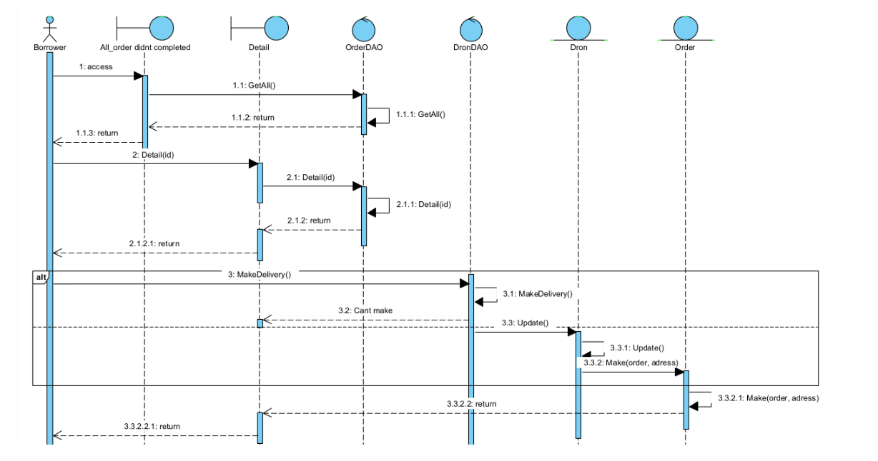

Hình 1. : Sequnece Diagram 5

## II. Requirement Analysis

## 1. Write 50 CRC Cards

## 2. Draw a class diagram (analysis) with 50 classes

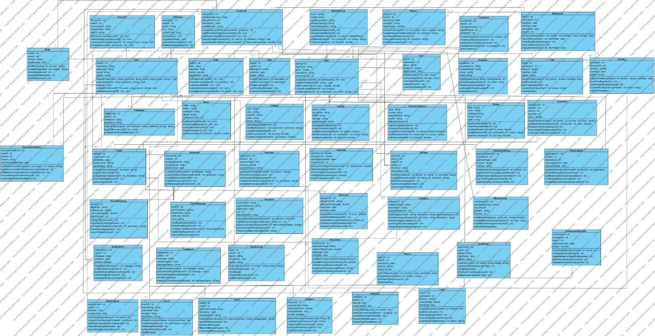

Hình 2. : class diagram (analysis) with 50 classes

## 3. Construct data dictionary

## 4. Create data model

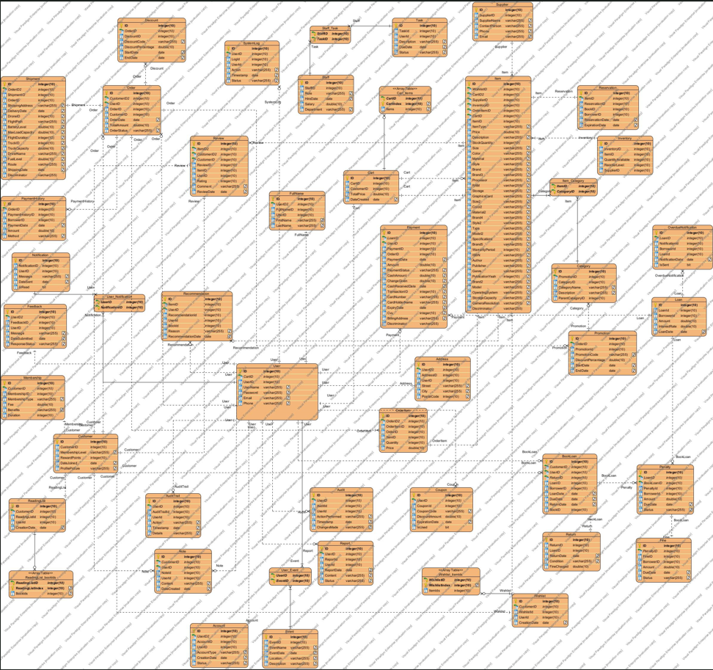

Hình 2. : data model

## III. Design

### 1. Construct a class diagram (design)

#### 1.1 Validate the class diagram in analysis (Name, attributes, methods, relationship...)

#### 1.2 Add attributes, add methods, change multiplicity, change relationship

#### 1.3 Change association classes into suitable relationships (aggregation, composition)

### 2. Using MVC model to design the e-commerce system

#### 2.1 Using DAO pattern to classes

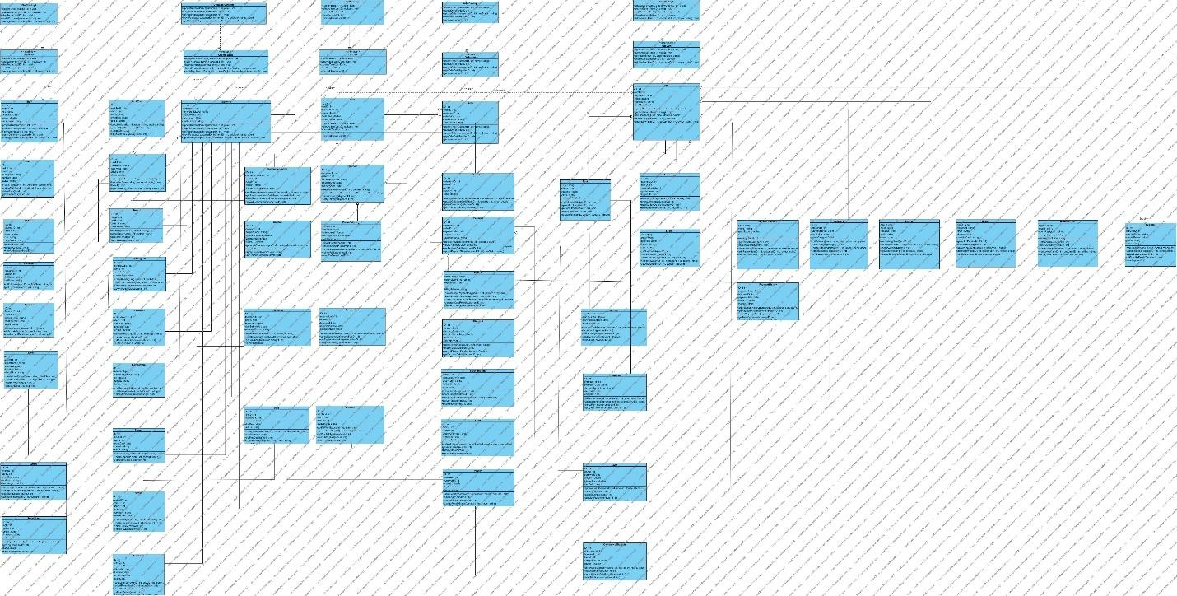

Hình 3. : DAO pattern to classes

#### 2.2 Using package notion in UML to group classes into packages and layers with the model MVC: Model layer, Controller model, View model

##### 2.2.1 Tổng quát

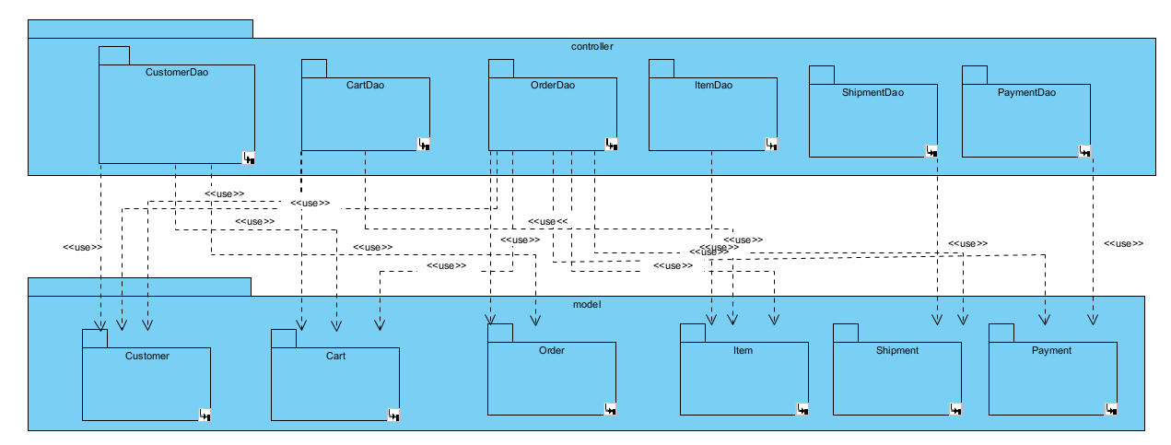

Hình 3. : Package layer

##### 2.2.2 Customer

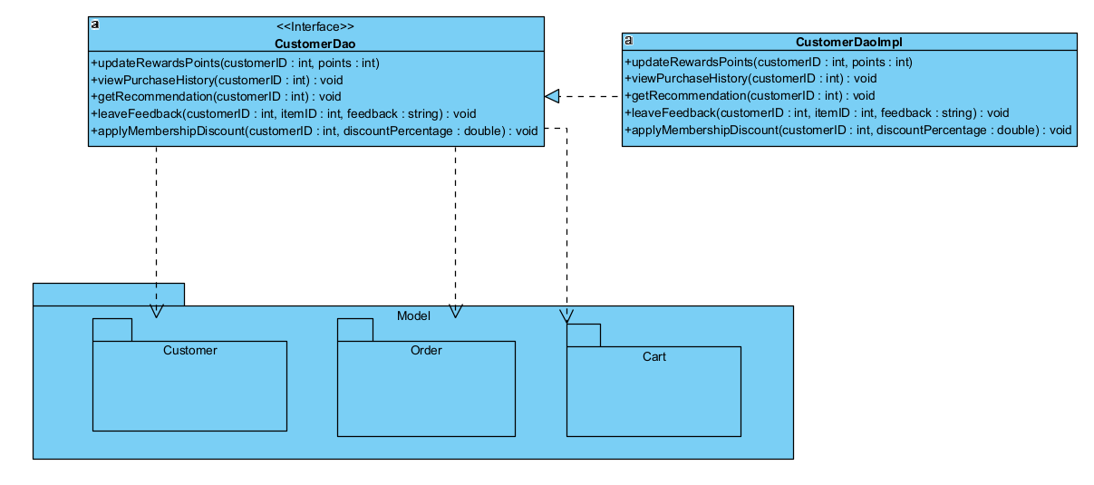

Hình 3. : CustomerDAO

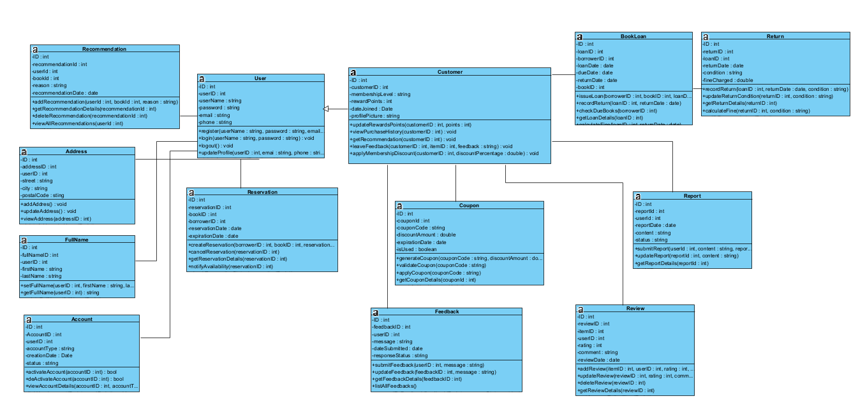

Hình 3. : Class Diagram Customer

##### 2.2.3 Cart

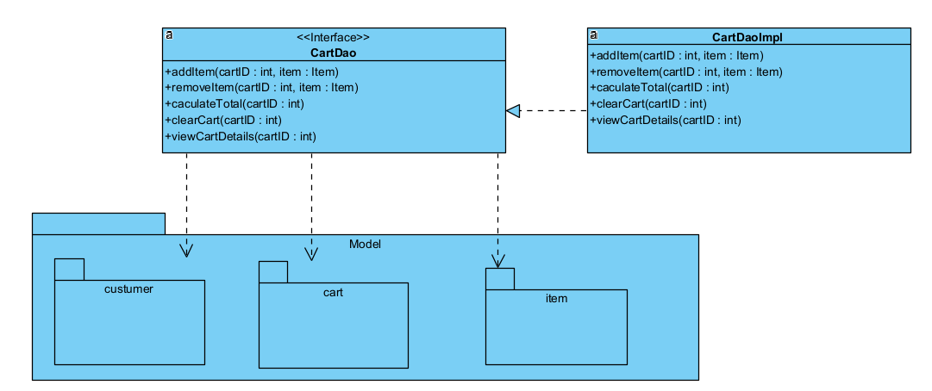

Hình 3. : CartDAO

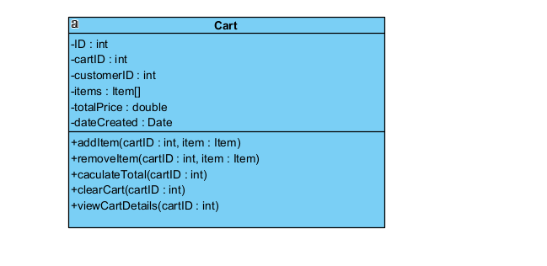

Hình 3. : Class Diagram Cart

##### 2.2.4 Order

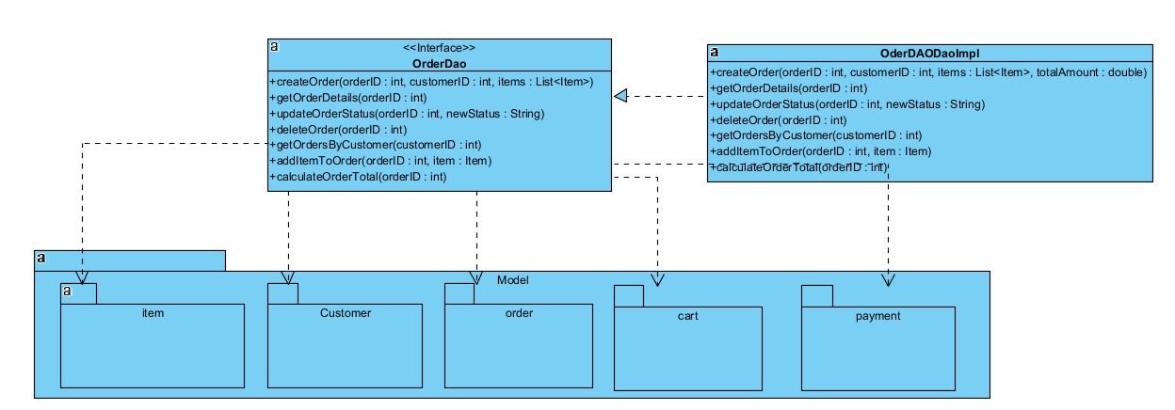

Hình 3. : OrderDAO

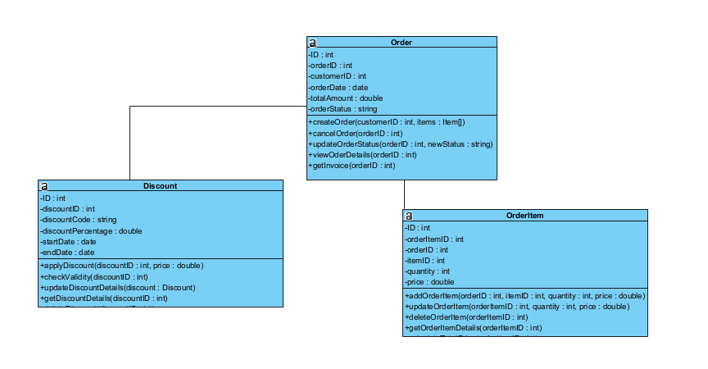

Hình 3. : Class Diagram Order

##### 2.2.5 Item

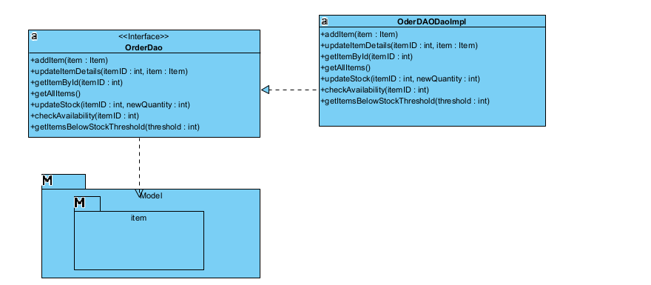

Hình 3. : ItemDAO

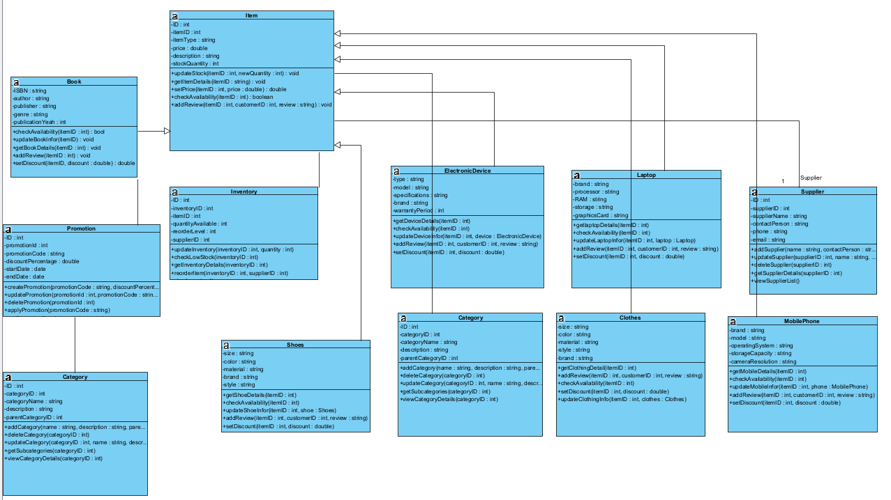

Hình 3. : Class Diagram Item

##### 2.2.6 Payment

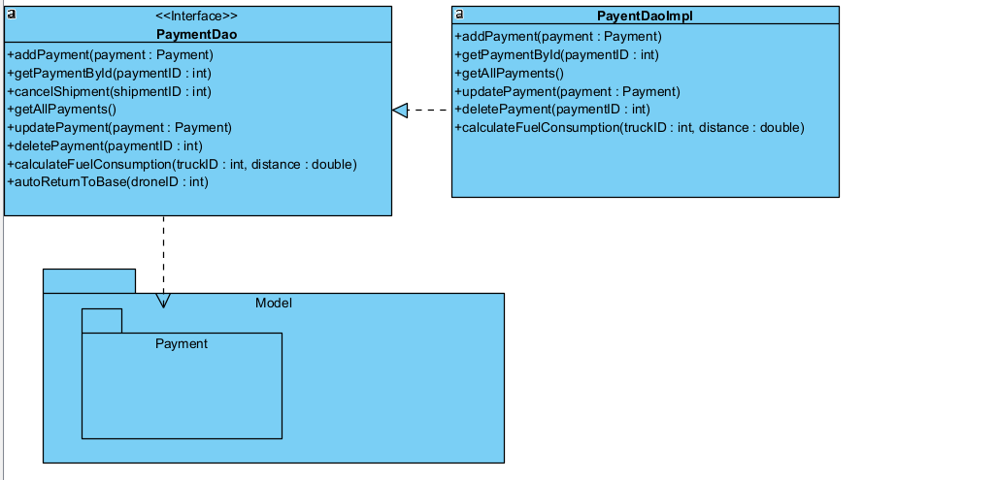

Hình 3. : PaymentDAO

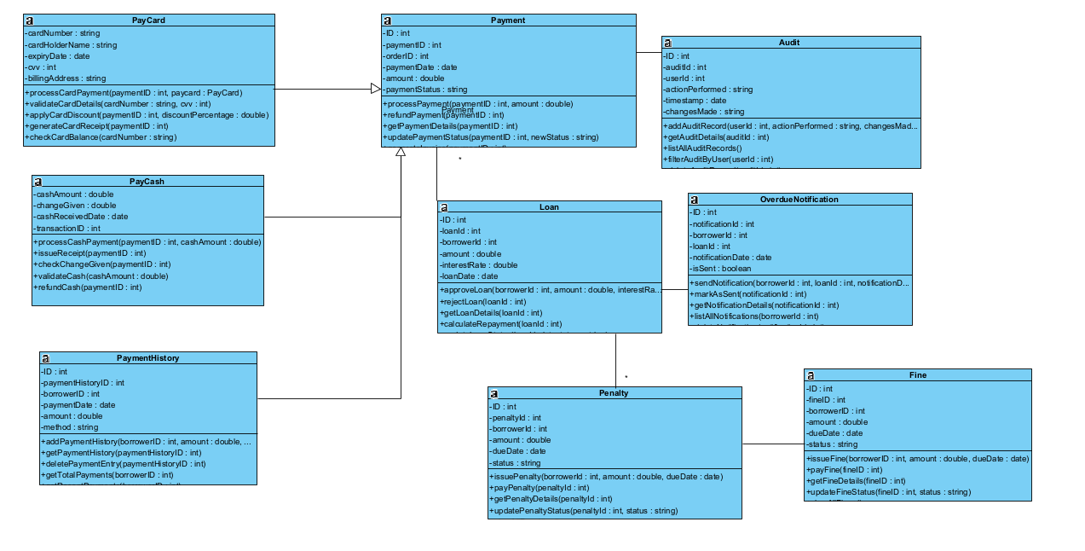

Hình 3. : Class Diagram Payment

##### 2.2.7 Shipment

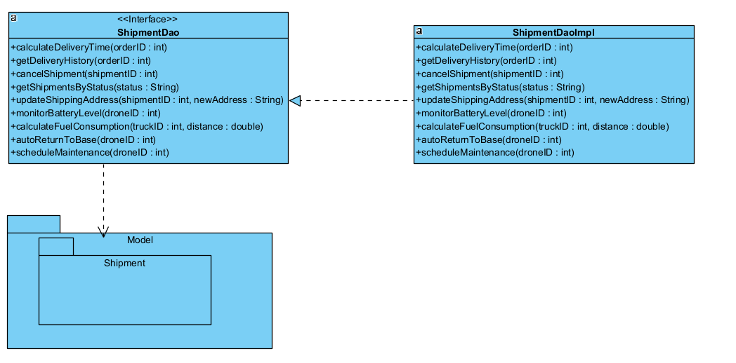

Hình 3. : ShipmentDAO

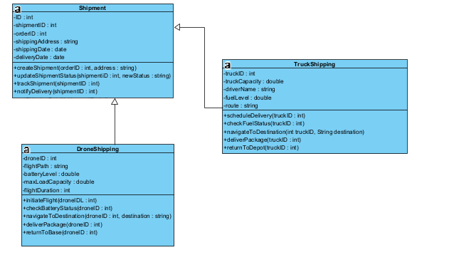

Hình 3. : Class Diagram Shipment

### 3. Construct database

#### 3.1 Validate data model: check fields, key, connection multilicity...

##### 3.3.1 Customer

- id (Primary Key): Kiểu INT, tự tăng.

- name: Kiểu VARCHAR(255), lưu tên khách hàng.

- email: Kiểu VARCHAR(255), đảm bảo duy nhất (unique).

- phone: Kiểu VARCHAR(20), số điện thoại khách hàng.

- address: Kiểu VARCHAR(255), địa chỉ khách hàng.

##### 3.3.2 Order

- id (Primary Key): Kiểu INT, tự tăng.

- customer_id (Foreign Key): Liên kết với bảng Customer (id).

- order_date: Kiểu DATETIME, ngày đặt hàng, mặc định `CURRENT_TIMESTAMP`.

- total_amount: Kiểu DECIMAL(10, 2), tổng số tiền của đơn hàng.

- status: Kiểu ENUM ('Pending', 'Shipped', 'Completed', 'Cancelled'), trạng thái đơn hàng.

##### 3.3.3 Item

- id (Primary Key): Kiểu INT, tự tăng.

- name: Kiểu VARCHAR(255), tên sản phẩm.

- price: Kiểu DECIMAL(10, 2), giá của sản phẩm.

- stock: Kiểu INT, số lượng sản phẩm còn lại trong kho.

- description: Kiểu TEXT, mô tả sản phẩm.

##### 3.3.4 Cart

- id (Primary Key): Kiểu INT, tự tăng.

- customer_id (Foreign Key): Liên kết với bảng Customer (id).

- item_id (Foreign Key): Liên kết với bảng Item (id).

- quantity: Kiểu INT, số lượng sản phẩm trong giỏ hàng.

##### 3.3.5 Payment

- id (Primary Key): Kiểu INT, tự tăng.

- order_id (Foreign Key): Liên kết với bảng Order (id).

- amount: Kiểu DECIMAL(10, 2), số tiền thanh toán.

- payment_type: Kiểu ENUM ('CreditCard', 'PayPal', 'Cash'), phương thức thanh toán.

- payment_date: Kiểu DATETIME, ngày thanh toán, mặc định `CURRENT_TIMESTAMP`.

##### 3.3.6 Shipment

- id (Primary Key): Kiểu INT, tự tăng.

- order_id (Foreign Key): Liên kết với bảng Order (id).

- shipment_date: Kiểu DATETIME, ngày vận chuyển, mặc định `CURRENT_TIMESTAMP`.

- address: Kiểu VARCHAR(255), địa chỉ giao hàng.

- vehicle: chọn phương tiện giao(“drone”,”car”,”motorbike")

##### 3.3.7 Mô hình hóa mối quan hệ

**Customer** ↔ **Order**: 1-N (Một khách hàng có thể có nhiều đơn hàng).

**Order** ↔ **Payment**: 1-1 (Mỗi đơn hàng chỉ có một giao dịch thanh toán).

**Order** ↔ **Shipment**: 1-1 (Mỗi đơn hàng chỉ có một thông tin vận chuyển).

**Cart**: Liên kết giữa **Customer** và **Item**, thể hiện sản phẩm mà khách hàng đã thêm vào giỏ hàng.

#### 3.2 Select a model for inheritance

Xây dựng cho Payment

Bảng Payment có các loại:

type = "CreditCard".

type = "PayPal".

type = "Cash".

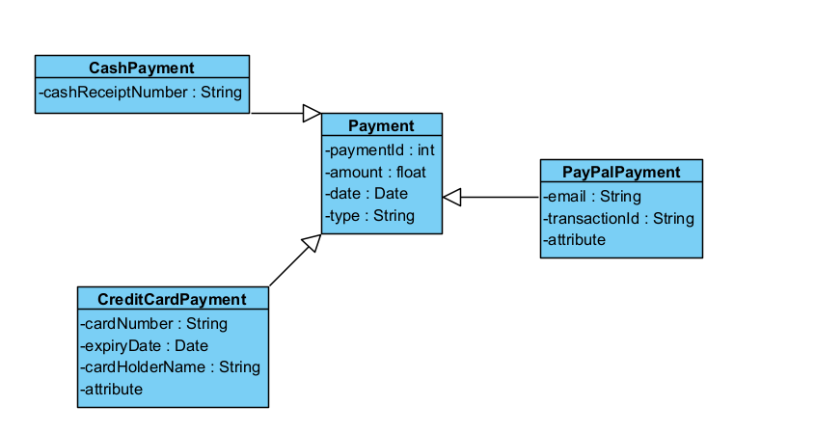

Xây dựng cho Shipment

Bảng Shipment có các loại:

type = "DroneShipment".

type = "CarShipment".

type = "MotorbikeShipment".

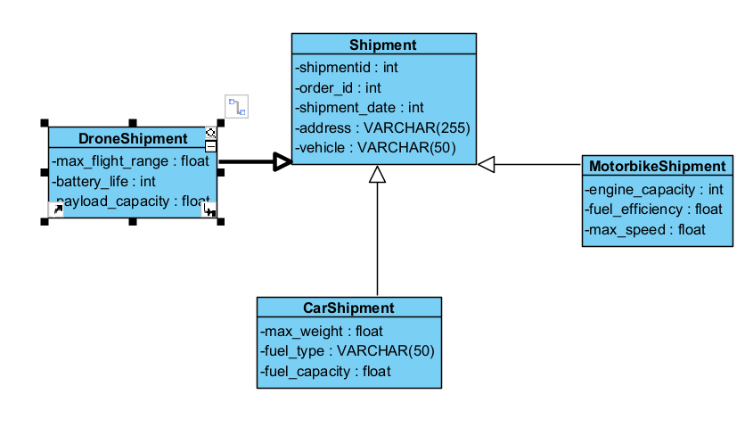

#### 3.3 Generate database with

SET @OLD_UNIQUE_CHECKS=@@UNIQUE_CHECKS, UNIQUE_CHECKS=0;

SET @OLD_FOREIGN_KEY_CHECKS=@@FOREIGN_KEY_CHECKS, FOREIGN_KEY_CHECKS=0;

SET @OLD_SQL_MODE=@@SQL_MODE, SQL_MODE='ONLY_FULL_GROUP_BY,STRICT_TRANS_TABLES,NO_ZERO_IN_DATE,NO_ZERO_DATE,ERROR_FOR_DIVISION_BY_ZERO,NO_ENGINE_SUBSTITUTION';

-- -----------------------------------------------------

-- Schema shopping-cart

-- -----------------------------------------------------

-- -----------------------------------------------------

-- Schema shopping-cart

-- -----------------------------------------------------

CREATE SCHEMA IF NOT EXISTS `shopping-cart` DEFAULT CHARACTER SET utf8mb4 COLLATE utf8mb4_0900_ai_ci ;

USE `shopping-cart` ;

-- -----------------------------------------------------

-- Table `shopping-cart`.`product`

-- -----------------------------------------------------

DROP TABLE IF EXISTS `shopping-cart`.`product` ;

CREATE TABLE IF NOT EXISTS `shopping-cart`.`product` (

  `pid` VARCHAR(45) NOT NULL,

  `pname` VARCHAR(100) NULL DEFAULT NULL,

  `ptype` VARCHAR(20) NULL DEFAULT NULL,

  `pinfo` VARCHAR(350) NULL DEFAULT NULL,

  `pprice` DECIMAL(12,2) NULL DEFAULT NULL,

  `pquantity` INT NULL DEFAULT NULL,

  `image` LONGBLOB NULL DEFAULT NULL,

  PRIMARY KEY (`pid`))

ENGINE = InnoDB

DEFAULT CHARACTER SET = utf8mb4

COLLATE = utf8mb4_0900_ai_ci;

-- -----------------------------------------------------

-- Table `shopping-cart`.`orders`

-- -----------------------------------------------------

DROP TABLE IF EXISTS `shopping-cart`.`orders` ;

CREATE TABLE IF NOT EXISTS `shopping-cart`.`orders` (

  `orderid` VARCHAR(45) NOT NULL,

  `prodid` VARCHAR(45) NOT NULL,

  `quantity` INT NULL DEFAULT NULL,

  `amount` DECIMAL(10,2) NULL DEFAULT NULL,

  `shipped` INT NOT NULL DEFAULT 0,

  PRIMARY KEY (`orderid`, `prodid`),

  INDEX `productid_idx` (`prodid` ASC) VISIBLE,

  CONSTRAINT `productid`

    FOREIGN KEY (`prodid`)

    REFERENCES `shopping-cart`.`product` (`pid`)

    ON DELETE NO ACTION

    ON UPDATE NO ACTION)

ENGINE = InnoDB

DEFAULT CHARACTER SET = utf8mb4

COLLATE = utf8mb4_0900_ai_ci;

-- -----------------------------------------------------

-- Table `shopping-cart`.`user`

-- -----------------------------------------------------

DROP TABLE IF EXISTS `shopping-cart`.`user` ;

CREATE TABLE IF NOT EXISTS `shopping-cart`.`user` (

  `email` VARCHAR(60) NOT NULL,

  `name` VARCHAR(30) NULL DEFAULT NULL,

  `mobile` BIGINT NULL DEFAULT NULL,

  `address` VARCHAR(250) NULL DEFAULT NULL,

  `pincode` INT NULL DEFAULT NULL,

  `password` VARCHAR(20) NULL DEFAULT NULL,

  PRIMARY KEY (`email`))

ENGINE = InnoDB

DEFAULT CHARACTER SET = utf8mb4

COLLATE = utf8mb4_0900_ai_ci;

-- -----------------------------------------------------

-- Table `shopping-cart`.`transactions`

-- -----------------------------------------------------

DROP TABLE IF EXISTS `shopping-cart`.`transactions` ;

CREATE TABLE IF NOT EXISTS `shopping-cart`.`transactions` (

  `transid` VARCHAR(45) NOT NULL,

  `username` VARCHAR(60) NULL DEFAULT NULL,

  `time` DATETIME NULL DEFAULT NULL,

  `amount` DECIMAL(10,2) NULL DEFAULT NULL,

  PRIMARY KEY (`transid`),

  INDEX `truserid_idx` (`username` ASC) VISIBLE,

  CONSTRAINT `truserid`

    FOREIGN KEY (`username`)

    REFERENCES `shopping-cart`.`user` (`email`)

    ON DELETE NO ACTION

    ON UPDATE NO ACTION,

  CONSTRAINT `transorderid`

    FOREIGN KEY (`transid`)

    REFERENCES `shopping-cart`.`orders` (`orderid`)

    ON DELETE NO ACTION

    ON UPDATE NO ACTION)

ENGINE = InnoDB

DEFAULT CHARACTER SET = utf8mb4

COLLATE = utf8mb4_0900_ai_ci;

-- -----------------------------------------------------

-- Table `shopping-cart`.`user_demand`

-- -----------------------------------------------------

DROP TABLE IF EXISTS `shopping-cart`.`user_demand` ;

CREATE TABLE IF NOT EXISTS `shopping-cart`.`user_demand` (

  `username` VARCHAR(60) NOT NULL,

  `prodid` VARCHAR(45) NOT NULL,

  `quantity` INT NULL DEFAULT NULL,

  PRIMARY KEY (`username`, `prodid`),

  INDEX `prodid_idx` (`prodid` ASC) VISIBLE,

  CONSTRAINT `userdemailemail`

    FOREIGN KEY (`username`)

    REFERENCES `shopping-cart`.`user` (`email`)

    ON DELETE NO ACTION

    ON UPDATE NO ACTION,

  CONSTRAINT `prodid`

    FOREIGN KEY (`prodid`)

    REFERENCES `shopping-cart`.`product` (`pid`)

    ON DELETE NO ACTION

    ON UPDATE NO ACTION)

ENGINE = InnoDB

DEFAULT CHARACTER SET = utf8mb4

COLLATE = utf8mb4_0900_ai_ci;

-- -----------------------------------------------------

-- Table `shopping-cart`.`usercart`

-- -----------------------------------------------------

DROP TABLE IF EXISTS `shopping-cart`.`usercart` ;

CREATE TABLE IF NOT EXISTS `shopping-cart`.`usercart` (

  `username` VARCHAR(60) NULL DEFAULT NULL,

  `prodid` VARCHAR(45) NULL DEFAULT NULL,

  `quantity` INT NULL DEFAULT NULL,

  INDEX `useremail_idx` (`username` ASC) VISIBLE,

  INDEX `prodidcart_idx` (`prodid` ASC) VISIBLE,

  CONSTRAINT `useremail`

    FOREIGN KEY (`username`)

    REFERENCES `shopping-cart`.`user` (`email`)

    ON DELETE NO ACTION

    ON UPDATE NO ACTION,

  CONSTRAINT `prodidcart`

    FOREIGN KEY (`prodid`)

    REFERENCES `shopping-cart`.`product` (`pid`)

    ON DELETE NO ACTION

    ON UPDATE NO ACTION)

ENGINE = InnoDB

DEFAULT CHARACTER SET = utf8mb4

COLLATE = utf8mb4_0900_ai_ci;

SET SQL_MODE=@OLD_SQL_MODE;

SET FOREIGN_KEY_CHECKS=@OLD_FOREIGN_KEY_CHECKS;

SET UNIQUE_CHECKS=@OLD_UNIQUE_CHECKS;

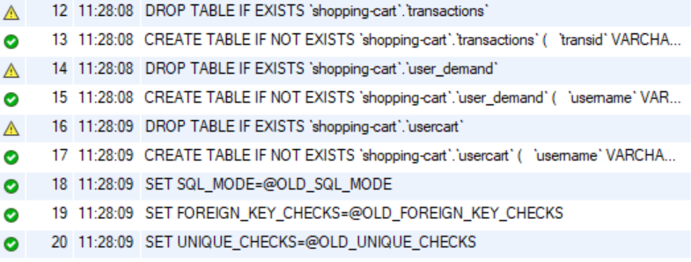

Create Successfully:

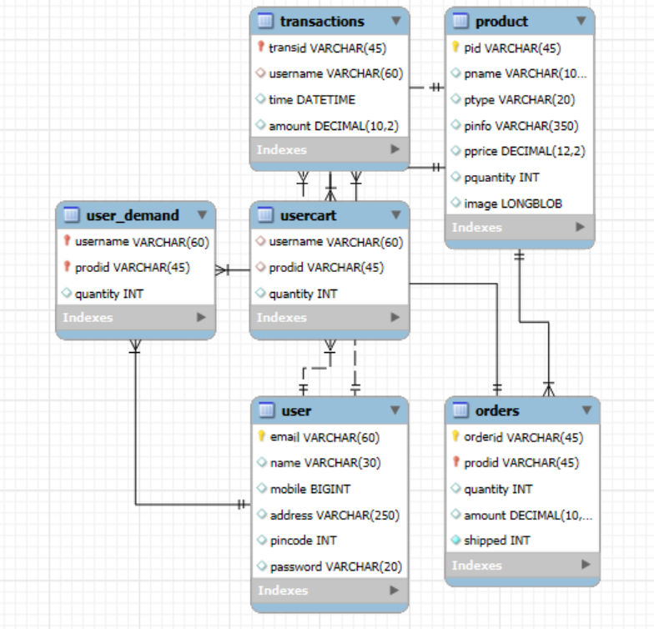

### 4. Design interface (user interface and system interface)

#### Máy tính PC:

##### User:

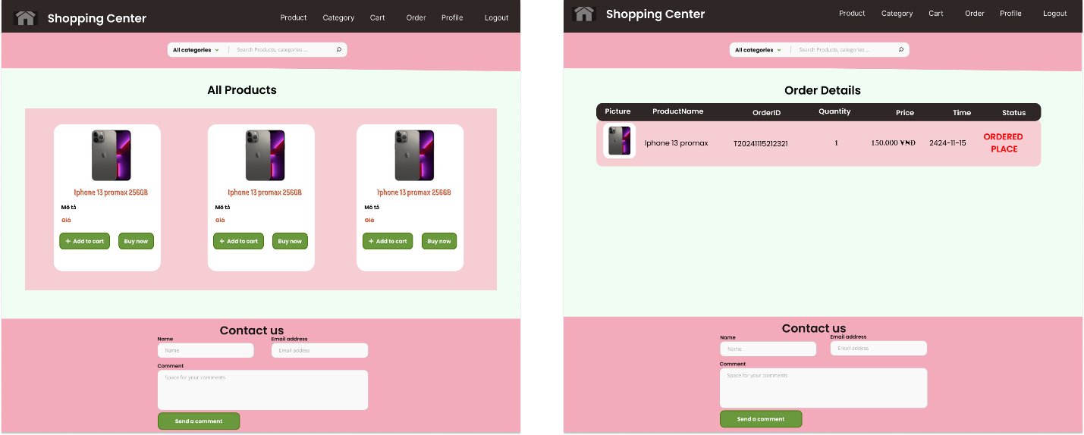

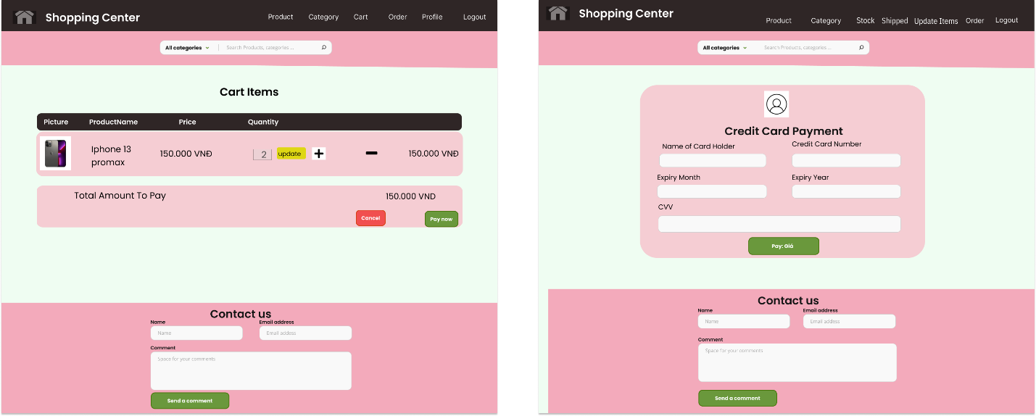

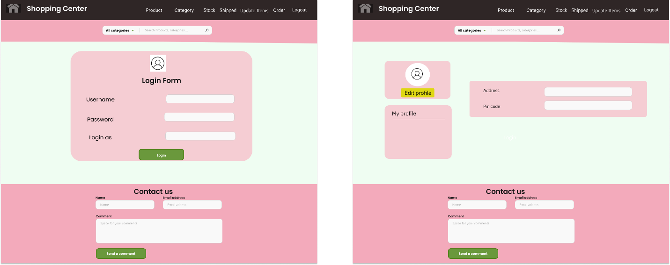

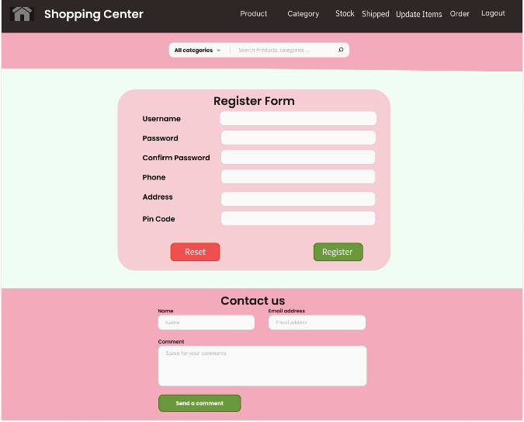

##### Admin:

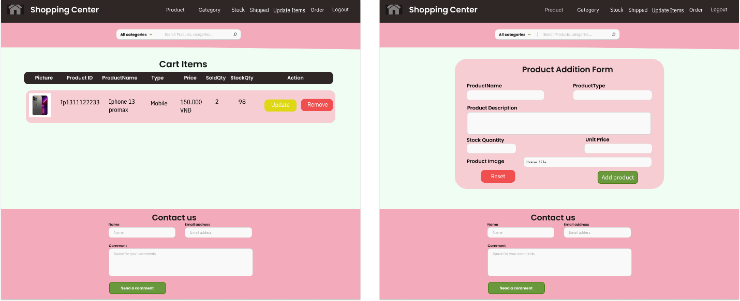

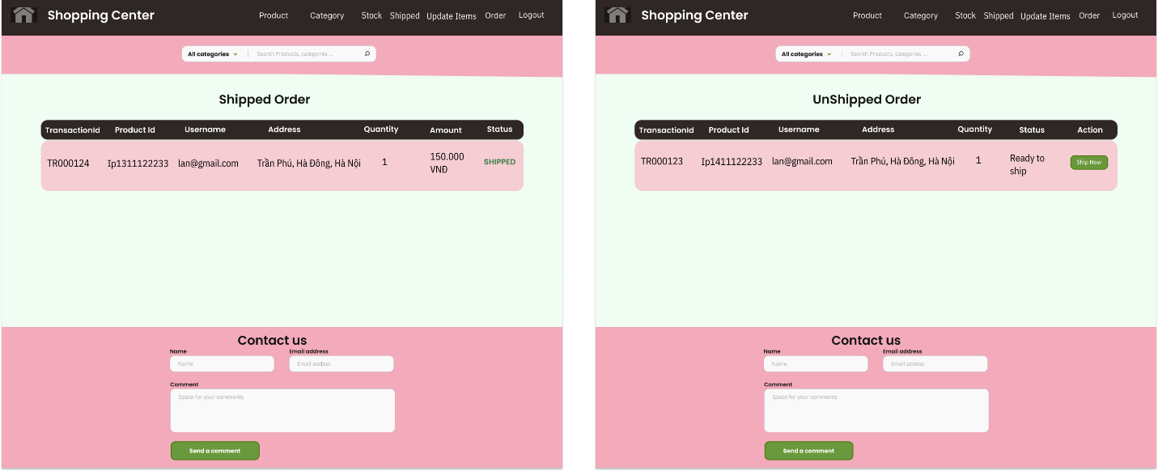

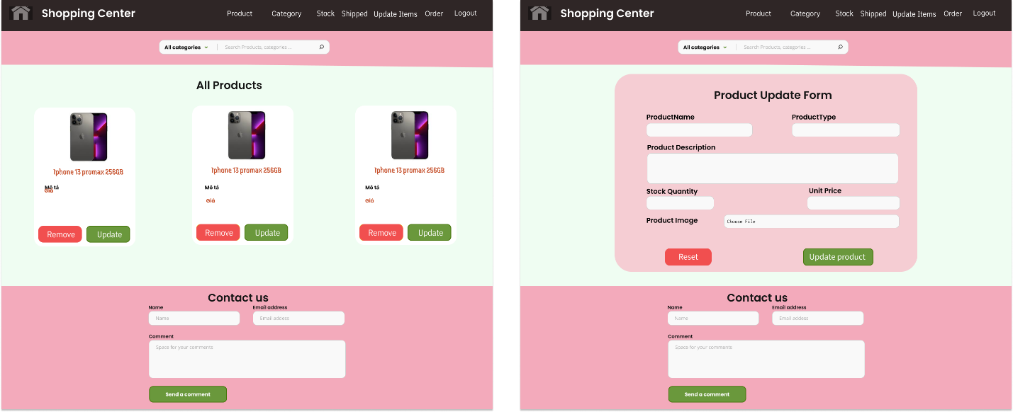

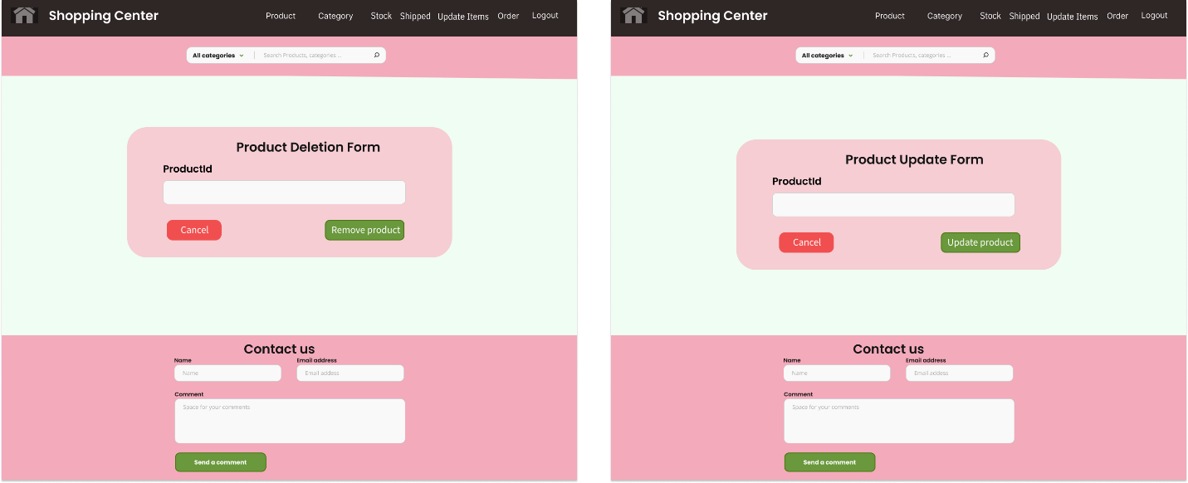

#### Mobile:

##### Admin:

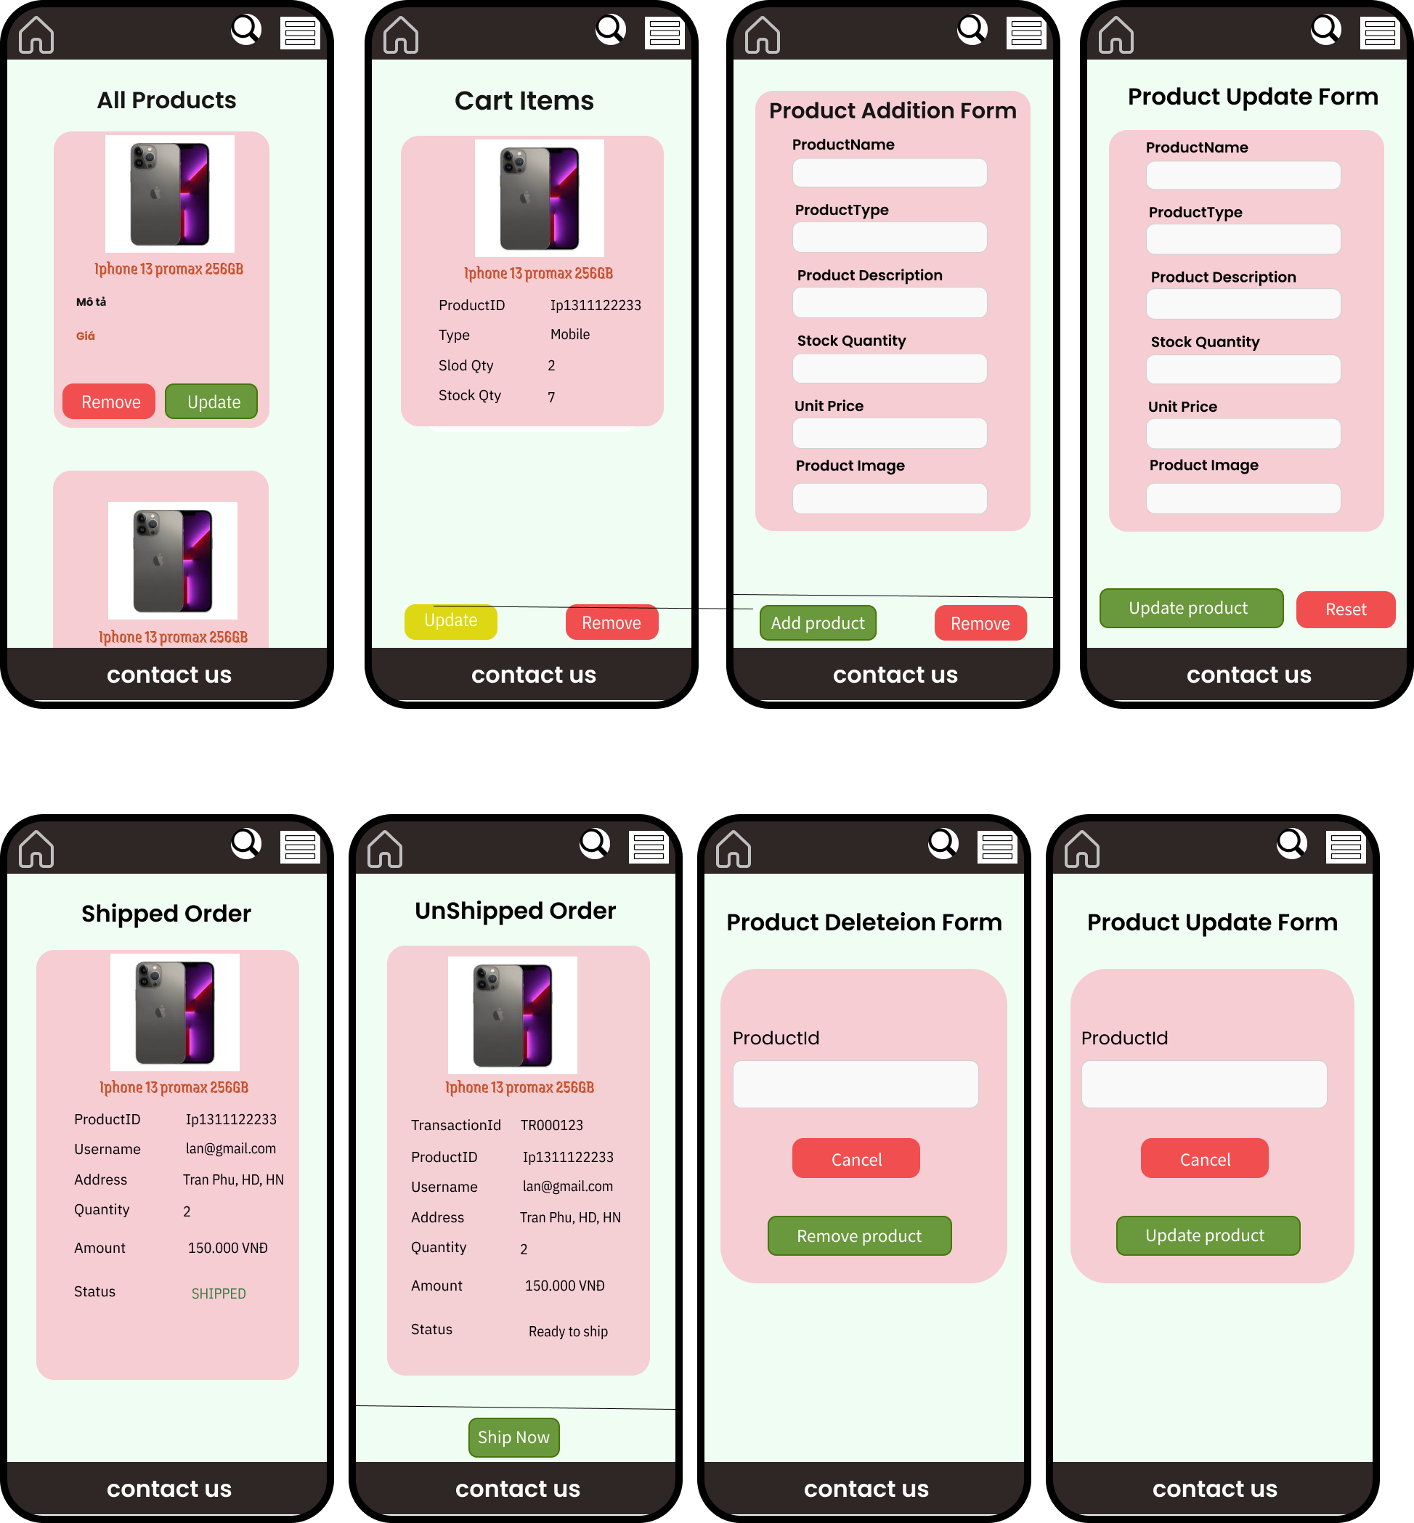

##### User:

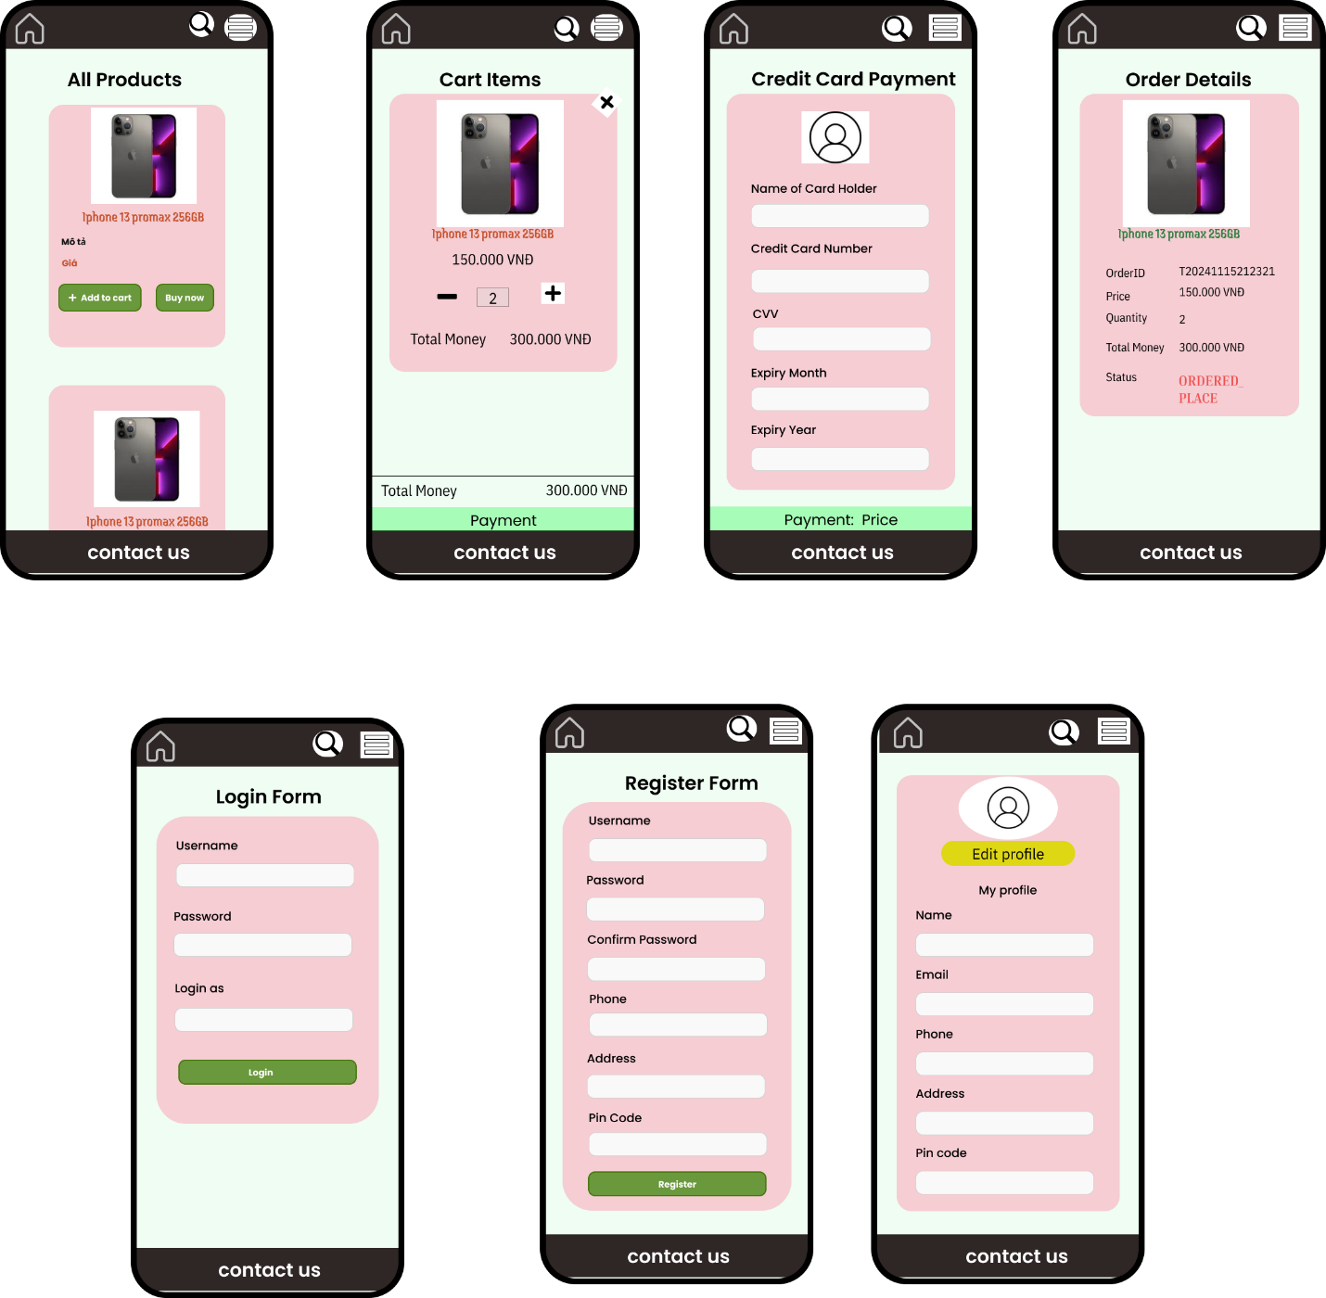

## IV. Programming and Integration

### 1. Using Java Spring (Boot), JSP, CSS, NoteJS....

### 2. Developing/utilizing techniques in deep learning to build modules search, analyze opinions/comments, recommender items, generate plots of analyzing customer’s tendency….